Renaissance Worldviews
We are learning to understand how Renaissance Europe shaped the beliefs and values of the Western world.
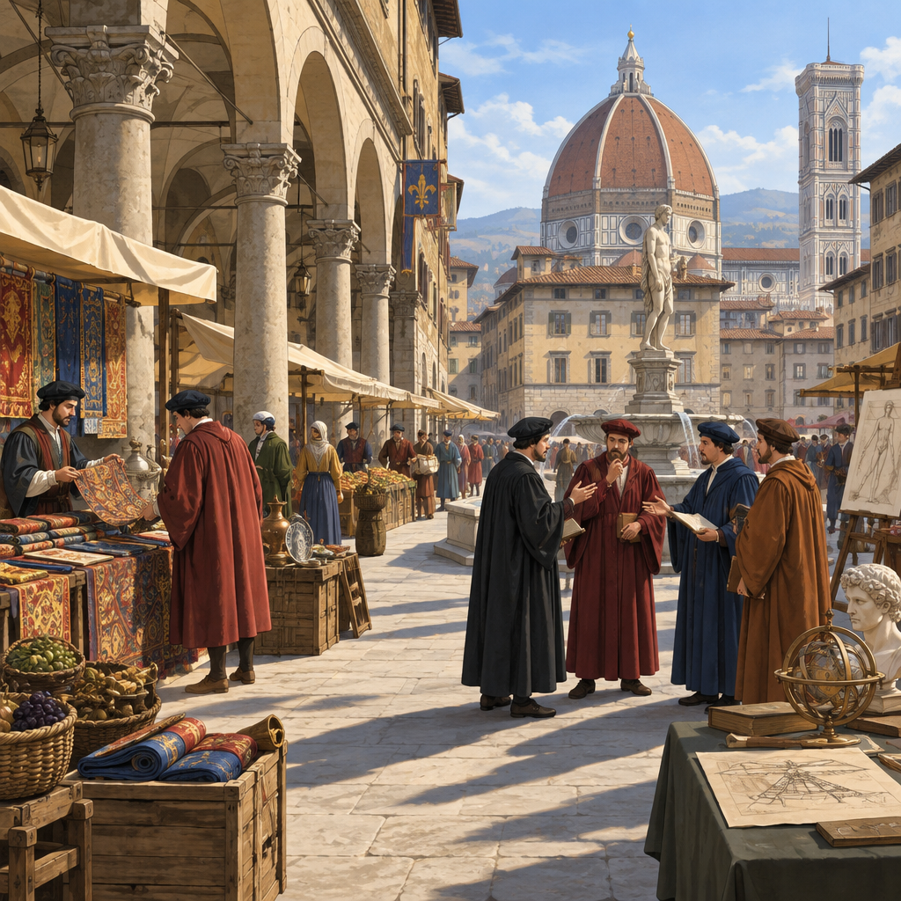

Learning intentions
We are learning to understand how the Renaissance changed European thinking about the world, humanity and knowledge (Topic).
We are learning to recognize how beliefs and values are shaped by time, place and society (Outcome).

Success criteria
I can explain what the Renaissance was and why it mattered to the development of Western worldviews (Outcome).
I can identify at least three ways that trade, geography or the exchange of ideas shaped Renaissance thinking (Outcome).
I can consider and respect different worldviews from the Renaissance period and today (Outcome, Outcome).

Curriculum alignment
Specific Outcomes 8.2.1, 8.2.2, 8.2.3, 8.2.4 (Outcome, Outcome, Outcome, Outcome)

Materials
- Whiteboard or chart paper and markers
- Images of Renaissance art, architecture and maps (teacher-sourced)
- Index cards or slips of paper with worldview statements (prepared before lesson)
- Handout: "Renaissance Ideas in Your World" (one per student)

Lesson sequence

1. Hook: What shaped how you see the world? (5 minutes)
Ask students: "What shapes how you see the world? Think about where you live, what you read, who you talk to, what technology you use."
Take three or four answers. Write them on the board without comment. Examples might include: "my family," "social media," "where I live," "my school," "my religion."
Say: "The people of Renaissance Europe asked themselves the same question, but their answers were very different from ours. Their world was changing fast. In the next 40 minutes, we're going to find out what changed their minds."

2. Direct instruction: What was the Renaissance and why did it happen? (10 minutes)
Explain: "The Renaissance began in Italy around the 1300s and spread across Europe over the next 300 years. The word means 'rebirth.' Europeans were rediscovering ideas from ancient Greece and Rome, but they were also creating entirely new ways of thinking."
Ask: "Why Italy first?" Draw a simple map on the board showing the Mediterranean Sea, Italy, and trade routes.
Explain: "Geography mattered. Italy sat at the crossroads of trade routes connecting Europe, Africa and Asia. Italian city-states like Florence, Venice and Genoa became wealthy and powerful because merchants bought and sold goods from all over the world" (Outcome). "When you have money and contact with different cultures, ideas flow in both directions."
Show an image of a Renaissance city or a map of trade routes. Point out: "These cities were independent. They competed with each other. That competition pushed them to invest in art, learning, and new ideas. A wealthy merchant in Florence might hire an artist or a scholar to make his city more impressive than Venice's."
Ask: "What does that tell us about how power and money shape what people believe?" Listen for responses about how resources allow ideas to spread.
Explain: "Renaissance thinkers developed something called humanism. Humanists believed that human beings, human potential and human experience were worth studying and celebrating. They weren't rejecting religion, but they were saying: let's also pay attention to what humans can do, create and discover in this world, not just the next one" (Outcome).

3. Guided practice: Identifying Renaissance worldview shifts (12 minutes)
Display three statements on the board or read them aloud:
Statement A: "The best way to understand the world is to read ancient texts and trust what authorities tell us."
Statement B: "We should observe the world ourselves, test our ideas, and see what we discover. We should also study what the ancients wrote, but we can disagree with them."
Statement C: "Human beings are capable of amazing things. We should celebrate art, learning, beauty and achievement in this life."
Ask: "Which of these sounds more like a medieval worldview, and which sounds more like a Renaissance worldview?"
Take answers. Explain: "Statement A is more medieval. Statements B and C reflect Renaissance ideas about the growth and exchange of knowledge, or the influence of thinkers and philosophers on society. The Renaissance wasn't about rejecting the past. It was about adding new questions: What can we learn from observation? What can humans achieve? How should we live in this world?"
Ask: "Can you think of a modern example of each worldview? When do we trust authority? When do we test things ourselves? When do we celebrate human achievement?"
Take examples. You might hear: "We test things in science class" (Statement B), "We trust doctors and teachers" (Statement A), "We celebrate athletes and musicians" (Statement C).
Say: "All three ways of thinking still exist today. The Renaissance didn't erase the old worldview. It added new ones."

4. Independent practice: Connecting Renaissance ideas to the present (10 minutes)
Distribute the handout "Renaissance Ideas in Your World" or display it on the board.
Students work individually for 5 minutes on this prompt:
"Choose one of these Renaissance ideas:
- Observation and testing (learning by doing, not just reading)
- Humanism (celebrating human potential and achievement)
- Exchange of ideas (learning from different cultures and people)
Write or draw one example of how that idea shows up in your life or in the world today. It could be something you do, something you see in school, something you see online, or something in your community."
Circulate. Ask follow-up questions: "Why did you choose that example? How is that person or group thinking like a Renaissance humanist?"
After 5 minutes, invite volunteers to share one example each (2 minutes). Listen for connections between Renaissance thinking and modern life.

5. Consolidation: Worldviews are shaped by context (3 minutes)
Bring the class together. Say: "We started by asking: what shapes how you see the world? Today you've learned that Renaissance Europeans had a different worldview than medieval Europeans, and both are different from ours. Why?"
Prompt: "What was different about their time, their place, their opportunities?"
Take 2 to 3 answers. Reinforce: "Trade brought new ideas. Wealth allowed people to study and create. Competition between cities pushed innovation. Geography connected them to other cultures. All of that shaped what they believed was possible and important" (Outcome, Outcome).
Close: "A worldview isn't something you're born with. It's built from the world around you. Understanding that helps us respect people with different beliefs, because we understand that their beliefs make sense in their context, just as ours make sense in ours" (Outcome, Outcome).

Differentiation

Extension
Ask students to research one Renaissance thinker or artist (e.g., Leonardo da Vinci, Michelangelo, Petrarch, Machiavelli) and write a short paragraph explaining how their work or ideas reflected the humanist worldview or the spirit of inquiry. Have them present their findings to the class in a 1-minute share.
Alternatively, ask: "The Renaissance was called a 'rebirth.' What was being reborn? What was new? What stayed the same?" This pushes students to think about continuity and change.

Support
Provide a word bank with key terms: humanism, observation, trade, city-state, worldview, Renaissance.
During the independent practice, offer sentence starters: "In my life, I see observation and testing when... / I see human achievement celebrated when... / I see exchange of ideas when..."
Pair students with a partner for the independent practice activity so they can discuss their thinking aloud before writing.

Assessment
Formative check during guided practice (Statement A, B, C activity):
Listen for students' ability to distinguish between a medieval and Renaissance worldview. Look for evidence that they understand:
- Renaissance thinkers valued observation and testing, not just authority
- Humanism celebrated human potential and achievement
- These ideas coexisted with older ways of thinking; they didn't replace them entirely
If a student struggles to identify the difference, ask: "Which statement sounds like it's asking people to try new things and test ideas?" or "Which one celebrates what humans can do?"
If a student grasps the distinction quickly, ask: "Can you think of a time when a modern person uses a medieval approach? When do we still trust authority without testing?"

AILI rapid lesson · en · claude-haiku-4-5-20251001 · 2026-09-17

