Cells as the Building Blocks of Life
Investigating how cells work together to form living systems.
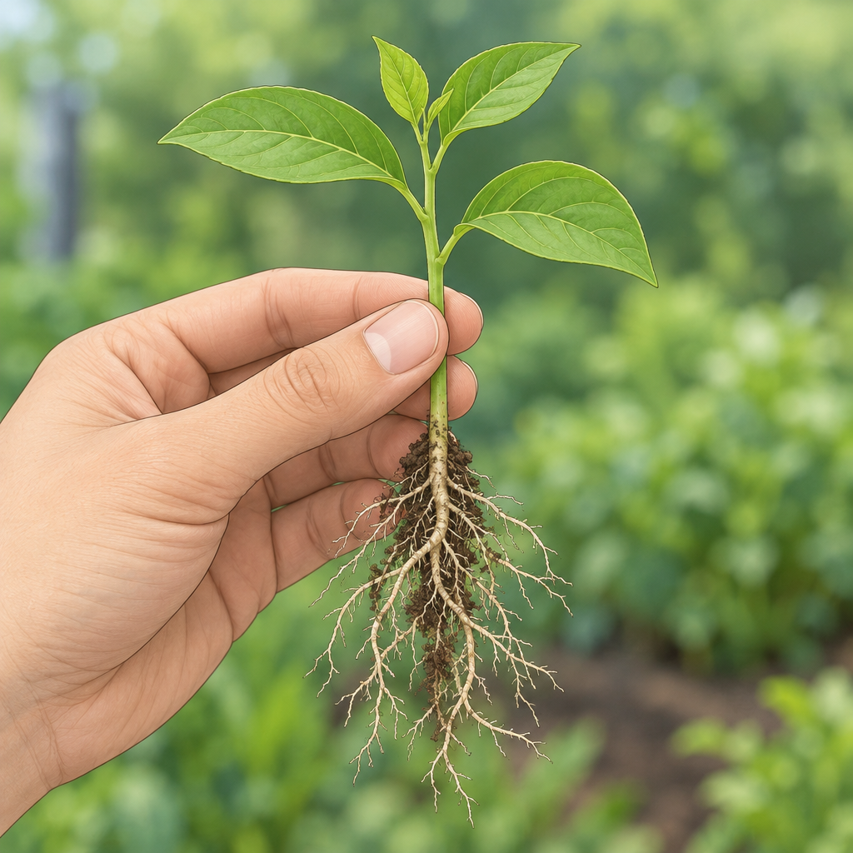

Learning intentions
We are learning to understand cells as the basic unit of life and how they work together in organisms to carry out life functions.

Success criteria
I can:
- describe the role of cells as a basic unit of life (Outcome)
- identify and explain the differences between plant and animal cells (Outcome)
- recognize how cells, tissues and organs work together in living things (Outcome)
- explain how organisms meet similar functions in different ways (Outcome)

Curriculum alignment
Specific Outcome 1: Apply the concept of system in describing familiar organisms and analyzing their general structure and function (Outcome, Outcome).
Specific Outcome 2: Investigate and describe the role of cells within living things; distinguish between plant and animal cells; examine plant and animal structures and identify contributing roles of cells, tissues and organs (Outcome, Outcome).

Materials
- Microscope slides and cover slips
- Onion skin samples (prepared in advance)
- Elodea (water plant) samples
- Cheek cell swabs or prepared cheek cell slides
- Microscopes (one per pair or small group)
- Staining agent (methylene blue or iodine solution)
- Large diagram of plant and animal cell structures (printed or projected)
- Coloured pencils or markers
- A4 paper for cell drawings
- Optional: video clip (2 to 3 minutes) showing cells under magnification
- Handout: "Plant vs. Animal Cells" comparison table (blank)

Lesson sequence
Stage 1: Hook (5 minutes)
Show students a single-celled organism image (an amoeba or paramecium) projected on screen. Ask: "This organism has no brain, no heart, no stomach. How does it eat, move and grow?" Allow 1 to 2 minutes of thinking. Take responses. Then say: "Everything it does, everything any living thing does, happens because of cells. Today we're going to find out what cells are and how they build bigger living things."
Stage 2: Direct instruction (10 minutes)
Explain that cells are the smallest unit of life. Every living thing is made of one or more cells. Write on the board: "Cell = basic unit of life."
Show the large diagram of a plant cell and an animal cell side by side. Point to and name these structures:
Plant cell: cell membrane, cell wall, nucleus, cytoplasm, chloroplasts, mitochondria.
Animal cell: cell membrane, nucleus, cytoplasm, mitochondria.
Ask students: "What do both cells have?" (Cell membrane, nucleus, cytoplasm.) "What does the plant cell have that the animal cell doesn't?" (Cell wall and chloroplasts.) Explain that the cell wall gives plants their rigid structure and that chloroplasts are where plants make food using sunlight. Explain that mitochondria are found in both plant and animal cells and are where cells release energy from food through respiration.
Ask: "Why might a plant need a cell wall but an animal doesn't?" (Plants don't move around; they need support. Animals move, so they need flexibility.)
Introduce the idea of levels of organization: cells group into tissues, tissues group into organs, organs work together in systems (Outcome). Give an example: muscle cells form muscle tissue, muscle tissue combines with bone, skin and nerve tissue to form the arm, which contains organs that are part of both the skeletal and muscular systems.
Stage 3: Guided practice (15 minutes)
Activity A: Observing cells under the microscope (10 minutes)
Divide the class into pairs. Students will investigate and observe cells from living organisms.
Before they look, ask: "What do you predict you will see?" Write predictions on the board.
Safety reminder: Before distributing materials, review these important safety steps with students:
- You will only swab your own cheek.
- Use a clean swab and wear gloves if available.
- After observation, dispose of all swabs and slides in the designated waste container.
- Wash your hands thoroughly after the activity.
Distribute slides and microscopes. Guide students to:
- Start on low power.
- Apply a staining agent (methylene blue or iodine) to the slide to make cell structures visible.
- Students will observe cells using appropriate tools.
- Students will identify and distinguish between plant and animal cells.
Circulate and ask guiding questions: "Can you see the cell membrane?" "Do you see a nucleus?" "Are there any structures in the plant cells that aren't in the cheek cells?"
The class will discuss their observations of cells. Ask pairs to share one observation. Record observations on the board.
Activity B: Comparing cells (5 minutes)
Display the blank "Plant vs. Animal Cells" comparison table on the board or paper. Work through it together as a class, filling in rows for: nucleus, cell membrane, cell wall, chloroplasts, shape, function. Students will record their observations of similarities and differences between cell types.
Ask: "Why do you think plant cells have a cell wall?" (To support the plant and keep it upright.) "Why do animal cells not need one?" (Animals have skeletons or other support systems.)
Stage 4: Independent practice (7 minutes)
Students complete a task sheet with these prompts:
- Draw and label a plant cell and an animal cell. Include a variety of structures in each.
- Write one sentence explaining why plant cells have a cell wall.
- Look at this scenario: "A single-celled amoeba and a human both need to get oxygen and get rid of waste. Explain how they are different in how they do this." (Amoeba: the cell membrane does everything. Human: many different cells and organs work together to move oxygen around the body.)
Circulate and check for understanding. Listen for whether students can explain that single-celled organisms do all life functions with one cell, while multicelled organisms have specialized cells that work together (Outcome).
Stage 5: Consolidation (3 minutes)
Bring the class together. Ask three students to share their answer to question 3. Reinforce the key idea: "A single cell can do everything it needs to survive. But when you have billions of cells, they can specialize. Some cells just move oxygen. Some cells just digest food. Some cells just send messages. That's why multicelled organisms can be bigger and do more complex things."
Close with: "Tomorrow we'll look at how your body's cells and organs work together to keep you alive."

Differentiation
Extension
Ask students to research and write a short paragraph (5 to 7 sentences) comparing a single-celled organism (amoeba, paramecium, or single-celled alga) with a multicelled organism (grizzly bear, poplar tree, or human). They should analyze similarities and differences between single-celled and multicelled organisms(Outcome). Encourage them to use the microscope images or diagrams from the lesson as reference.
Support
Provide a partially completed cell diagram with labels already filled in. Ask students to colour-code the structures (nucleus in one colour, membrane in another, etc.) and match each structure to its function on a word card. Pair these students with a peer during microscope observation so they have a partner to help focus and identify structures.

Assessment
Formative checkpoint: Microscope observation and sketches
As students observe cells under the microscope, look for:
- Can they identify the cell membrane in both plant and animal cells?
- Can they spot the nucleus?
- Do they notice the cell wall in plant cells but not in animal cells?
- Are their sketches reasonably accurate and labelled?
If a student cannot identify structures, pause and point them out together under the microscope. Ask: "What do you see in the middle of the cell?" (Nucleus.) "What is the outer boundary?" (Cell membrane.) Repeat with one or two other structures.
If students are ready, ask them to predict what structures they will see before moving to the next slide.

AILI rapid lesson · en · claude-haiku-4-5-20251001 · 2026-09-17

