The Particle Model of Matter
Exploring how particles explain the properties of solids, liquids, and gases
Audience: Grade 5 science students
Grades: Grade 5
Subjects: Science
Time: about 60 minutes
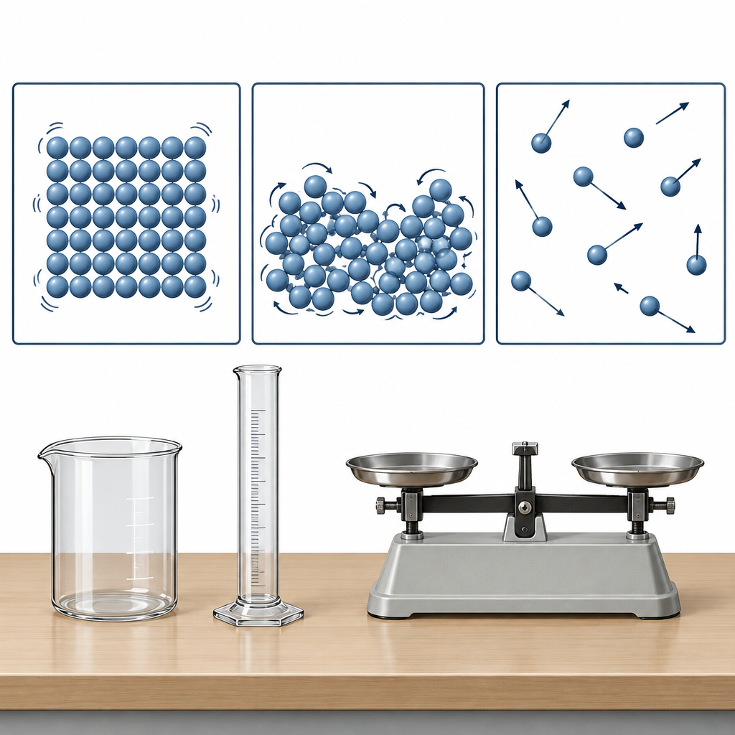

Overview
This Grade 5 lesson introduces the particle model of matter as a tool for explaining the physical properties of solids, liquids, and gases (Outcome). Students begin by investigating a puzzle: why does a syringe of air compress easily while a syringe of water does not? This hook draws directly on the particle model of matter, which explains that particles have spaces between them(Details).
Students then build the particle model through direct instruction, hands-on diagramming at rotating stations, and a density investigation using a balance scale and graduated cylinder, all skills and procedures identified for this outcome (Details). The lesson closes by returning to the syringe puzzle, asking students to apply the particle model to explain compressibility in writing. The lesson connects to the particle model of matter, which explains how heating causes particles to move faster and cooling causes them to move slower.

Outcomes covered
- Students investigate the particle model of matter in relation to the physical properties of solids, liquids, and gases. (Outcome)
This outcome gives students a conceptual model that explains why solids, liquids, and gases behave differently, forming the foundation for later work on phase changes and fluid properties in Grades 6 and 8.
- The particle model of matter explains the behaviour of particles in matter: all matter is made up of small particles that are always moving and have spaces between them, with particles close together and vibrating in place in solids, separated by spaces and able to slide past each other in liquids, and separated by large spaces and moving constantly in all directions in gases. (Details)
Understanding particle arrangement and movement allows students to explain everyday observations, such as why gases compress easily and liquids do not.
- The movement and arrangement of particles affect the physical properties of matter, including state, mass, volume, density, and compressibility. (Details)
Connecting particle behaviour to measurable properties like density and compressibility gives students the vocabulary and reasoning they will need for quantitative work with density formulas in later grades.

Materials
- Plastic syringes (one air-filled and one water-filled per pair, tips sealed)
- Small counters or beads for particle modelling (enough for six groups)
- Trays for particle arrangement activity
- Balance scales (one per small group)
- Sets of SI mass pieces (grams)
- Graduated cylinders marked in millilitres
- Two solid cubes of equal volume but different density (e.g., wood and metal)
- Water and vegetable oil (50 mL each per group)
- Clear containers for the density column
- Worksheets for particle diagrams (solid, liquid, gas)
- Document camera or board for group diagram review
- Paper towels for spill cleanup

Sequence of activities

1. Hook: Squishing Air and Water (8 min, pairs)
- Give each pair two identical sealed plastic syringes: one filled with air, one filled with water (tip sealed with a small cap or tape).
- Ask students to push the plunger on each syringe as far as it will go, without opening the tip.
- Ask: Which one lets the plunger move? Which one barely moves at all?
- Record a one-sentence prediction: Why does the air syringe compress but the water syringe does not?
- Bring the class together and collect two or three predictions on the board without confirming or correcting yet.
This activity surfaces prior ideas about compressibility before naming the particle model. Do not correct misconceptions yet; return to these predictions during the explanation activity. Watch for students who say water compresses when they push hard; this is the key idea to revisit (Details).
Sources: Details

2. Direct Teach: Introducing the Particle Model (12 min, whole class)
- Explain that all matter, solid, liquid, or gas, is made up of extremely small particles that are always moving and always have spaces between them (Details).
- Draw three boxes on the board labelled Solid, Liquid, Gas. Sketch particle arrangements: solid particles close together in a fixed pattern, liquid particles close but able to slide past each other, gas particles far apart moving freely.
- Explain attractive forces: particles pull on their neighbours, and this pull is strongest in solids and weakest in gases (Details).
- Connect the model back to the syringe activity: in the gas, the large spaces between particles allow them to be pushed closer together; in the liquid, particles are already almost touching, so there is very little space left to compress (Details).
- Ask two students to restate the difference between solids, liquids, and gases in their own words, using the terms particles, spaces, and attractive forces.
Formative checkpoint: listen for correct use of the three key terms (particles, spaces, attractive forces) during the restating step. If students only describe shape or texture, prompt with: What are the particles doing? How far apart are they?
Sources: Details

3. Particle Model Diagram Stations (15 min, small group)
- Divide the class into six small groups and set up three stations: Solid, Liquid, Gas, with two groups per station rotating every 4 minutes.
- At each station, groups use small counters or beads on a tray to physically arrange particles to model that state of matter, then sketch the arrangement on a worksheet.
- For each state, groups label on their worksheet: how close particles are, how they move, and how strong the attractive forces are.
- At the Solid station, groups also compare mass and volume: given a labelled block, they estimate whether density would be high or low based on how tightly packed the particles are.
- Groups rotate until they have completed all three diagrams.
- As a class, review one diagram per state on the document camera and correct any misplaced particles or mislabelled forces.
Formative checkpoint: check that solid diagrams show a fixed, orderly, close arrangement; liquid diagrams show close but disordered particles; gas diagrams show widely spaced, scattered particles (Details). This activity directly practises the skill of representing states using the particle model.
Sources: Details

4. Investigation: Comparing Density with a Balance Scale (15 min, small group)
- Give each group a balance scale, a set of SI mass pieces, a graduated cylinder marked in millilitres, and two solid objects of equal volume but different materials (for example, a wooden cube and a metal cube of the same size).
- Groups measure the mass of each cube in grams using the balance scale and record results.
- Since both cubes have the same volume, groups compare mass directly to decide which cube is denser (Details).
- Groups then measure 50 mL of water and 50 mL of vegetable oil using the graduated cylinder, pour both into the same clear container, and observe which liquid floats.
- Groups record which liquid is less dense based on the float/sink observation and explain their reasoning using the terms mass, volume, and density.
- Groups complete a short answer: Using the particle model, explain why one liquid floats on the other. (Expect answers referencing particles being more spread out, or more mass packed into the same space, in the denser liquid.)
Reinforce safe handling of glassware and liquids before starting; review WHMIS-style safety habits such as wiping spills immediately and not tasting materials (Details). Correct SI unit use: grams and kilograms for mass, millilitres and litres for volume (Details). Expected result: oil floats on water because it is less dense.
Sources: Details

5. Consolidation: Explaining the Syringe Puzzle (10 min, individual)
- Return to the syringe predictions from the opening activity.
- Individually, students write a short explanation (three to five sentences) answering: Using the particle model of matter, explain why the air-filled syringe compresses easily and the water-filled syringe does not.
- A strong answer should state that gas particles have large spaces between them so they can be pushed closer together, while liquid particles are already close together with very little space left to compress (Details).
- Collect the written explanations as an exit response.
- Read two or three anonymized responses aloud and discuss as a class what makes an explanation complete.
This is the summative checkpoint for the lesson. Look for correct use of particle spacing to explain compressibility, not just a restated observation. Students who only say gas is squishy and water is not have not yet applied the model.
Sources: Details

Differentiation
Extension
- Ask students to predict, using the particle model, what would happen to the spacing and movement of particles in the water syringe if the water were heated instead of compressed, previewing the Grade 6 focus on heating and cooling (Details).
- Challenge students to research one everyday example where compressibility matters, such as compressed air tanks or car airbags, and explain it using particle spacing.
- Have students calculate and compare density qualitatively for a third liquid (such as corn syrup) added to the water and oil column, predicting where it will settle before testing.
Support
- Provide a partially completed particle diagram template with solid and gas already filled in, so students only need to complete the liquid box.
- Pair students who need extra support with a peer during the balance scale investigation and provide pre-measured mass pieces labelled clearly in grams.
- Offer sentence starters for the exit response, such as: The gas can be squished because... The water cannot be squished because...
Inclusive supports
- Use physical manipulatives (beads, counters) at every station so students who benefit from tactile learning can model particle arrangement with their hands rather than only drawing.
- Read all worksheet instructions aloud and post key vocabulary (particle, mass, volume, density, compressibility) on the board with simple visual icons.
- Allow students to record their exit explanation orally or through a labelled diagram instead of full sentences if writing is a barrier.

Assessment
Formative. During the direct teach segment, ask two students to restate the difference between solids, liquids, and gases using the terms particles, spaces, and attractive forces.
Look for: Correct and independent use of all three terms indicates the student is beginning to internalize the particle model rather than relying on surface descriptions like hard or runny. (Details)
Formative. Review one station diagram per state of matter on the document camera during the diagram stations activity.
Look for: Solid diagrams show tightly packed, ordered particles; liquid diagrams show close but disordered particles; gas diagrams show widely spaced, freely moving particles, matching the arrangement described in the particle model. (Details)
Summative. Collect the individual written explanation of why the air-filled syringe compresses but the water-filled syringe does not, using the particle model.
Look for: A complete answer explains that gas particles have large spaces between them, allowing compression, while liquid particles are already close together, leaving little room to compress further. (Details)

Vocabulary
- Particle model of matter: The scientific idea that all matter is made up of small particles that are always moving and have spaces between them, used to explain the behaviour of solids, liquids, and gases.
- Attractive forces: The pulling forces between particles that hold them together. These forces are strongest in solids and weakest in gases.
- Mass: The amount of matter in a solid, liquid, or gas, measured in SI units such as grams (g) and kilograms (kg).
- Volume: The amount of space a solid, liquid, or gas takes up, measured in SI units such as millilitres (mL) and litres (L).
- Density: A comparison of the mass of a solid, liquid, or gas to its volume. A material with more mass packed into the same volume has a higher density.
- Compressibility: The ability of a liquid or gas to reduce in volume when placed under pressure. Gases are much more compressible than liquids because their particles have large spaces between them.

For families
- Ask your child to explain, using their hands, how particles move differently in a solid, a liquid, and a gas.
- At home, try pressing on a closed empty water bottle versus one full of water and ask your child to explain the difference using what they learned about particles and spaces.
- Look at ice cubes melting in a drink together and ask your child what is happening to the particles as the ice changes from solid to liquid.

Sources
- Topic: "Matter: Understandings of the physical world are deepened by investigating matter and energy."
- Guiding question: "How can states of matter and other physical properties be explained using the particle model of matter?"
- Outcome: "Students investigate the particle model of matter in relation to the physical properties of solids, liquids, and gases."
- Details: "In solids, the particles are close together and vibrate in place. In liquids, the particles are separated by spaces and can slide past each other. In gases, the particles are separated by large spaces and are constantly moving in all directions."

All materials and activities (sealed syringes, balance scales, water, and vegetable oil) are standard, low-risk classroom science supplies appropriate for Grade 5 students, and the content presents matter and particle behaviour in a factual, culturally neutral manner.

AILI detailed pack · en · claude-sonnet-5 · 2026-09-17

