The Calorimetry Challenge
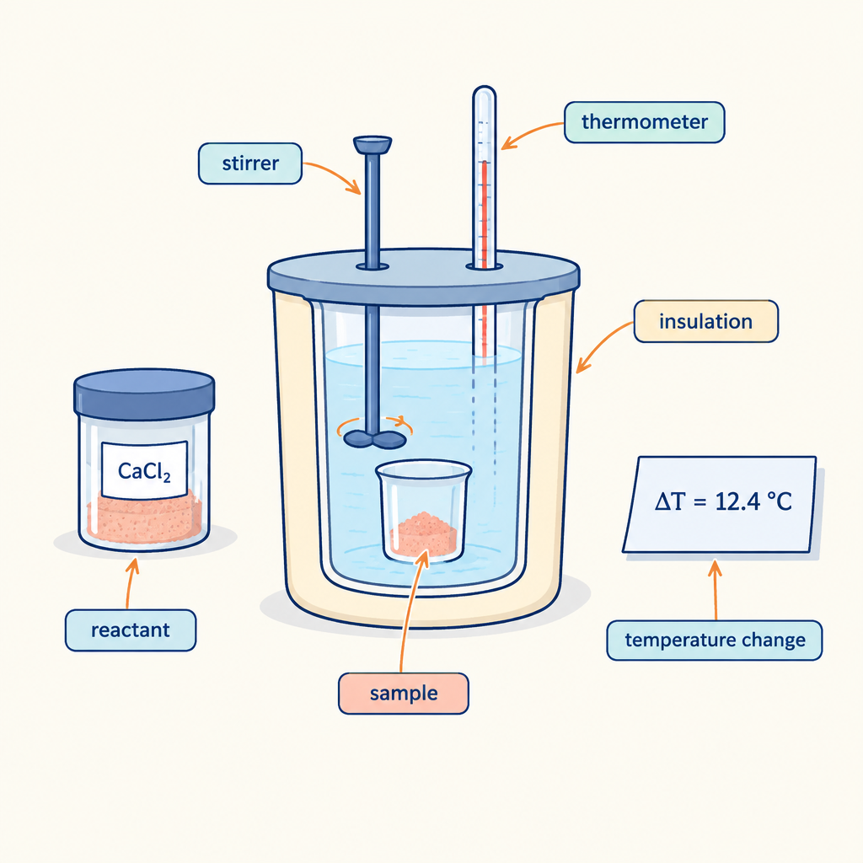
This puzzle tests your ability to apply the heat-transfer equation and interpret enthalpy data from a calorimetry experiment (Outcome, Outcome). You will use calorimetry data to determine energy changes in chemical reactions and work with ΔH notation to communicate results (Outcome).

The puzzle
A student burns 2.0 grams of a food sample in a bomb calorimeter containing 1000 grams of water. The water temperature rises from 20.0°C to 28.4°C. The specific heat capacity of water is 4.18 J/(g·°C).
The student then repeats the experiment with 4.0 grams of the same food sample in the same calorimeter with the same mass of water at the same starting temperature. This time the water temperature rises to 36.8°C.
The student claims that the food contains twice as much energy per gram as the student initially calculated. Is this claim correct? Explain your reasoning using the data and the relationship Q = mcΔt.

Hints
Hint 1: Calculate the total heat released (Q) in each trial using Q = mcΔt. Remember that the mass m refers to the mass of water, not the food sample.
Hint 2: After you find Q for each trial, divide by the mass of food burned to find the energy released per gram of food.
Hint 3: Compare the energy per gram from trial 1 with the energy per gram from trial 2. If the claim were true, trial 2 would show twice the energy per gram. Does it?

Answer key
The claim is incorrect. The food contains the same energy per gram in both trials.
Reasoning:
Trial 1: Q = mcΔt = (1000 g)(4.18 J/(g·°C))(28.4 − 20.0)°C = (1000)(4.18)(8.4) = 35,112 J
Energy per gram of food = 35,112 J ÷ 2.0 g = 17,556 J/g
Trial 2: Q = mcΔt = (1000 g)(4.18 J/(g·°C))(36.8 − 20.0)°C = (1000)(4.18)(16.8) = 70,224 J
Energy per gram of food = 70,224 J ÷ 4.0 g = 17,556 J/g
Both trials yield the same energy per gram. When the mass of food doubles, the total heat released doubles, but the energy per gram remains constant. The student confused total energy with energy per unit mass. The enthalpy value (energy per gram) is an intensive property that does not change with sample size.

AILI game · en · claude-haiku-4-5-20251001 · 2026-09-17

