The Almond That Changed the Temperature
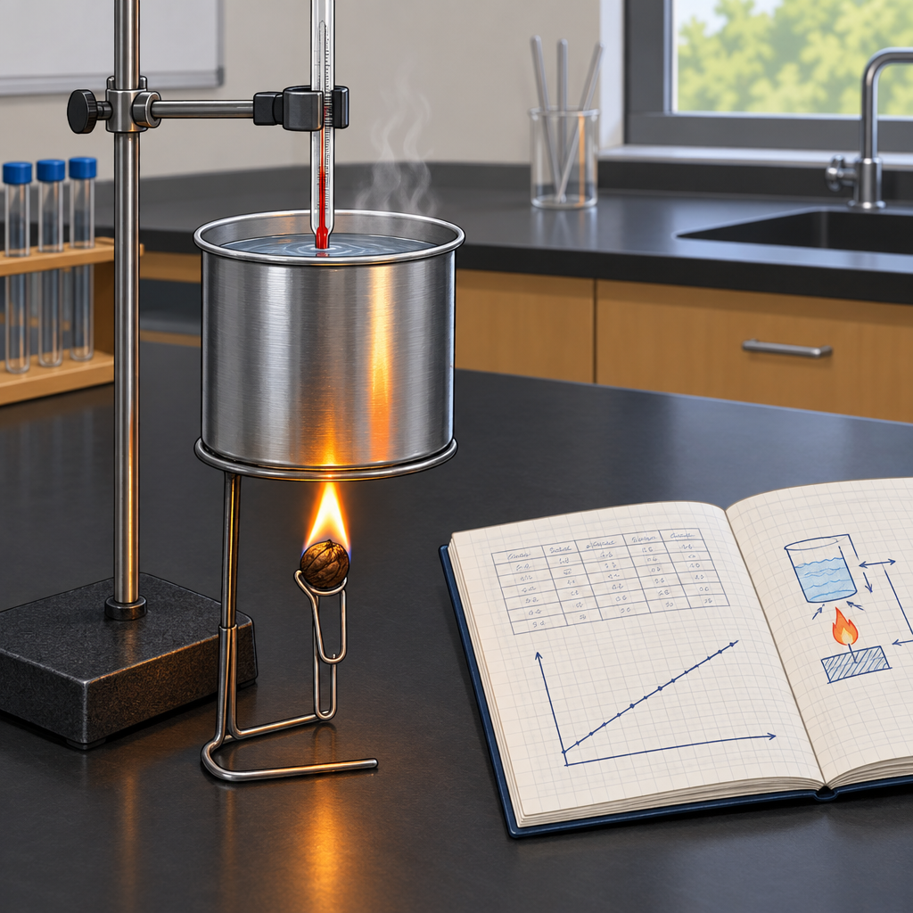
Priya clamped a thermometer into a soup can of water and skewered an almond on a bent paperclip below it. "Diploma review," she said. "Molar enthalpy of combustion. Ready, Dev?" Dev held the lighter. "Mass of water?" "100 grams. Starting temp, 21.4 degrees Celsius." He lit the almond. It caught, sputtering orange under the can. Water shimmered, then climbed: 21.4, 26.8, 31.2, finally settling at 34.9. "Delta t is 13.5 degrees," Priya said, scribbling. "Q equals mcΔt, so 100 times 4.19 times 13.5. That's our heat absorbed by the water." "And that heat came from the almond," Dev added, "so enthalpy of the reaction is negative. Exothermic." "Divide by moles burned for molar enthalpy." Dev grinned. "Calorimetry actually makes sense.

Words to know
- Enthalpy (ΔH): The heat content change of a system during a chemical reaction, measured at constant pressure.
- Molar enthalpy: The enthalpy change per mole of a substance reacting or produced in a reaction.
- Q = mcΔt: The formula relating heat transferred (Q) to mass (m), specific heat capacity (c), and temperature change (Δt).
- Calorimetry: The experimental technique of measuring heat transfer during a physical or chemical process.
- Exothermic: A reaction that releases heat energy to its surroundings, giving a negative ΔH.
Curriculum link: Outcome, Outcome, Outcome, Outcome, Outcome, Resource
Listen to the narration

AILI audio story · en · claude-sonnet-5 · 2026-09-17

