Integers and Fractions: Grade 7 Number Operations
Central concept: Number Operations

Connections
- Number Operations (includes) -> Integers
- Number Operations (includes) -> Fractions
- Number Operations (includes) -> Decimal Numbers
- Number Operations (uses) -> Operations on Positive and Negative Numbers
- Number Operations (applies) -> Equivalent Forms
- Integers (has) -> Apply Operations to Positive and Negative Numbers
- Integers (has) -> Apply Operations to Positive and Negative Numbers
- Fractions (has) -> Multiply Fractions
- Fractions (has) -> Divide Fractions
- Divide Fractions (uses) -> Reciprocal
- Decimal Numbers (has) -> Multiply and Divide Decimals
- Equivalent Forms (facilitates) -> Multiply and Divide Decimals

Notes
- Number Operations: Systems for calculating with integers, fractions, and decimals Outcome, Outcome
- Integers: Positive and negative whole numbers with operations Outcome, Knowledge
- Fractions: Parts of a whole with numerators and denominators Outcome, Knowledge
- Decimal Numbers: Numbers expressed using place value and decimal point Outcome, Understanding
- Add and Subtract Integers: Combine or remove positive and negative quantities Knowledge, Skills
- Multiply and Divide Integers: Rules for signs: same signs give positive, different signs give negative Knowledge, Skills
- Multiply Fractions: Multiply numerators and denominators; result is part of a part Knowledge, Understanding
- Divide Fractions: Multiply by the reciprocal; quotient is number of fraction-sized groups Knowledge, Understanding
- Reciprocal: Multiplicative inverse; fraction and reciprocal multiply to 1 Knowledge
- Multiply and Divide Decimals: Use equivalent expressions, algorithms, or area models Understanding, Knowledge
- Order of Operations: Conventional sequence for evaluating expressions Knowledge, Skills
- Equivalent Forms: Different expressions that represent the same value Understanding, Understanding
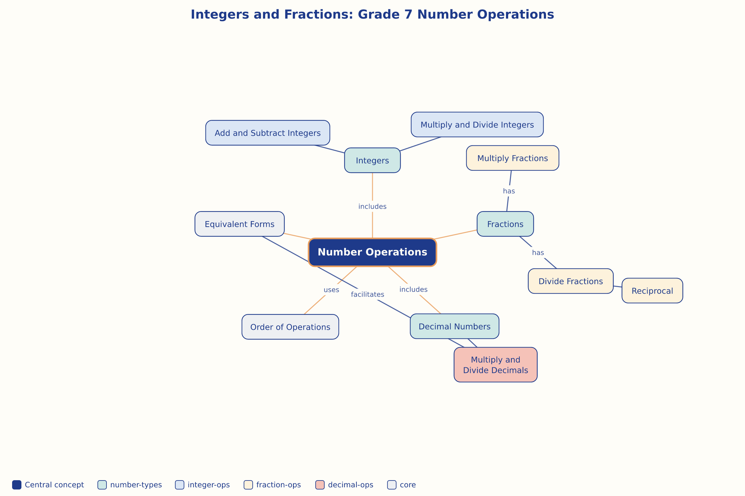

AILI word map · en · claude-haiku-4-5-20251001 · 2026-09-17

