Communities in Alberta
Central concept: Alberta's Communities

Connections
- Alberta's Communities (includes) -> First Nations
- Alberta's Communities (includes) -> Métis People
- Alberta's Communities (includes) -> Francophones
- Alberta's Communities (includes) -> Early Settlers
- Alberta's Communities (includes) -> Immigrants
- Alberta's Communities (governed by) -> Provincial Government
- Alberta's Communities (governed by) -> Municipal Government
- First Nations (speak) -> Languages
- First Nations (use) -> Cultural Symbols
- Métis People (speak) -> Languages
- Métis People (use) -> Cultural Symbols
- Francophones (speak) -> Languages
- Students relate diversity to Alberta's western identity
- Alberta's Communities -> Civic Action
- Students explore diverse communities in Alberta

Notes
- Alberta's Communities: Diverse, pluralistic communities that make up Alberta Knowledge
- First Nations: Forty-eight distinct First Nations communities with unique languages and cultures Knowledge
- Métis People: Communities with distinct culture blending First Nations and European traditions Knowledge
- Francophones: French-speaking communities that originated from missionary immigration Knowledge
- Early Settlers: People from various countries who came for farmland and faced challenges Knowledge
- Immigrants: People from around the world seeking jobs, family, land, and religious freedom Knowledge
- Provincial Government: Provides education, health care, and provincial parks Knowledge
- Municipal Government: Provides local services like fire, libraries, parks, and roads Knowledge
- Civic Action: Volunteering and charity that improve community quality of life Knowledge
- Cultural Symbols: Flags, sashes, and emblems that represent communities and heritage Knowledge
- Languages: Cree, Blackfoot, Dené, French, Michif, and many others Knowledge
- Quality of Life: Safety, comfort, health, and happiness in communities Knowledge
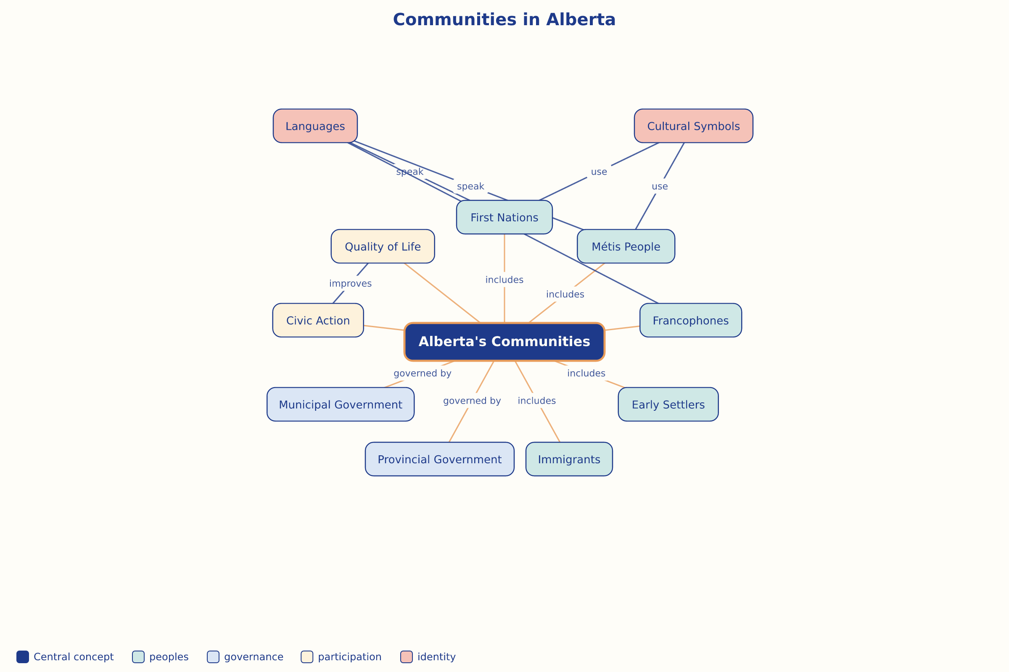

AILI word map · en · claude-haiku-4-5-20251001 · 2026-09-17

