The Cell Detective Challenge
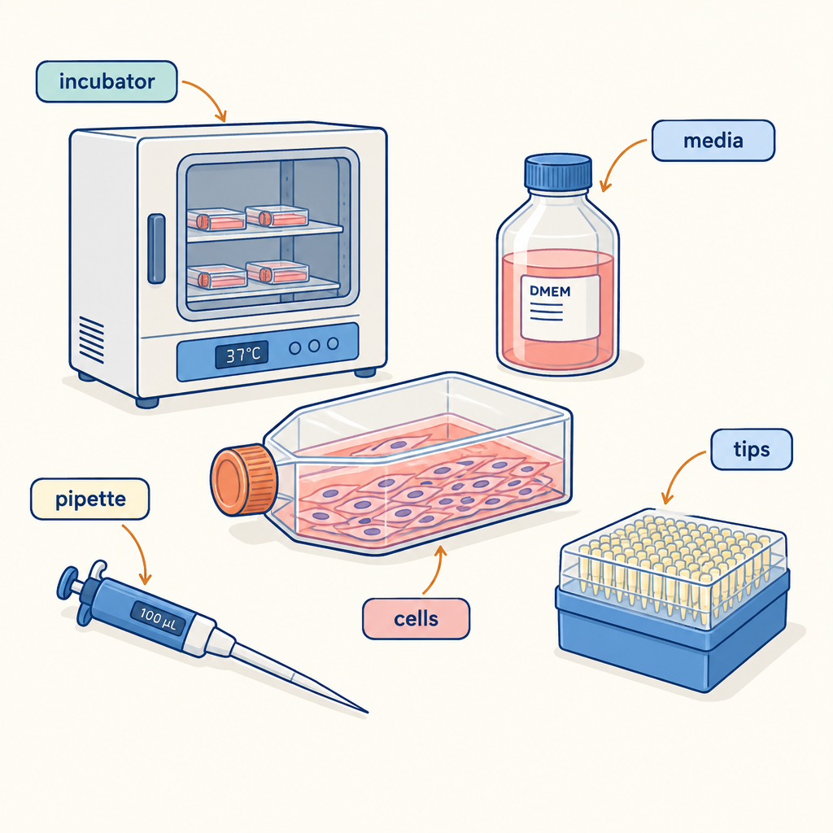
Understanding how cells function as the basic unit of life is central to making sense of all living things (Outcome). This puzzle asks you to apply what you know about the differences between plant and animal cells, and how they work as part of larger systems, to solve a real-world mystery (Outcome, Outcome).

The puzzle
A biologist is studying four organisms: a bacterium, an amoeba, a moss plant, and a goldfish. She observes each one under a microscope and records four facts:
- One organism has a cell wall and chloroplasts. It is multicelled.
- One organism has no nucleus and no cell wall. It is single-celled.
- One organism has a cell membrane but no cell wall. It is single-celled.
- One organism has a cell membrane but no cell wall. It is multicelled.
Here is what you know about each organism:
- The bacterium is the oldest type of living thing on Earth.
- The amoeba moves by flowing its cytoplasm and can engulf food particles.
- The moss plant carries out photosynthesis using structures in its cells.
- The goldfish has organs like gills that work as a system to extract oxygen from water.
Match each organism to its correct fact (1, 2, 3, or 4). Explain why each match makes sense based on what you know about cells.

Hints
Hint 1: Think about which organisms are single-celled and which are multicelled. A bacterium is the simplest living thing. A moss plant has many cells working together. A goldfish is made of trillions of cells.
Hint 2: Plant cells have cell walls and chloroplasts. Animal cells have only a cell membrane. Bacteria are different from both plant and animal cells because they lack a nucleus.
Hint 3: Fact 2 describes a bacterium because bacteria are prokaryotes without a nucleus. Fact 3 describes an amoeba because it is a single-celled animal-like organism. Fact 1 describes a moss because it is a multicelled plant. Fact 4 describes a goldfish because it is a multicelled animal.

Answer key
Correct matches:
- Bacterium → Fact 2 (no nucleus, no cell wall, single-celled)
- Amoeba → Fact 3 (cell membrane only, no cell wall, single-celled)
- Moss plant → Fact 1 (cell wall and chloroplasts, multicelled)
- Goldfish → Fact 4 (cell membrane only, no cell wall, multicelled)
Reasoning:
Bacteria are prokaryotes, meaning they have no nucleus and no cell wall in the way plant cells do (Outcome). They are also single-celled organisms, the simplest form of life.
The amoeba is a single-celled organism that belongs to the protist group. Like all animal cells, it has a cell membrane but no cell wall (Outcome). It moves and feeds by flowing its cytoplasm around food particles, which is a function met in a variety of ways across different organisms (Outcome).
The moss plant is multicelled and, as a plant, has both a cell wall and chloroplasts in its cells. The cell wall gives the plant structure and support, while chloroplasts allow the plant to make its own food through photosynthesis (Outcome).
The goldfish is multicelled and made of animal cells. Animal cells have a cell membrane but no cell wall (Outcome). The goldfish's cells work together in systems like the circulatory and respiratory systems to keep the organism alive and functioning (Outcome).

AILI game · en · claude-haiku-4-5-20251001 · 2026-09-17

