The Particle Model of Matter
Central concept: Particle Model of Matter

Connections
- Particle Model of Matter (includes) -> All Matter is Particles
- Particle Model of Matter (includes) -> Particles Always Moving
- Particle Model of Matter (includes) -> Spaces Between Particles
- Particle Model of Matter (explains) -> Solids
- Particle Model of Matter (explains) -> Liquids
- Particle Model of Matter (explains) -> Gases
- Particle Model of Matter (affects) -> Physical Properties
- Solids (have strong) -> Attractive Forces
- Liquids (have moderate) -> Attractive Forces
- Gases (have weak) -> Attractive Forces
- Physical Properties (includes) -> Density
- Physical Properties (includes) -> Mass and Volume
- Physical Properties (includes) -> Compressibility

Notes
- Particle Model of Matter: Framework explaining behaviour of particles and states of matter PDF p.1, Understanding
- All Matter is Particles: Fundamental idea that everything is made of small particles Knowledge, PDF p.1
- Particles Always Moving: Particles in all matter are in constant motion Knowledge, PDF p.1
- Spaces Between Particles: Matter contains gaps between its particles Knowledge, PDF p.1
- Solids: Particles close together, vibrating in place with strong attractive forces Knowledge
- Liquids: Particles separated by spaces, sliding past each other with moderate forces Knowledge
- Gases: Particles separated by large spaces, moving in all directions with weak forces Knowledge
- Attractive Forces: Forces between particles strongest in solids, weakest in gases Knowledge
- Physical Properties: State, mass, volume, density, and compressibility of matter Knowledge
- Density: Comparison of mass to volume; denser objects sink, less dense float Knowledge
- Mass and Volume: Mass measured in grams or kilograms; volume in millilitres or litres Knowledge
- Compressibility: Ability of liquids and gases to reduce in volume under pressure Knowledge
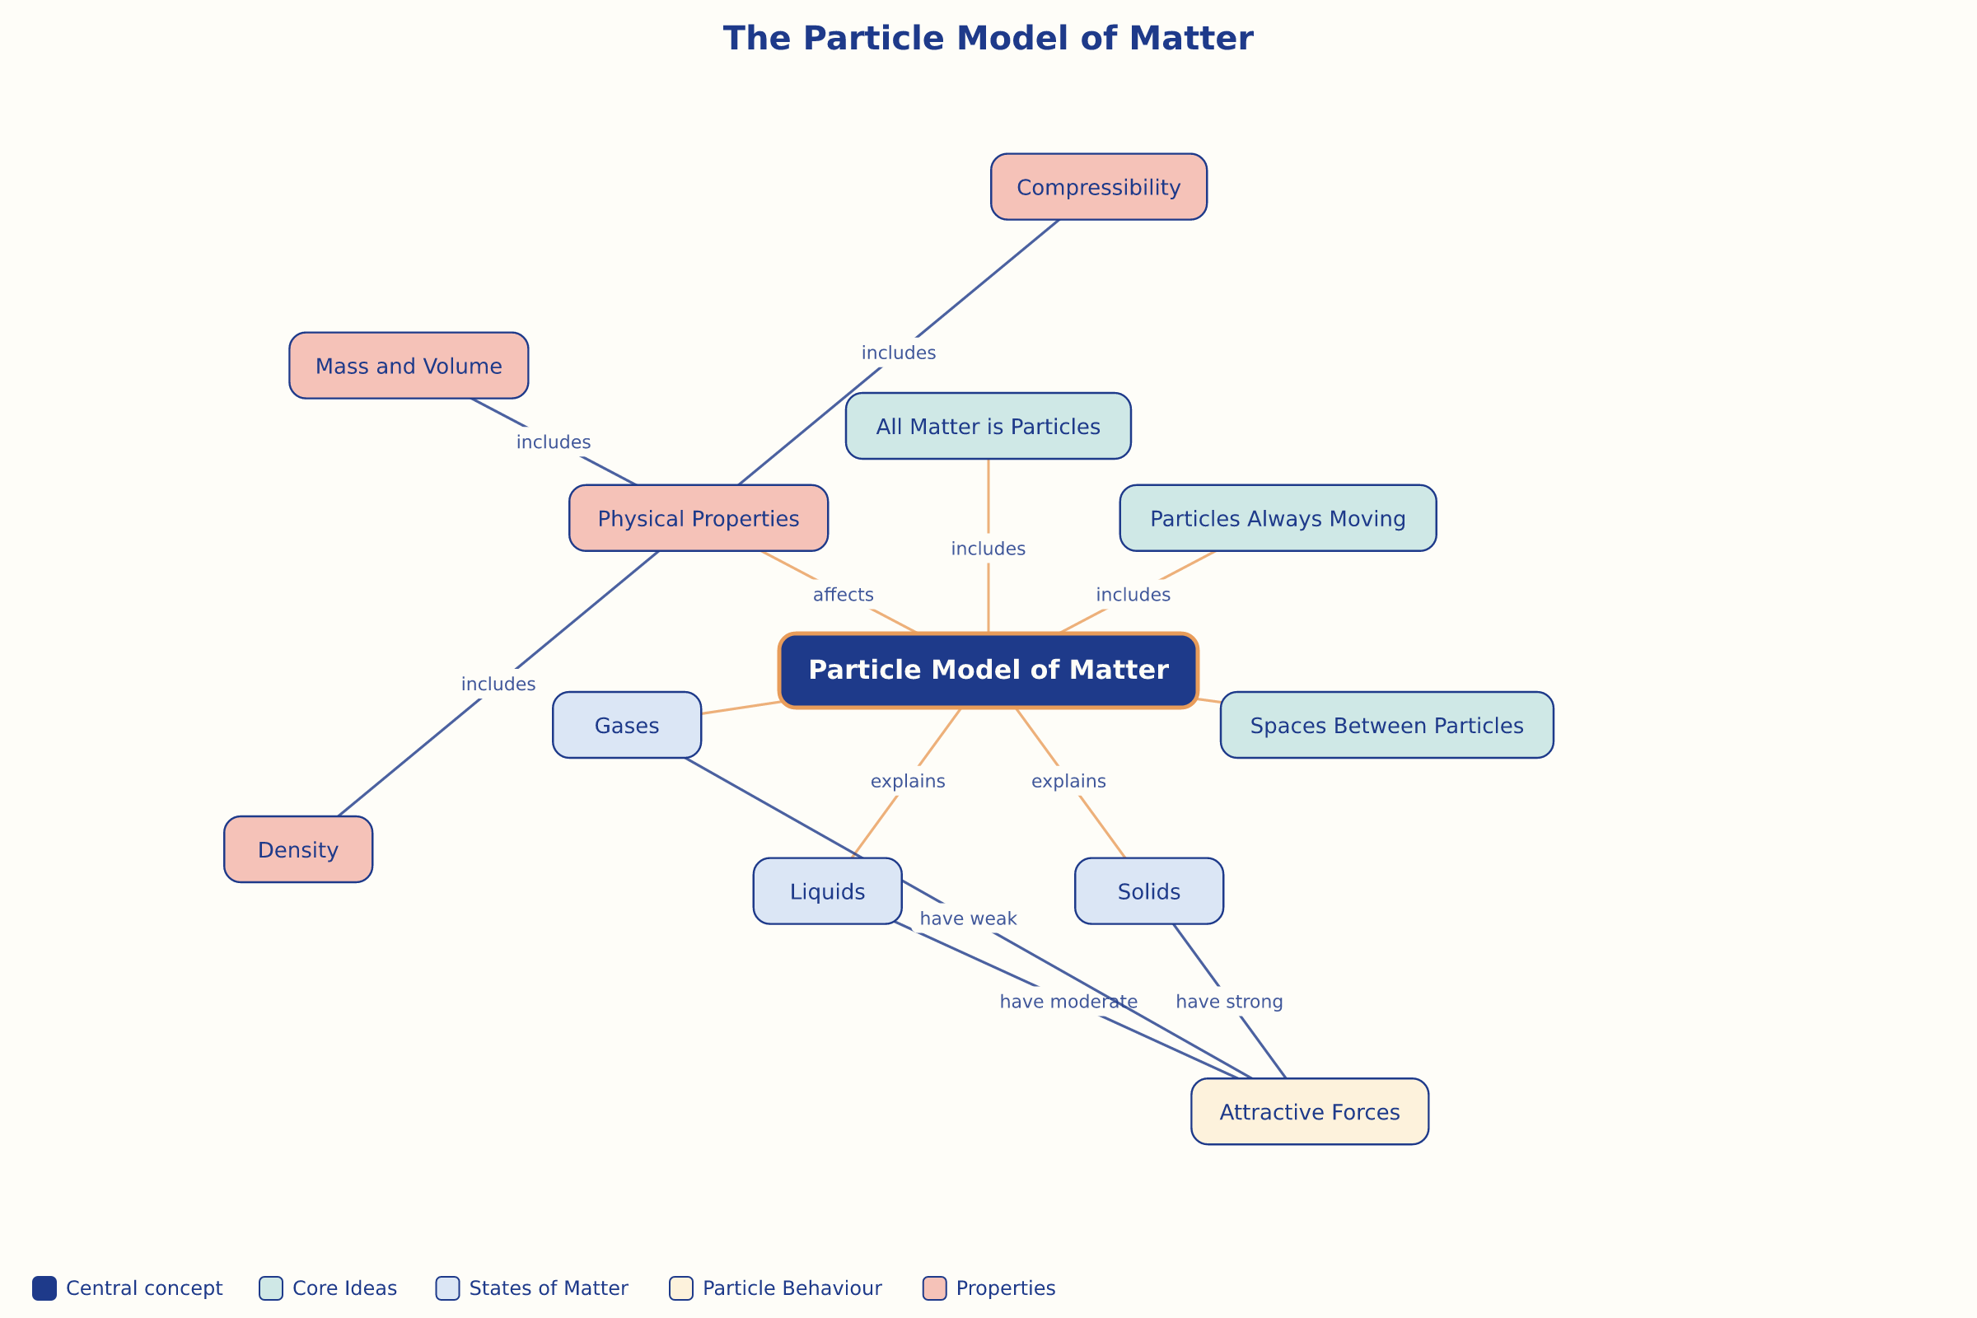

AILI word map · en · claude-haiku-4-5-20251001 · 2026-09-17

