The Particle Model of Matter
Discover how tiny, invisible particles explain why solids, liquids and gases behave so differently.


Learning intentions
We are learning to:
- Explain that all matter is made of tiny particles that are always moving and have spaces between them.
- Describe how particles are arranged and how they move in solids, liquids and gases.
- Explain how attractive forces between particles affect whether something is a solid, liquid or gas.

Success criteria
I can:
- Say the three big ideas of the particle model of matter.
- Draw particles in a solid, a liquid and a gas, showing their spacing and movement.
- Explain why solids hold their shape but liquids and gases do not.
- Use the word "attractive forces" correctly when I compare solids, liquids and gases.

Curriculum alignment
- Students investigate the particle model of matter in relation to the physical properties of solids, liquids, and gases (Outcome, Outcome).
- The particle model explains that matter is made of small, always-moving particles with spaces between them (Knowledge, Knowledge, PDF p.1).
- In solids particles vibrate close together, in liquids they slide past each other, and in gases they spread out and move in all directions (Knowledge, Knowledge, PDF p.9).
- Attractive forces are strongest in solids and weakest in gases (Knowledge, Knowledge, PDF p.9).
- Students represent solids, liquids and gases using the particle model and relate particle movement and arrangement to the state of matter (Skills, Skills).
- The particle model explains the behaviour of particles in matter, and the movement and arrangement of particles affect the physical properties of matter (Understanding, Understanding, Understanding, Understanding).
- Guiding question for this unit: How can states of matter and other physical properties be explained by using the particle model of matter? (Guiding question)

Materials
- Anchor chart: Particle Model of Matter (Resource), printed or displayed on the board
- Three clear containers: one with ice cubes, one with water, one empty (to represent air/gas)
- A balloon, inflated
- Whiteboard or chart paper divided into three columns labelled Solid, Liquid, Gas
- Small pom-poms, beans or counters (about 15 per pair of students) to model particles
- One paper plate or hoop per pair, to act as a "container" for the particles
- Student science notebooks or a printed worksheet with three blank boxes labelled Solid, Liquid, Gas
- Pencils and erasers

Lesson sequence

1. Hook (5 minutes)
Hold up the three containers: ice, water and the empty container with the balloon beside it.
Ask the class: "What is the same about all three of these? Ice, water, and the air in this balloon." Take two or three quick answers. Steer the discussion toward: they are all matter, and they are all made of the same kind of tiny building blocks, even though they look and act completely different.
Say: "Today we are going to find out what those tiny building blocks are doing inside a solid, a liquid and a gas, and why that makes them behave so differently."

2. Direct instruction (10 minutes)
Display the anchor chart (Resource) and walk through the three big ideas of the particle model of matter (Knowledge, PDF p.1):
- All matter is made up of small particles.
- Particles of matter are always moving.
- Particles of matter have spaces between them.
Say: "Nobody has ever seen a single particle with their eyes, because they are far too small. Scientists use this model because it explains what we do see, like ice melting or a balloon staying round."
Now describe each state using the chart:
- "In a solid, like this ice cube, the particles are packed close together and they vibrate in place. They don't travel around, they just jiggle." (Knowledge)
- "In a liquid, like this water, the particles have more space between them and they can slide past each other. That's why liquid takes the shape of its container." (Knowledge, PDF p.9)
- "In a gas, like the air inside this balloon, the particles are spread far apart and they move quickly in every direction." (Knowledge)
Introduce attractive forces: "Particles pull on each other a little, like tiny magnets. That pull is called an attractive force. It is strongest in solids, which is why solids hold their shape. It is weakest in gases, which is why a gas spreads out to fill any space it can find." (Knowledge, PDF p.9)
Ask a quick check-in question: "If attractive forces are strongest in solids, why do you think solids don't flow like water does?" Take one or two responses (look for: the particles are held tightly in place, so they can't slide around freely).

3. Guided practice (12 minutes)
Organize students into pairs. Give each pair 15 counters or pom-poms and a paper plate or hoop.
Say: "Your counters are particles. Your plate is a container. I want you to arrange your particles to show a solid first."
Model this on the board or table yourself: particles packed tightly in a neat cluster inside the container.
Give the instruction: "Now build a liquid with your particles. Remember, liquid particles have more space and can slide past each other."
Circulate and ask pairs: "Why did you spread them out a bit more than the solid?" (Look for: more space between particles, no fixed pattern.)
Give the instruction: "Now build a gas. Remember, gas particles are spread far apart and move in every direction."
Circulate and ask: "What did you do differently this time?" (Look for: particles spread across the whole container or even outside its edges, showing lots of empty space.)
As a whole class, ask: "In which state were your particles pulling on each other the most strongly? Which state had the weakest pull?" Confirm: strongest in solid, weakest in gas (Knowledge).

4. Independent practice (12 minutes)
Hand out the science notebook page or worksheet with three boxes labelled Solid, Liquid, Gas.
Instruct: "Draw particles in each box to show how they are arranged and how they move. Use dots or small circles for particles, and use arrows to show movement. Underneath each drawing, write one sentence describing the arrangement, the movement and the strength of the attractive forces."
Give a sentence starter for support: "In a ______, the particles are ______ and the attractive forces are ______."
While students work, circulate and check that:
- Solid drawings show particles close together with short vibration arrows, not particles jumping around freely.
- Liquid drawings show particles closer than gas but looser than solid, with sliding arrows.
- Gas drawings show particles spread far apart with long arrows in many directions.
For a real-world connection, ask students to think of one example each of a solid, a liquid and a gas from their own life (examples from home or lunch work well, such as an ice cube in a drink, juice in a cup, or the air in a bike tire) and add it beside their drawing.
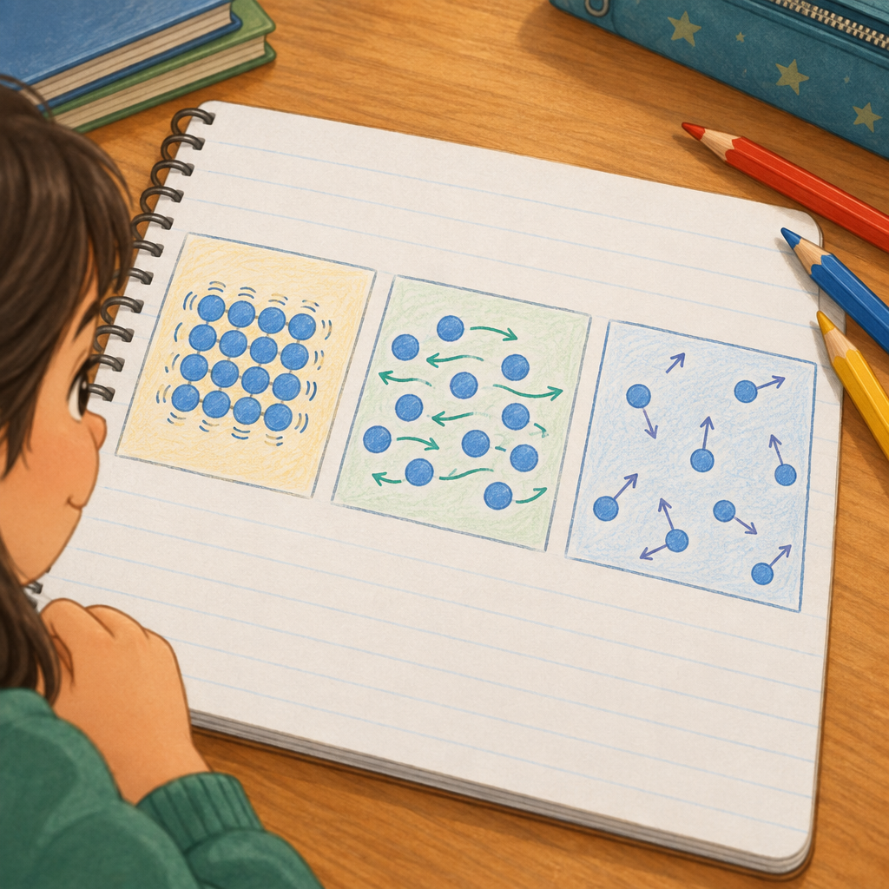

5. Consolidation (6 minutes)
Bring the class back together. Ask three students to share one sentence each, one for solid, one for liquid, one for gas.
Pose a final question to the whole class: "If I could shrink down and sit inside a particle of water as it turned into steam, what would change about my neighbours around me?" Take one or two answers, listening for: the neighbours would move farther apart, move faster, and pull on each other less strongly.
Close by restating the three big ideas from the anchor chart (Resource) once more, pointing to each as you say it, and remind students that these ideas will help them explain mass, volume and density in the next lesson (Knowledge, Skills).

Differentiation
Extension: Ask early finishers to predict what happens to the spacing and movement of particles when a solid is heated until it melts, and to sketch a fourth box showing that in-between moment. Challenge them to explain why liquid water is unusual, since its particles are closer together as a liquid than when frozen as ice (PDF p.9).
Support: Provide a partly completed worksheet where the words "close together," "sliding," "spread apart," "vibrate," "strongest" and "weakest" are given in a word bank to place under the correct diagram. Pair these students with a peer during the counters activity so they can build the models together before drawing independently.

Assessment
Formative check: Collect or review the independent practice worksheets (or scan them while circulating).
Look for:
- Correct particle spacing in each diagram (tight for solid, medium for liquid, wide for gas).
- Correct movement shown (vibration in place, sliding, moving freely in all directions).
- Accurate use of the term attractive forces, with solids identified as strongest and gases as weakest.
- A complete sentence for each state that connects arrangement, movement and attractive force strength, not just a label.
Students who mix up liquid and gas spacing, or who describe attractive forces backwards (strongest in gas), need a quick re-teach with the counters model before the next lesson on physical properties.

AILI rapid lesson · en · claude-sonnet-5 · 2026-09-17

