The Race
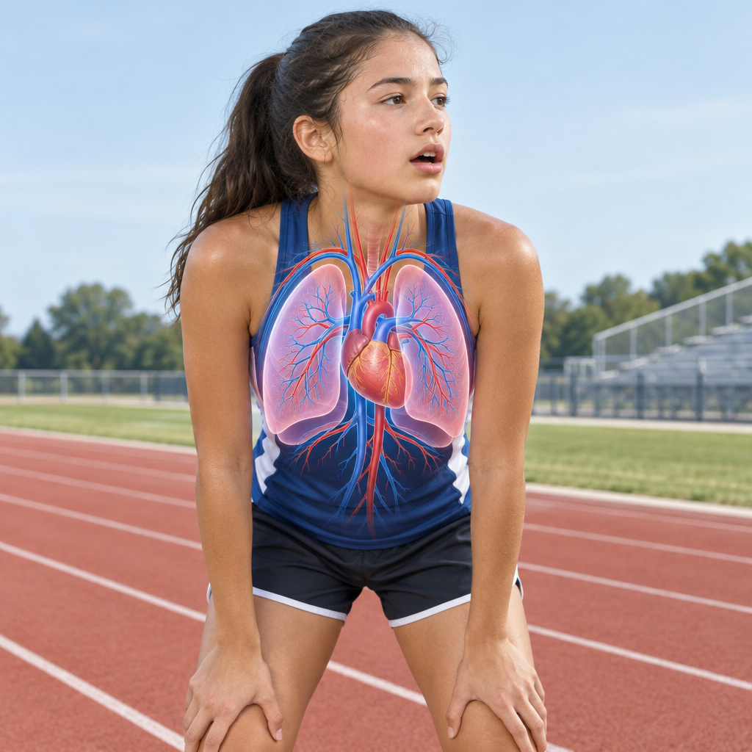
Malia laced up for the eight hundred metre run, heart already thumping. "Feel that?" asked Coach Devi. "Your heart is part of a system. It's pumping blood to carry oxygen to your muscle cells." At the gun, Malia sprinted. Her breathing deepened. "Lungs first," she thought, "then blood, then muscles." After, doubled over, she asked, "Why does my heart keep pounding even after I stop?" "Your body's adjusting," said Devi. "Cells need extra oxygen to recover. Nerve cells signal your brain, blood vessels widen, heart rate stays up until things balance out." Later in class, comparing an onion cell to her own cheek cell under the microscope, Malia grinned. "Different cells, same idea. Everything's built from tiny working parts." "Exactly,".

Words to know
- Cell: The basic unit of life that makes up all living things
- System: Parts working together to perform a function, like the circulatory system
- Diffusion: Movement of gases or liquids from an area of higher to lower concentration
- Stimuli: Changes in the environment or body that trigger a response
Curriculum link: Outcome, Outcome, Outcome, Topic
Listen to the narration

AILI audio story · en · claude-sonnet-5 · 2026-09-17

