Addition and Subtraction Within 100 (Grade 2)
Central concept: Addition & Subtraction to 100

Connections
- Addition & Subtraction to 100 (explores) -> Composing 100
- Composing 100 (shows) -> Sums Made Many Ways
- Composing 100 (uses) -> Order Doesn't Change Sum
- Addition & Subtraction to 100 (relies on) -> Number Facts
- Number Facts (supports) -> Strategies
- Strategies (includes) -> Make Tens
- Strategies (includes) -> Use Doubles
- Addition & Subtraction to 100 (practices) -> Add to 100
- Addition & Subtraction to 100 (practices) -> Subtract from 100
- Add to 100 (verified by) -> Check with Inverse
- Subtract from 100 (verified by) -> Check with Inverse
- Addition & Subtraction to 100 (finds) -> Missing Number
- Addition & Subtraction to 100 (means) -> Represents Quantities
- Represents Quantities (used for) -> Solve Problems

Notes
- Addition & Subtraction to 100: Grade 2 students investigate addition and subtraction within 100. Outcome
- Composing 100: 100 can be seen as a mix of groups of 10. Skills
- Sums Made Many Ways: One sum can be made in more than one way, even with extra addends. Understanding, Skills
- Order Doesn't Change Sum: Adding numbers in a different order still gives the same sum. Knowledge
- Number Facts: Knowing facts to 10 helps with bigger addition and subtraction. Knowledge
- Strategies: Ways to add and subtract two-digit numbers. Knowledge
- Make Tens: Group numbers into tens to add or subtract easier. Knowledge
- Use Doubles: Doubles facts, like 5+5, help solve harder problems. Knowledge
- Add to 100: Add numbers so the total reaches up to 100. Skills
- Subtract from 100: Subtract numbers starting from up to 100. Skills
- Check with Inverse: Use the opposite operation to check a sum or difference. Skills
- Missing Number: Find a missing part in an addition or subtraction problem. Skills
- Represents Quantities: Addition and subtraction show totals or differences of things we count or measure. Understanding
- Solve Problems: Use addition and subtraction with objects or lengths to solve real problems. Skills, Understanding
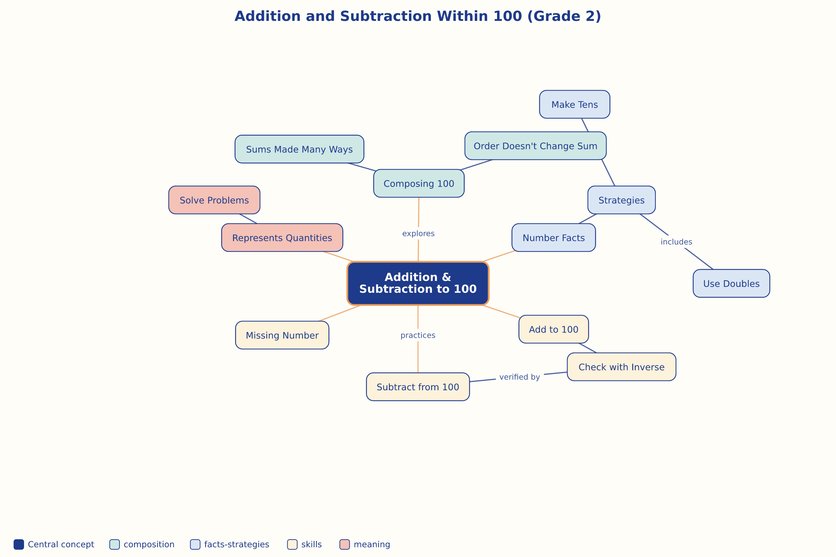

AILI word map · en · claude-sonnet-5 · 2026-09-17

