Movement and Relationships Logic Challenge
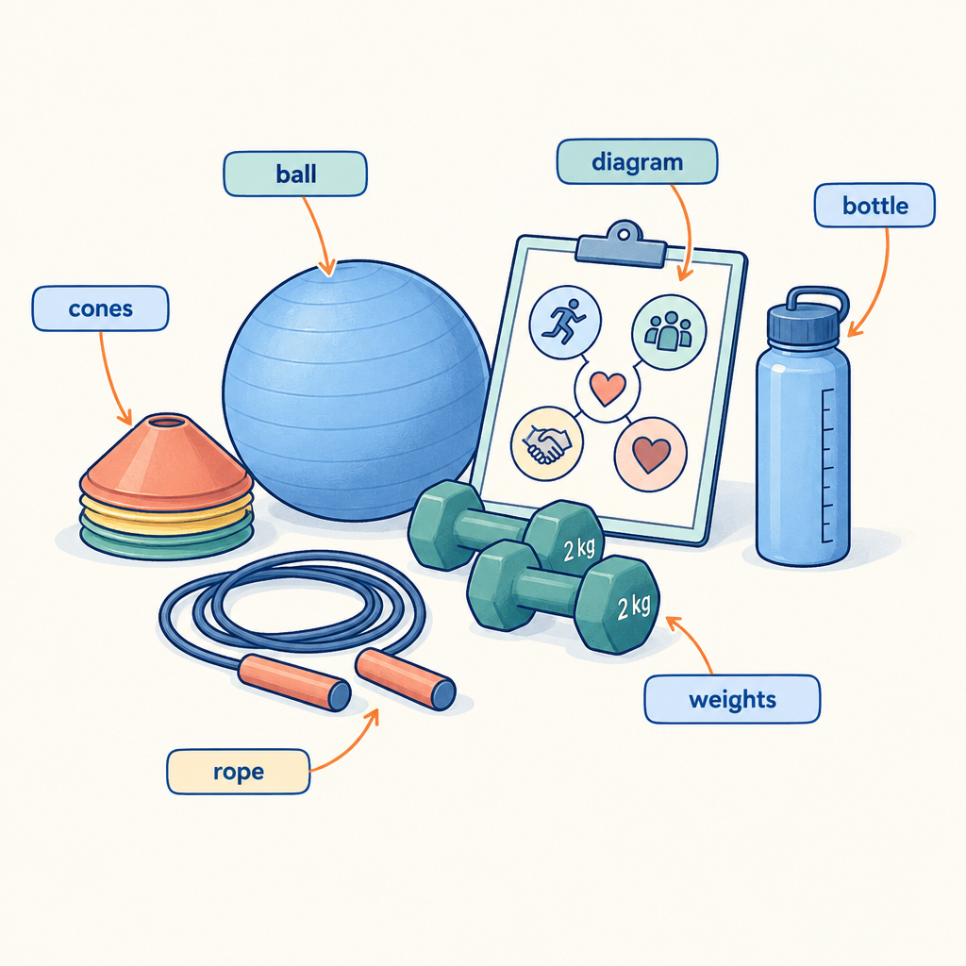
This brain teaser draws on two organizing ideas that run through the Physical Education and Wellness curriculum: Movement Skill Development and Healthy Social Relationships. Across Grade 7, students relate practice to the development of movement patterns and skills (Topic, Outcome) while also relating changes during adolescence to the development of healthy relationships built on respect, communication, and trust (Topic, Outcome). Personal well-being is supported through healthy relationships built on respect, communication, and trust (Topic, Outcome). By Grade 9, students explore specialized movement patterns and skills, using feedback and self-assessment to guide ongoing refinement (Topic, Outcome, Details). This puzzle asks students to apply logical reasoning to a scenario grounded in these same ideas: matching individuals to the movement skills they practise, the feedback strategies they use, and the healthy relationship behaviours they demonstrate.

How to play
- The puzzle is about 4 students and 3 categories. Each one has exactly one value in each category, and each value is used once.
- Read the 8 clues. Every clue is true. Use the grid to mark what is certain and cross out what is impossible.
- Exactly one arrangement fits every clue; the server has checked it. The hints go from gentle to direct, and the answer key shows the solution with the reasoning.

The puzzle
Four Grade 6 students each focus on a different topic in Physical Education and Wellness class this week. Use the clues to work out each student's topic, presentation day, and class period.
Maya, Owen, Priya and Dawit each have one item from every category below, and no two of them share an item.
- Topic: improving stability through practice, recognizing emotional manipulation, practising active listening, creating a rhythmic movement sequence
- The order of presenting (in order, from first to fourth): first, second, third, fourth
- Class period: period 1, period 2, period 3, period 4
Use the clues to work out who has what. Mark in the grid what each clue rules out.
Name | Topic | The order of presenting | Class period
Maya
Owen
Priya
Dawit

- Priya has creating a rhythmic movement sequence.
- The student with creating a rhythmic movement sequence also has period 1.
- The student with period 3 is between the student with period 2 and the student with recognizing emotional manipulation in the order of presenting.
- The student with period 2 is between the student with period 1 and the student with practising active listening in the order of presenting.
- The student with period 1 comes before the student with period 4 in the order of presenting.
- Maya does not have practising active listening.
- Maya does not have period 2.
- Dawit does not have third.

Hints
- Start with clue 1. Mark in the grid what it rules out before you read on.
- Clues 1 and 2 together show that Priya has period 1.
- Priya has creating a rhythmic movement sequence, first and period 1.

Answer key
Name | Topic | The order of presenting | Class period
Maya | recognizing emotional manipulation | fourth | period 4
Owen | practising active listening | third | period 3
Priya | creating a rhythmic movement sequence | first | period 1
Dawit | improving stability through practice | second | period 2

Reasoning
- Clue 1: Priya has creating a rhythmic movement sequence. This fixes Priya has creating a rhythmic movement sequence; 3456 arrangements remain.
- Clue 2: The student with creating a rhythmic movement sequence also has period 1. This fixes Priya has period 1; 864 arrangements remain.
- Clue 3: The student with period 3 is between the student with period 2 and the student with recognizing emotional manipulation in the order of presenting. Nothing is fixed yet; 96 arrangements remain.
- Clue 4: The student with period 2 is between the student with period 1 and the student with practising active listening in the order of presenting. Nothing is fixed yet; 12 arrangements remain.
- Clue 5: The student with period 1 comes before the student with period 4 in the order of presenting. This fixes Priya has first; 6 arrangements remain.
- Clue 6: Maya does not have practising active listening. Nothing is fixed yet; 4 arrangements remain.
- Clue 7: Maya does not have period 2. This fixes Maya has recognizing emotional manipulation, Maya has fourth and Maya has period 4; 2 arrangements remain.
- Clue 8: Dawit does not have third. This fixes Owen has practising active listening, Dawit has improving stability through practice, Owen has third, Dawit has second, Owen has period 3 and Dawit has period 2, and only one arrangement remains.

AILI game · en · claude-sonnet-5 · 2026-09-17

