Cells and Systems
Grade 8 Science: from single cells to whole-body systems

Slide 1: Cells and Systems
Grade 8 Science: from single cells to whole-body systems
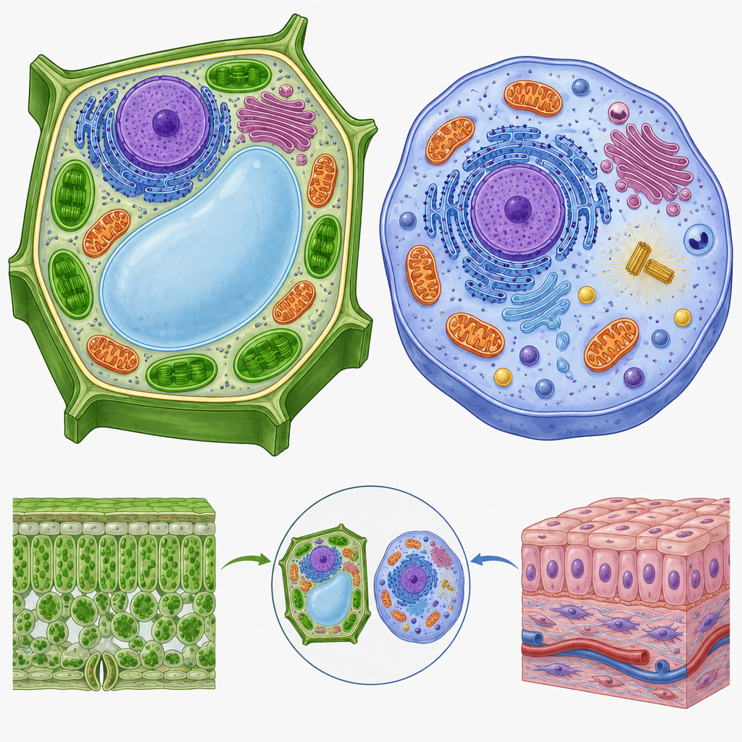
Notes: Introduce the unit by connecting prior knowledge from Grade 5 (body systems) to the Grade 8 focus on cells as the basic unit of life. Ask students what they already know about cells from earlier grades.

Slide 2: Learning Intentions and Success Criteria
- We are investigating living things and applying scientific ideas to interpret structure, function and organization (Outcome).
- We are investigating and describing the role of cells within living things (Outcome).
- We are interpreting the healthy function of human body systems and how the body reacts to stimuli (Outcome).
- Success: I can investigate and describe the characteristics of living things and apply the concept of system in describing familiar organisms and analyzing their general structure and function.
- Success: I can illustrate and explain how different organisms have similar functions that are met in a variety of ways.
- Success: I can describe how different organisms have similar functions that are met in a variety of ways and apply the concept of system in describing familiar organisms and analyzing their general structure and function.
Sources: Outcome, Outcome, Outcome
Notes: Materials: whiteboard, projector, cell diagram handouts, microscopes and prepared slides if available. Timing: 10 minutes to unpack learning intentions and co-construct success criteria with students. Formative checkpoint: thumbs-up check on understanding of 'system' as a concept before moving on.

Slide 3: Plant Cells vs Animal Cells
Animal Cells
Animal cells have a cell membrane but no cell wall (Outcome). They rely on internal systems such as digestion, respiration, circulation and the musculoskeletal system to carry out life processes (Details). Movement, nutrition, respiration, growth and reproduction are vital processes carried out by these systems working together (Details).
Plant Cells
Plant cells have a rigid cell wall in addition to a cell membrane, distinguishing them from animal cells (Outcome). Plant cells also contain chloroplasts for photosynthesis and a large central vacuole that stores water, nutrients and waste. Instead of a circulatory system with a heart and blood vessels, plants move water and sugars through xylem and phloem tissue.
Sources: Outcome, Details
Notes: Timing: 15 minutes. Have students sketch and label a plant cell and an animal cell, circling the structure that is present in one but not the other (cell wall). Support: provide a partially labelled diagram for students who need scaffolding. Extension: ask students to research chloroplasts and explain why animal cells lack them.

Slide 4: How Body Systems Work Together
- Digestive System: Breaks down food and absorbs nutrients using the mouth, stomach, intestines, liver and pancreas (Details).
- Respiratory System: Exchanges oxygen and carbon dioxide through the trachea, lungs and diaphragm (Details).
- Circulatory System: Moves blood, oxygen and nutrients around the body using the heart and blood vessels (Details).
- Cells and Tissues: Individual cells in nerves, muscle, blood, skin and bone each contribute to healthy body function (Outcome).
- Whole-Body Response: The body changes its functions in response to conditions, such as heart rate rising during exercise (Outcome).
Sources: Details, Outcome
Notes: Timing: 15 minutes. Walk through the flowchart as a class, asking students to trace an oxygen molecule from lungs to a muscle cell. Formative checkpoint: exit-ticket question asking students to name one biological system and describe one of its vital functions. Extension: have students research how the excretion or sensory system fits into this chain.

Slide 5: Diffusion and Osmosis in Cells
Gases and liquids move into and out of cells during diffusion and osmosis, driven by differences in concentration rather than a pump (Outcome). This is a general concept, not a detailed mechanism, so students should focus on the idea that particles move from areas of higher concentration to lower concentration until balance is reached. Understanding this helps explain how oxygen diffuses from the alveoli into the blood and then into red blood cells, and how plant root hairs absorb water.
Why cells move gases and liquids without pumps
Diffusion and osmosis explain how gases and liquids cross cell membranes without a pump: particles simply move from areas of higher concentration to areas of lower concentration until they reach balance. Although this is a general concept rather than a detailed mechanism, it explains why oxygen diffuses from the alveoli into the blood and then into red blood cells, and why water moves into plant root hairs during osmosis.
Sources: Outcome
Notes: Timing: 20 minutes. Run a simple demonstration: drop food colouring into still water and observe diffusion over several minutes. Ask students to relate this to gas exchange in lungs or water uptake in roots. Support: provide a concentration-gradient diagram with arrows already drawn. Extension: ask students why cell size is limited by surface area to volume ratio, connecting to later grades' study of this concept.

Slide 6: Wrapping Up: Cells and Systems
Cells are the basic unit of life: in a single-celled organism such as an amoeba one cell carries out all life processes, while in a multicellular organism such as a human, cells work together in tissues, organs and systems. Human body systems such as digestion, respiration and circulation illustrate how healthy organisms function as balanced systems, responding to changes such as exercise or temperature (Outcome).
Question: If one cell type in your body, like a red blood cell, stopped doing its job properly, which body system would be affected first, and why?
Sources: Outcome, Outcome
Notes: Timing: 10 minutes. Use the closing question as an exit ticket or a think-pair-share discussion. Sample answer: describe how the circulatory system carries oxygen and nutrients to the body's various tissues and organs through blood circulation, and explain how the respiratory system exchanges oxygen and carbon dioxide through the lungs. Students should describe ways in which various types of cells contribute to the healthy functioning of the human body, such as describing the roles of individual cells in nerves, muscle, blood, skin and bone.

AILI presentation · en · claude-sonnet-5 · 2026-09-17

