Personal Choices, Well-Being, and Consequences: A Logic Puzzle
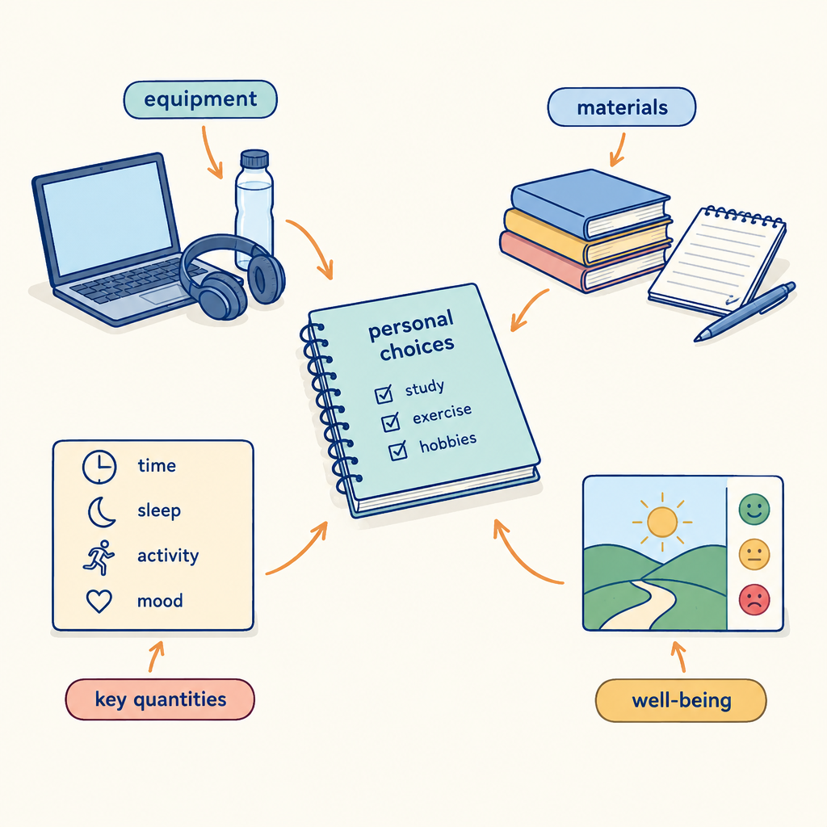
This brain teaser challenges you to reason through connections between personal choices and their effects on health, echoing the progression across grades in which students compare personal health choices to established standards (Outcome), examine the relationship between choices and resulting consequences (Outcome), and develop strategies that support healthy habits for themselves and others (Outcome). Solving the puzzle draws on the same kind of analytical thinking used to weigh factors such as nutrition, grooming, substance use, and lifestyle pressures against their outcomes (Outcome, Outcome, Outcome, Outcome).

How to play
- The puzzle is about 4 students and 3 categories. Each one has exactly one value in each category, and each value is used once.
- Read the 8 clues. Every clue is true. Use the grid to mark what is certain and cross out what is impossible.
- Exactly one arrangement fits every clue; the server has checked it. The hints go from gentle to direct, and the answer key shows the solution with the reasoning.

The puzzle
Four students in a Career and Life Management class each researched a different personal health focus for a class presentation on well-being. Each student also chose a factor that most influences their choices in that area.
Priya, Marcus, Lena and Tyrell each have one item from every category below, and no two of them share an item.
- Personal health focus: physical activity habits, nutrition choices, sleep patterns, grooming and cleanliness habits
- Influencing factor: media messages, peer pressure, body image, family involvement
- Order of presenting (in order, from first to fourth): first, second, third, fourth
Use the clues to work out who has what. Mark in the grid what each clue rules out.
Name | Personal health focus | Influencing factor | Order of presenting
Priya
Marcus
Lena
Tyrell

- Priya has family involvement.
- Lena has sleep patterns.
- Marcus has grooming and cleanliness habits.
- The student with nutrition choices also has body image.
- Lena does not have peer pressure.
- The student with body image also has fourth.
- The student with family involvement comes before the student with peer pressure in order of presenting.
- Marcus does not have third.

Hints
- Start with clue 1. Mark in the grid what it rules out before you read on.
- Clues 1 to 4 together show that Priya has physical activity habits.
- Priya has physical activity habits, family involvement and first.

Answer key
Name | Personal health focus | Influencing factor | Order of presenting
Priya | physical activity habits | family involvement | first
Marcus | grooming and cleanliness habits | peer pressure | second
Lena | sleep patterns | media messages | third
Tyrell | nutrition choices | body image | fourth

Reasoning
- Clue 1: Priya has family involvement. This fixes Priya has family involvement; 3456 arrangements remain.
- Clue 2: Lena has sleep patterns. This fixes Lena has sleep patterns; 864 arrangements remain.
- Clue 3: Marcus has grooming and cleanliness habits. This fixes Marcus has grooming and cleanliness habits; 288 arrangements remain.
- Clue 4: The student with nutrition choices also has body image. This fixes Priya has physical activity habits, Tyrell has nutrition choices and Tyrell has body image; 48 arrangements remain.
- Clue 5: Lena does not have peer pressure. This fixes Marcus has peer pressure and Lena has media messages; 24 arrangements remain.
- Clue 6: The student with body image also has fourth. This fixes Tyrell has fourth; 6 arrangements remain.
- Clue 7: The student with family involvement comes before the student with peer pressure in order of presenting. Nothing is fixed yet; 3 arrangements remain.
- Clue 8: Marcus does not have third. This fixes Priya has first, Marcus has second and Lena has third, and only one arrangement remains.

AILI game · en · claude-sonnet-5 · 2026-09-17

