Matter and the Particle Model (Grade 5)
Central concept: Particle Model of Matter

Connections
- Particle Model of Matter (includes) -> Basic Ideas
- Particle Model of Matter (describes) -> Solids
- Particle Model of Matter (describes) -> Liquids
- Particle Model of Matter (describes) -> Gases
- Particle Model of Matter (explains) -> Physical Properties
- Particle Model of Matter (answers) -> Guiding Question
- Basic Ideas (relates to) -> Attractive Forces
- Solids (has strongest) -> Attractive Forces
- Gases (has weakest) -> Attractive Forces
- Physical Properties (includes) -> Mass
- Physical Properties (includes) -> Volume
- Physical Properties (includes) -> Density
- Physical Properties (includes) -> Compressibility
- Mass (measured by) -> Measuring Tools
- Volume (measured by) -> Measuring Tools
- Density (compares) -> Mass
- Density (compares) -> Volume
- Compressibility (greater in) -> Gases
- Compressibility (lesser in) -> Liquids
- Particle Model of Matter (uses) -> Representing Particles
- Representing Particles (shows) -> Solids
- Representing Particles (shows) -> Liquids
- Representing Particles (shows) -> Gases

Notes
- Particle Model of Matter: Explains the behaviour of particles that make up all matter. Outcome, Understanding, PDF p.1
- Basic Ideas: All matter is made of small particles that are always moving and have spaces between them. Knowledge, PDF p.1
- Solids: Particles are close together and vibrate in place. Knowledge, Knowledge
- Liquids: Particles have spaces between them and can slide past each other. Knowledge, Knowledge
- Gases: Particles have large spaces and move constantly in all directions. Knowledge, Knowledge
- Attractive Forces: Strongest in solids, weakest in gases; heating weakens them, cooling strengthens them. Knowledge, Skills, PDF p.6
- Physical Properties: Includes state, mass, volume, density, and compressibility. Knowledge, Understanding
- Mass: Amount of matter in an object, measured in grams and kilograms. Knowledge, Skills
- Volume: Amount of space matter takes up, measured in millilitres and litres. Knowledge, Skills
- Density: Compares mass to volume; denser objects sink, less dense objects float. Knowledge, PDF p.6
- Compressibility: Ability of liquids and gases to shrink in volume under pressure; gases compress more easily. Knowledge, PDF p.6
- Measuring Tools: Balance scales and volume instruments used with SI units to measure mass and volume. Skills
- Representing Particles: Students draw and describe particle arrangements for solids, liquids, and gases. Skills, Skills, Resource
- Guiding Question: How can states of matter and other physical properties be explained by using the particle model of matter? Guiding question
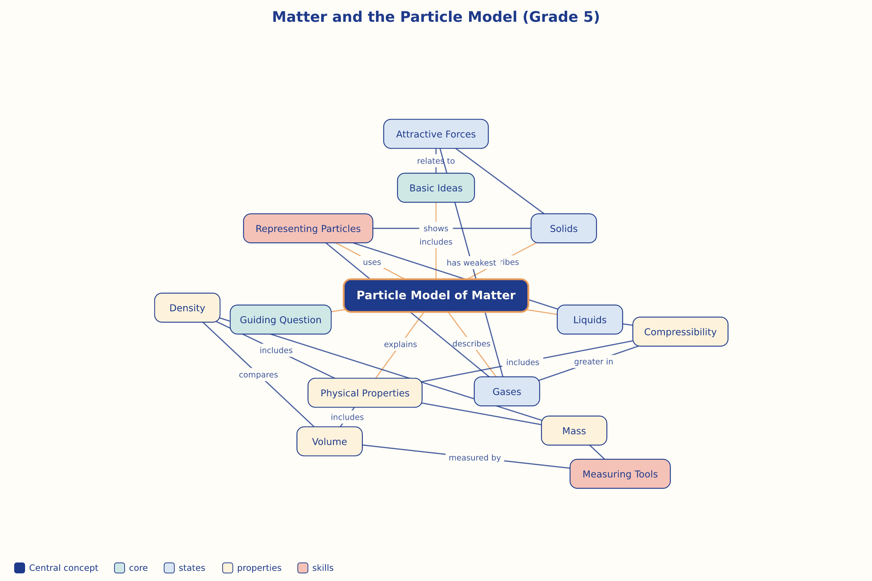

AILI word map · en · claude-sonnet-5 · 2026-09-17

