Addition and Subtraction Within 100
Central concept: Addition & Subtraction to 100

Connections
- Addition & Subtraction to 100 (explores) -> Composing 100
- Composing 100 (uses) -> Multiples of Ten
- Composing 100 (shows) -> Many Ways to Sum
- Addition & Subtraction to 100 (follows) -> Associative Property
- Addition & Subtraction to 100 (relies on) -> Number Facts
- Number Facts (builds) -> Two-Digit Strategies
- Addition & Subtraction to 100 (uses to check) -> Inverse Operations
- Addition & Subtraction to 100 (finds) -> Missing Number
- Addition & Subtraction to 100 (applies to) -> Problem Solving
- Problem Solving (involves) -> Quantities & Lengths
- Problem Solving (requires) -> Sums & Differences to 100
- Two-Digit Strategies (helps solve) -> Sums & Differences to 100

Notes
- Addition & Subtraction to 100: Students investigate addition and subtraction within 100. Outcome
- Composing 100: 100 can be seen as multiples of 10 put together in different ways. Skills
- Multiples of Ten: Building blocks used to visualize 100. Skills
- Many Ways to Sum: A sum can be made in more than one way, even with more than two addends. Understanding, Skills
- Associative Property: Changing the order you add numbers does not change the total. Knowledge
- Number Facts: Knowing facts to 10 helps with adding and subtracting bigger numbers. Knowledge
- Two-Digit Strategies: Includes making multiples of ten and using doubles. Knowledge
- Inverse Operations: Use addition to check subtraction, and subtraction to check addition. Skills
- Missing Number: Find an unknown part in a sum or difference within 100. Skills
- Problem Solving: Solve problems about countable things or lengths using addition and subtraction. Understanding, Skills
- Quantities & Lengths: Addition and subtraction can show a sum or difference of objects or measured lengths. Understanding
- Sums & Differences to 100: Add up to a sum of 100 and subtract with a minuend up to 100. Skills
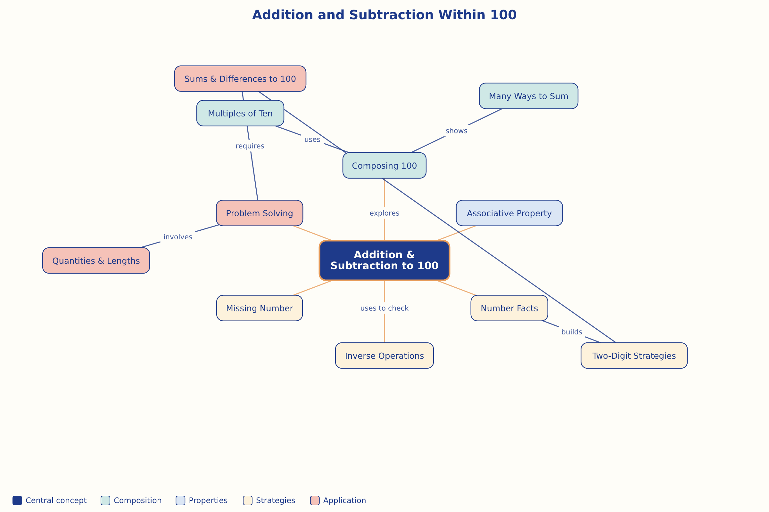

AILI word map · en · claude-sonnet-5 · 2026-09-17

