Kinematics: Describing Motion with Displacement, Velocity and Acceleration
Displacement, velocity and acceleration: building the foundation of Unit A
Audience: Grade 11 Physics 20 students preparing for further study in kinematics, dynamics and diploma-level physics.
Grades: Grade 11
Subjects: Physics
Time: about 60 minutes
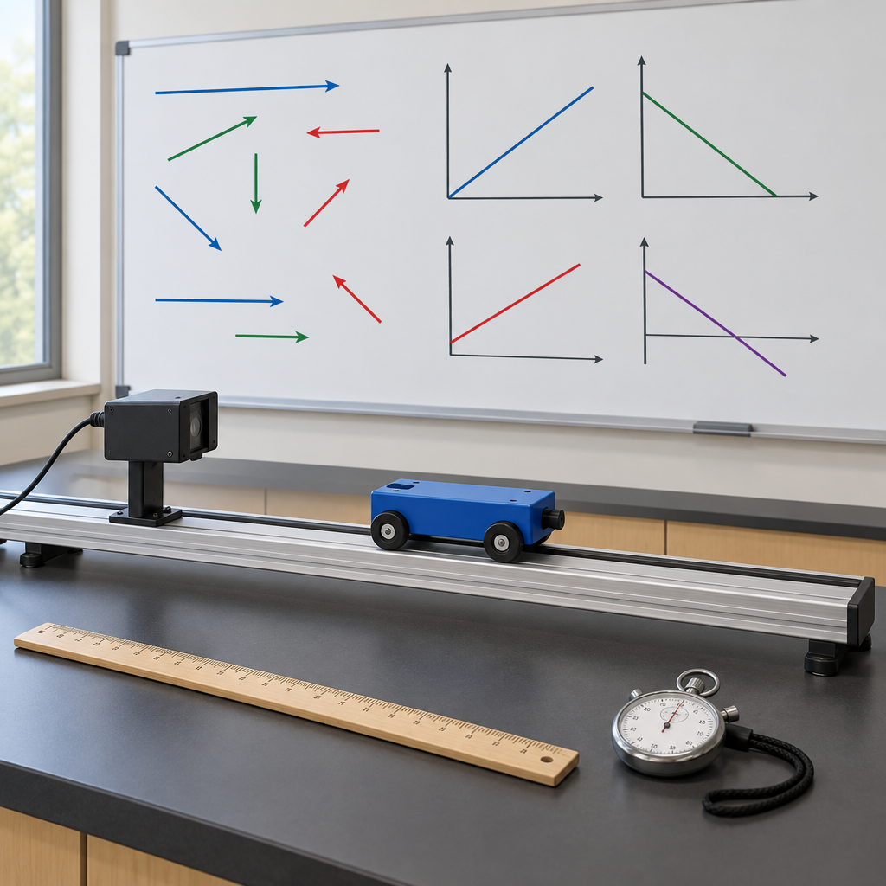

Overview
This lesson opens Unit A of Physics 20, in which students investigate changes in position and velocity as part of a study of kinematics (Topic). The 60-minute lesson builds the conceptual and mathematical foundation for the unit: the distinction between scalar and vector quantities, operational definitions of displacement, velocity and acceleration, and the qualitative and quantitative difference between uniform and uniformly accelerated motion (Outcome, Outcome, Outcome).
Students then apply these ideas to relative motion problems along a single axis and preview how two-dimensional motion is described using vector components, work that continues in subsequent lessons (Outcome, Outcome). The lesson closes by connecting kinematics to real technologies, such as calculating average speed for a trip or the acceleration needed to launch an aircraft from a carrier, reinforcing that the goal of science is knowledge about the natural world (Outcome)."

Outcomes covered
- Students will describe motion in terms of displacement, velocity, acceleration and time. (Topic)
This is the general outcome for the entire kinematics unit and frames every specific skill developed in this lesson.
- Define, qualitatively and quantitatively, displacement, velocity and acceleration (20-A1.1k). (Outcome)
Precise definitions of these quantities are the foundation for every calculation and graph students will encounter in the unit, including later work in dynamics.
- Define, operationally, and compare and contrast scalar and vector quantities (20-A1.2k). (Outcome)
Distinguishing scalars from vectors prevents common errors, such as confusing speed with velocity, and is essential for correct problem-solving throughout physics.
- Explain, qualitatively and quantitatively, uniform and uniformly accelerated motion when provided with written descriptions and numerical and graphical data (20-A1.3k). (Outcome)
Recognizing these two motion types on graphs allows students to predict future position and velocity, a skill tested throughout the unit and on the diploma exam.
- Describe motion in terms of displacement and velocity vectors. (Outcome)
Relative motion reasoning applies directly to real situations such as walking on a moving train or a boat crossing a current, and prepares students for vector addition in two dimensions.
- Explain, quantitatively, two-dimensional motion in a horizontal or vertical plane, using vector components (20-A1.5k). (Outcome)
This outcome describes motion in terms of displacement, velocity, acceleration and time, providing groundwork for upcoming lessons.
- Explain that the goal of science is knowledge about the natural world, identifying common applications of kinematics such as determining the average speed of a run, bike ride or car trip, or the acceleration required to launch an aircraft from a carrier (20-A1.1sts). (Outcome)
Connecting kinematics to everyday and technological applications shows students why the mathematics of motion matters beyond the classroom.

Materials
- Whiteboard and markers
- Mini-whiteboards or scrap paper for sketching graphs
- Exit slip handout (one per student)
- Formula reference cards (for support group)
- Graph paper
- Calculators
- Optional: toy cart, track and motion sensor for demonstration

Sequence of activities

1. Warm-Up: Scalars, Vectors and the Language of Motion (8 min, whole class)
- Display two statements on the board: "The car travelled 80 km" and "The car travelled 80 km east."
- Ask students to identify what information the second statement adds that the first lacks.
- Introduce the definitions of scalar and vector quantities, having students record examples of each from everyday motion (distance vs. displacement, speed vs. velocity) (Outcome).
- Cold-call three students to classify quantities you provide orally: mass, time, force, temperature, displacement, velocity. Confirm answers as a class.
- Pose the focusing question for the unit: How do changes in position, velocity and acceleration allow us to predict the paths of moving objects and systems? (Topic)
Watch for students who confuse distance and displacement because both use the same unit (metres). Reinforce that direction is the distinguishing feature of a vector. This activity sets the conceptual foundation before any calculation work begins.
Sources: Topic, Outcome

2. Direct Instruction: Displacement, Velocity and Acceleration (15 min, whole class)
- Define displacement (Δd), velocity (v) and acceleration (a) both qualitatively (in words, with direction) and quantitatively (with formulas) (Outcome).
- Present the formulas: Δd = d(final) − d(initial); v(average) = Δd / Δt; a(average) = Δv / Δt.
- Work through Example 1 as a class: A cyclist rides from a position of +20 m to +140 m in 15 s. Calculate average velocity.
Solution: Δd = 140 m − 20 m = 120 m [forward]; v = 120 m / 15 s = 8.0 m/s [forward].
- Work through Example 2: A car accelerates from 5.0 m/s [east] to 17 m/s [east] in 4.0 s. Calculate average acceleration.
Solution: Δv = 17 m/s − 5.0 m/s = 12 m/s [east]; a = 12 m/s / 4.0 s = 3.0 m/s^2 [east].
- Distinguish uniform motion (constant velocity, zero acceleration) from uniformly accelerated motion (constant, non-zero acceleration), referencing how each appears on position-time and velocity-time graphs (Outcome).
- Ask students to sketch, on mini-whiteboards, a position-time graph for uniform motion and a velocity-time graph for uniformly accelerated motion. Circulate and check for correct slope interpretation.
Formative checkpoint: the mini-whiteboard sketches reveal whether students connect slope on a position-time graph to velocity, and slope on a velocity-time graph to acceleration. Re-teach immediately if more than a few students draw a curved line for uniform motion.
Sources: Outcome, Outcome

3. Guided Practice: Relative Motion and Real-World Applications (12 min, pairs)
- Pose the relative motion scenario: A person walks at 1.5 m/s [east] on a train moving at 20 m/s [east]. What is the person's velocity relative to the ground?
- In pairs, students calculate the resultant velocity by adding the vectors: 1.5 m/s [east] + 20 m/s [east] = 21.5 m/s [east] (Outcome).
- Extend the scenario: the person now walks at 1.5 m/s [west] (toward the back of the train). Have pairs recalculate: 20 m/s [east] − 1.5 m/s [east] = 18.5 m/s [east].
- Ask each pair to identify one real-world application of kinematics, such as calculating the average speed of a run, a bike ride, or a car trip, or the acceleration needed to launch an aircraft from a carrier (Outcome).
- Select two or three pairs to share their application and explain, in one sentence, what displacement, velocity or acceleration value would need to be measured.
This activity operationalizes 20-A1.4k by having students add and subtract velocity vectors along a single axis before two-dimensional components are introduced later in the unit. The application-sharing step connects kinematics to technology, addressing the science-technology-society outcome.
Sources: Outcome, Outcome

4. Application Preview: Two-Dimensional Motion Components (10 min, small group)
- Introduce the idea that motion in a plane can be broken into horizontal and vertical (or perpendicular) components, previewing the concept needed for projectile-style problems later in the unit (Outcome).
- Present a simplified scenario in small groups: a boat crosses a river, moving at 4.0 m/s [north] relative to the water while the current flows at 3.0 m/s [east].
- Each group sketches a vector diagram showing the two component velocities as perpendicular arrows.
- Groups estimate, without formal trigonometry, which direction the boat actually travels relative to the shore (a mix of north and east) and discuss why the boat's path is not a straight line north.
- Bring the class together and confirm that a full quantitative solution using vector components will be developed in upcoming lessons, building on today's foundation.
Keep the trigonometric solution out of this lesson; the outcome is developed further later in the unit and does not require angles greater than 90° per the unit notes (Topic). The goal here is conceptual: components add to produce a resultant path.
Sources: Outcome, Topic

5. Consolidation and Exit Check (15 min, individual)
- Distribute an exit slip with three questions:
a) Classify as scalar or vector: (i) 60 km/h, (ii) 60 km/h [north], (iii) 15 kg.
b) A runner's position changes from +200 m to +350 m in 25 s. Calculate the average velocity.
c) In one or two sentences, describe the difference between uniform motion and uniformly accelerated motion, referring to what happens on a velocity-time graph.
- Students complete the exit slip individually and silently.
- Collect the slips as a formative assessment of the day's outcomes.
- While students finish, circulate to identify any student still confusing distance with displacement or velocity with acceleration, and note names for targeted follow-up next class.
- Close by restating the unit's focusing question and previewing that the next lesson develops uniformly accelerated motion using graphs and equations in more depth (Topic).
Answers: a) (i) scalar, (ii) vector, (iii) scalar. b) Δd = 150 m, v = 150 m / 25 s = 6.0 m/s [forward, in the direction of increasing position]. c) Uniform motion shows a horizontal line on a velocity-time graph (constant velocity, zero slope); uniformly accelerated motion shows a straight, sloped line (constant, non-zero acceleration). Use this exit slip to group students for support or extension in the next lesson.
Sources: Topic, Outcome, Outcome

Differentiation
Extension
- Ask students to solve the river-crossing scenario quantitatively using the Pythagorean theorem to find the resultant speed, previewing the trigonometric work of upcoming lessons.
- Have students research and present a real aircraft carrier launch acceleration value, calculating the time required to reach takeoff velocity given a known runway length.
- Challenge students to construct a position-time graph from a velocity-time graph for a two-stage trip (constant velocity followed by acceleration).
Support
- Provide a formula reference card with displacement, velocity and acceleration equations, units and sample substitutions.
- Pair students with a partner for the exit slip's written comparison question, allowing oral rehearsal before writing.
- Use colour-coded arrows (one colour per vector) when introducing relative motion addition to reduce cognitive load.
Inclusive supports
- Offer sentence starters for the written comparison question, such as 'On a velocity-time graph, uniform motion looks like... while uniformly accelerated motion looks like...'
- Provide graph paper with pre-drawn axes and labelled units for the mini-whiteboard sketching task.
- Allow extra processing time on the exit slip and permit calculators for all numerical work.

Assessment
Formative. Mini-whiteboard sketches of position-time and velocity-time graphs during direct instruction.
Look for: Students correctly draw a straight position-time line with constant, non-zero slope for uniform motion and a straight, sloped velocity-time line for uniformly accelerated motion, showing they connect slope to velocity and acceleration respectively. (Outcome)
Formative. Pair calculations and vector diagrams during the relative motion and two-dimensional motion activities.
Look for: Pairs correctly add or subtract velocity vectors along one axis and sketch perpendicular component vectors that combine into a resultant path. (Outcome, Outcome)
Students will describe motion in terms of displacement, velocity, acceleration and time.
Look for: Correct classification of quantities, correct numerical answer for average velocity with units and direction, and a written comparison that references graph slope or shape. (Topic, Outcome, Outcome, Outcome)

Vocabulary
- Displacement: A vector quantity describing the change in position of an object, including both magnitude and direction, denoted Δd.
- Velocity: A vector quantity describing the rate of change of displacement with respect to time, including direction.
- Acceleration: A vector quantity describing the rate of change of velocity with respect to time.
- Scalar quantity: A quantity described completely by magnitude alone, such as distance, speed or mass, with no associated direction.
- Vector quantity: A quantity described by both magnitude and direction, such as displacement, velocity or acceleration.
- Uniform motion: Motion at constant velocity, represented by a straight line of constant slope on a position-time graph and a horizontal line on a velocity-time graph.
- Uniformly accelerated motion: Motion in which velocity changes at a constant rate, represented by a curved position-time graph and a straight, sloped velocity-time graph.
- Relative motion: The velocity or displacement of one object as measured with respect to another moving or stationary reference object, found by vector addition or subtraction.
- Vector components: The perpendicular parts, typically horizontal and vertical, into which a vector can be resolved to analyze two-dimensional motion.

Sources
- Topic: "Students investigate changes in the position and velocity of objects and systems in a study of kinematics."
- Topic: "describe motion in terms of displacement, velocity, acceleration and time"
- Outcome: "define, qualitatively and quantitatively, displacement, velocity and acceleration"
- Outcome: "define, operationally, and compare and contrast scalar and vector quantities"
- Outcome: "explain, qualitatively and quantitatively, uniform and uniformly accelerated motion when provided with written descriptions and numerical and graphical data"
- Outcome: "interpret, quantitatively, the motion of one object relative to another, using displacement and velocity vectors"
- Outcome: "explain, quantitatively, two-dimensional motion in a horizontal or vertical plane, using vector components"
- Outcome: "identify common applications of kinematics, such as determining the average speed of a run, bike ride or car trip, or the acceleration required to launch an aircraft from a carrier"

All content involves classroom discussion, whiteboard diagrams and paper-based calculations with no hazardous materials or activities, and is age-appropriate and culturally respectful for Grade 11 students.

AILI detailed pack · en · claude-sonnet-5 · 2026-09-17

