The Mystery Sum
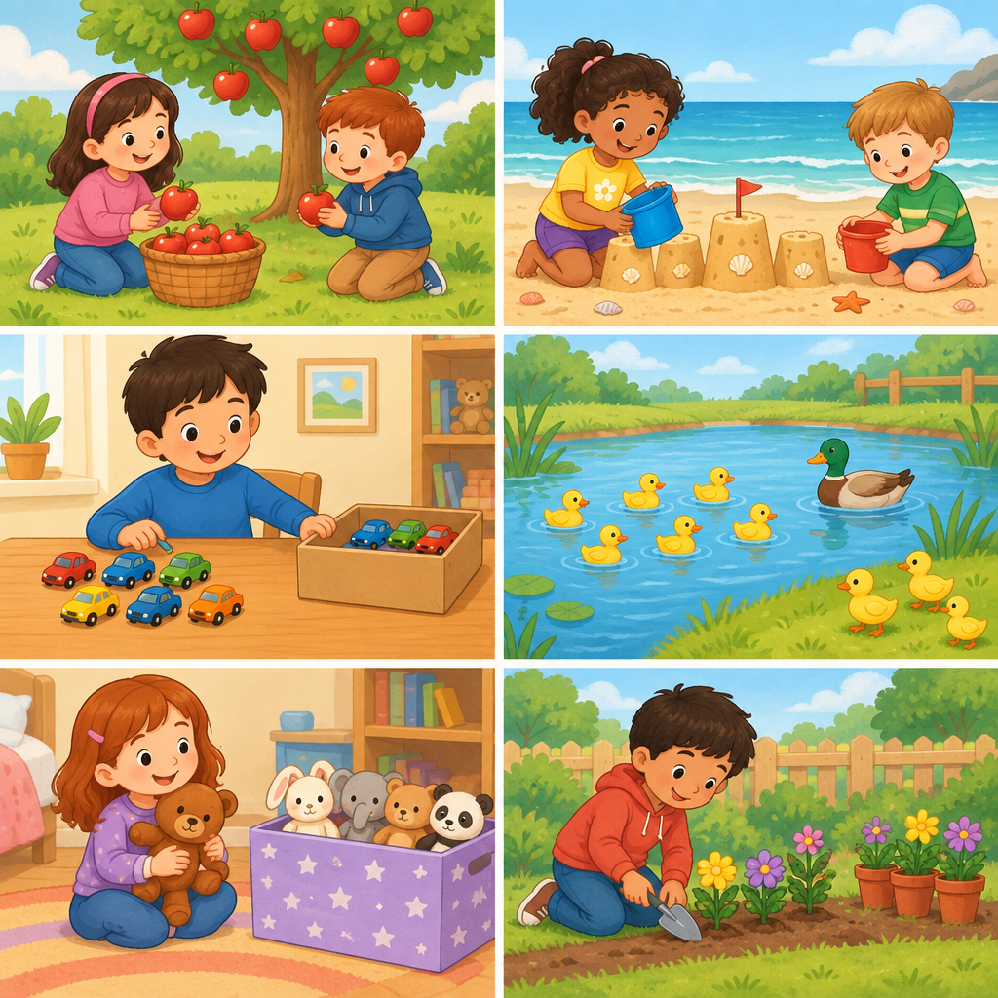
You are learning to add and subtract numbers within 100 (Outcome). This puzzle asks you to find a missing number by using what you know about how sums can be made in different ways (Understanding). You will use addition and subtraction together to solve it (Skills).

The puzzle
Three friends have toy cars. Maya has 15 cars. Jasper has 20 cars. Together, all three friends have 60 cars.
How many cars does the third friend have?

Hints
Hint 1: Start by adding the cars Maya and Jasper have together.
Hint 2: You now know how many cars two friends have. You know the total is 60. Think about subtraction.
Hint 3: 15 + 20 = 35. Now ask: what do I add to 35 to make 60?

Answer key
The answer is 25 cars.
The reasoning:
First, add Maya's and Jasper's cars: 15 + 20 = 35.
The three friends have 60 cars altogether. So the third friend has: 60 − 35 = 25.
You can check your answer by adding all three amounts: 15 + 20 + 25 = 60. The sum is correct.
This puzzle shows that a sum of 60 can be made in more than one way. You used addition to find the parts, then subtraction to find the missing part (Knowledge, Understanding).

AILI game · en · claude-haiku-4-5-20251001 · 2026-09-17

