Phonics and Word Recognition in Grade 1
Central concept: Phonics and Word Recognition

Connections
- Phonics and Word Recognition (builds on) -> Letter-Sound Relationships
- Phonics and Word Recognition (leads to) -> Reading Fluency
- Letter-Sound Relationships (uses) -> Alphabet Letters
- Letter-Sound Relationships (includes) -> Letter Combinations
- Alphabet Letters (contains) -> Consonants and Vowels
- Consonants and Vowels (produces) -> Vowel Sounds
- Consonants and Vowels (produces) -> Consonant Sounds
- Letter Combinations (can form) -> Vowel Sounds
- Sound Blending (develops) -> Reading Accuracy
- Reading Fluency (uses) -> Sound Blending
- Reading Fluency (includes) -> Accuracy, Rate, and Expression
- Reading Fluency (includes) -> Reading Expression

Notes
- Phonics and Word Recognition: Foundation for reading accuracy and fluency in Grade 1 Outcome, Outcome
- Letter-Sound Relationships: Connection between written letters and sounds they represent Understanding, Knowledge
- Alphabet Letters: 26 letters in upper and lower case that represent sounds Knowledge, Skills
- Consonants and Vowels: Two types of letters with different sound patterns Skills
- Letter Combinations: Two or more letters representing single sounds or units Knowledge, Understanding
- Vowel Sounds: Long and short vowel sounds in words, including r-influenced vowels Skills
- Consonant Sounds: Sounds at beginning, middle, and end of words Skills
- Sound Blending: Combining individual sounds into words with speed and accuracy Knowledge, Skills
- High-Frequency Words: Common words read automatically by sight, like the Knowledge, Skills
- Reading Accuracy: Decoding words correctly and recognizing letters quickly Skills, Understanding
- Reading Expression: Using voice pitch and pausing at punctuation marks Knowledge, Skills
- Reading Fluency: Smooth, accurate reading at appropriate rate with expression Outcome, Understanding, Understanding
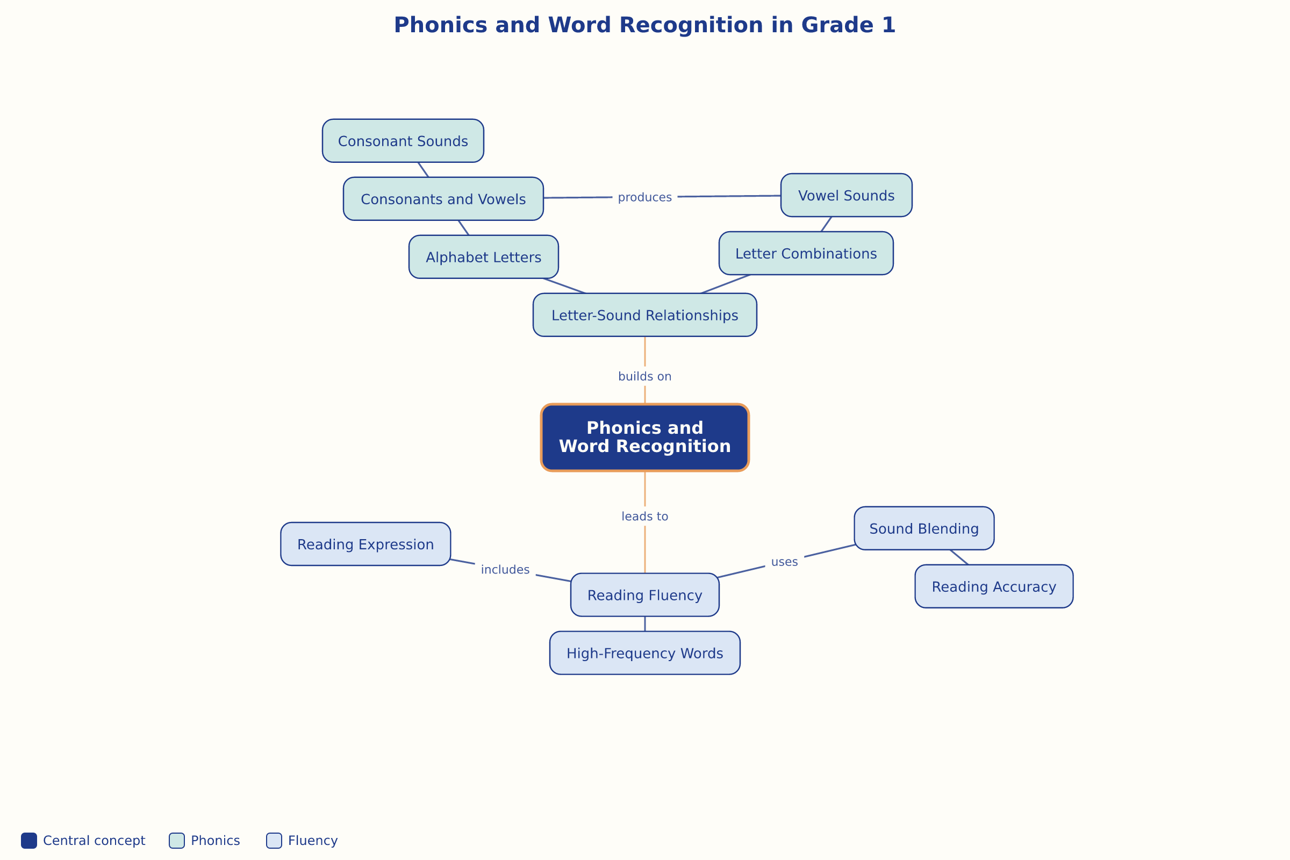

AILI word map · en · claude-haiku-4-5-20251001 · 2026-09-17

