Making Tens: Addition and Subtraction Strategies Within 100
We are learning to add and subtract two-digit numbers by making tens and using familiar number facts.
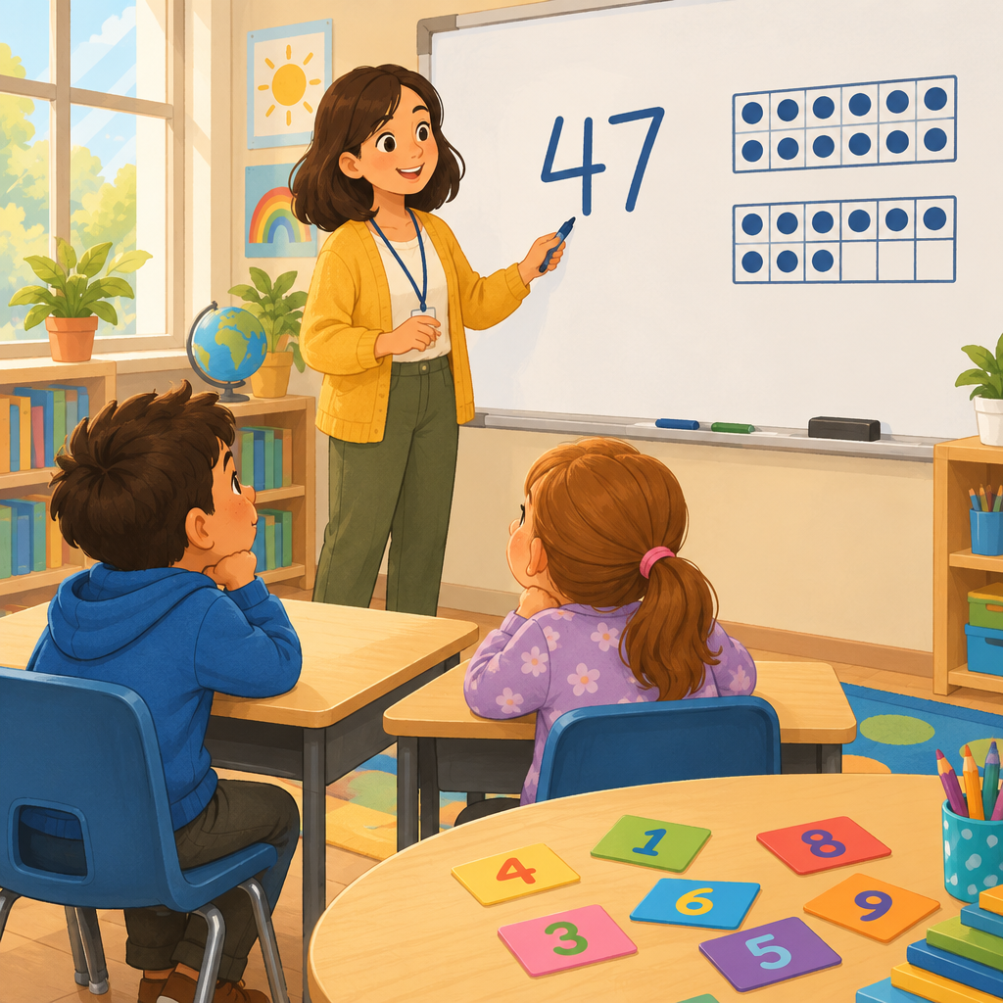

Learning intentions
We are learning to add and subtract two-digit numbers using strategies that make the work easier.
We are learning that the same sum can be made in different ways.

Success criteria
I can add two-digit numbers by making a ten.
I can subtract two-digit numbers by breaking apart tens.
I can show that the same total can be made using different numbers.

Curriculum alignment
Students investigate addition and subtraction within 100 (Outcome). Addition and subtraction strategies for two-digit numbers include making multiples of ten and using doubles (Knowledge, Knowledge). A sum can be composed in multiple ways (Understanding, Understanding). Familiar addition and subtraction number facts facilitate addition and subtraction strategies (Knowledge, Knowledge). Add numbers up to a sum of 100 and subtract numbers with a maximum minuend of 100 (Skills, Skills). Compose a sum in multiple ways, including with more than two addends (Skills, Skills).

Materials
- Ten-frames (printed or drawn on whiteboard)
- Base-ten blocks (rods and units) or bundled straws
- Number cards 1 to 100
- Individual whiteboards and markers for each student
- Counters or buttons
- Paper and pencils for recording

Lesson sequence

1. Hook (5 minutes)
Show the class 27 + 15 written on the board.
Ask: How many do we have altogether? Don't solve it yet. Just look at the numbers. What do you notice?
Take three or four answers. Listen for students who notice that 27 is close to 30, or that 15 is close to 20, or that we have tens and ones.
Say: Today we are going to use a trick to make these problems easier. We are going to make tens.

2. Direct instruction: Making tens in addition (10 minutes)
Write 27 + 15 on the board again.
Say: Let's use base-ten blocks to show this problem. Show 27 using two rods (tens) and seven units (ones). Show 15 using one rod and five units.
Ask: Do we have enough ones to make another ten? Count the ones together: 7 + 5 = 12. Yes, we can make a ten.
Say: When we put 7 ones and 5 ones together, we get 12 ones. That is 1 ten and 2 ones. Now let's count all our tens. Point to the blocks: 1 ten, 2 tens, 3 tens, 4 tens. And we have 2 ones left over. So 27 + 15 = 42.
Repeat with 34 + 18 using the same method.
Say: First, we add the ones: 4 + 8 = 12. That makes 1 ten and 2 ones. Then we count all the tens: 3 tens + 1 ten + 1 ten (the one we made) = 5 tens. And 2 ones. So 34 + 18 = 52.
Write the steps on the board:
Add the ones first.
If the ones make 10 or more, make a new ten.
Count all the tens.
Write the answer.

3. Direct instruction: Making tens in subtraction (8 minutes)
Write 43 − 16 on the board.
Say: We can use the same idea with subtraction. We start with 43. Show 4 rods and 3 units.
Ask: Can we take away 6 ones? We only have 3 ones. What do we do?
Say: We break apart one of our tens into 10 ones. Now we have 3 tens and 13 ones. Now we can take away 6 ones. 13 − 6 = 7. And we have 3 tens left. So 43 − 16 = 27.
Repeat with 52 − 25.
Say: We start with 52. That is 5 tens and 2 ones. We need to take away 5 ones. We only have 2 ones, so we break a ten. Now we have 4 tens and 12 ones. We take away 5 ones: 12 − 5 = 7. And we have 4 tens. So 52 − 25 = 27.
Write the steps on the board:
Look at the ones you need to take away.
If you don't have enough ones, break a ten.
Take away the ones.
Count the tens that are left.
Write the answer.

4. Guided practice (10 minutes)
Work through these problems together. Use base-ten blocks or draw ten-frames on the board.
Problem 1: 35 + 27
Ask: What are the ones? 5 and 7. Do they make a ten? 5 + 7 = 12. Yes. How many tens do we have now? 3 + 2 + 1 = 6. So the answer is 62.
Problem 2: 41 − 14
Ask: What ones do we need to take away? 4 ones. Do we have 4 ones? We have 1 one. Do we need to break a ten? Yes. Now we have 10 + 1 = 11 ones. Take away 4. 11 − 4 = 7. How many tens are left? 3 tens. So the answer is 37.
Problem 3: 28 + 14
Work through together. Ones: 8 + 4 = 12. Make a ten. Tens: 2 + 1 + 1 = 4. Answer: 42.
For each problem, ask students to show thumbs up when they agree, thumbs sideways if they are not sure, thumbs down if they disagree. Pause and check.

5. Independent practice (5 minutes)
Give each student four problems to solve. They may use base-ten blocks, draw ten-frames, or use counters.
Problem A: 23 + 18
Problem B: 56 − 19
Problem C: 32 + 29
Problem D: 64 − 27
Circulate. Ask students to explain their thinking: What did you do with the ones? Did you make a new ten? How many tens do you have now?

6. Consolidation (2 minutes)
Gather the class. Ask: Who can tell me the trick we learned today?
Listen for: We make tens. We add the ones first. If the ones are 10 or more, we make a new ten.
Say: Tomorrow we will practise more of these problems, and we will learn another trick called doubles.

Differentiation
Support
Provide pre-drawn ten-frames on paper. Students place counters in the frames instead of drawing. Offer problems with smaller numbers: 23 + 14, 35 − 12. Use only problems where making a ten is clear (ones that sum to exactly 10, 11, or 12).
Extension
Ask students to find two different ways to make the same total. For example: What two numbers add up to 50? Record: 25 + 25, 30 + 20, 35 + 15. Ask: Why can we make 50 in so many ways? (Understanding, Understanding) Challenge them with three addends: 15 + 12 + 8. Does the order matter? Try 8 + 15 + 12. Do you get the same answer? (Knowledge, Knowledge)

Assessment
Formative checkpoint (during independent practice)
Observe students solving 23 + 18.
Look for:
- Do they identify the ones (3 and 8)?
- Do they add the ones correctly (3 + 8 = 11)?
- Do they recognize that 11 ones is 1 ten and 1 one?
- Do they count all the tens (2 + 1 + 1 = 4)?
- Do they arrive at 41?
If a student struggles, ask: How many ones do we have? Can we make a ten? How many tens do we have altogether? Use base-ten blocks to show the thinking together.

AILI rapid lesson · en · claude-haiku-4-5-20251001 · 2026-09-17

