Histories and Stories of Ways of Life in Canada
Grade 5 Social Studies: People, Place and Time in Canada's Past

Slide 1: Histories and Stories of Ways of Life in Canada
Grade 5 Social Studies: exploring how people, place and time shaped Canada
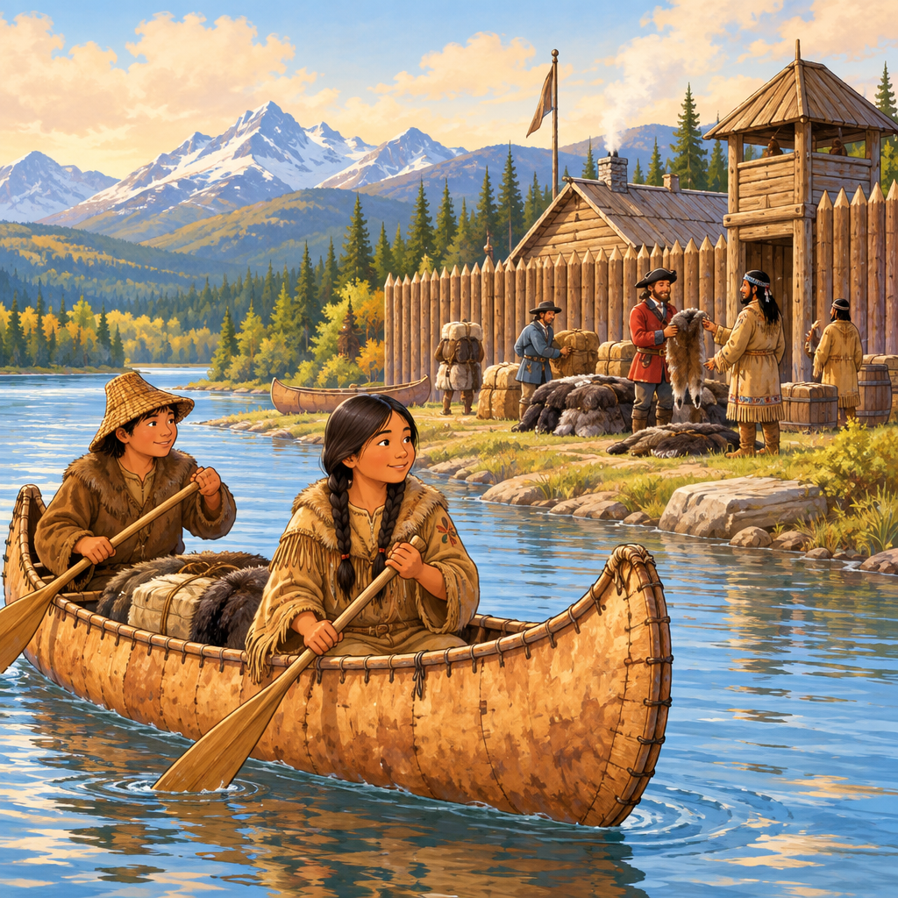
Notes: Introduce the unit. Grade 5 focuses on how Canada was formed — exploration, treaties, colonies, the fur trade and Confederation — and this deck introduces those stories, while ancient civilizations and democracy in Canada are studied in Grade 6. Explain to students that today's Canada grew out of many peoples, treaties, and events over centuries.

Slide 2: Learning Intentions and Success Criteria
- I can describe how First Nations and Europeans built relationships through treaties (Details).
- I can explain how colonies changed hands between France and Britain (Details).
- I can describe why Europeans migrated to the land now known as Canada(Details).
- I can explain how the fur trade connected different groups of people (Details).
- I can describe how Canada's government developed from historical events (Details).
Sources: Details, Details, Details
Notes: Read success criteria aloud. Ask students to restate one in their own words with a partner. Keep language plain: treaty means a formal agreement between groups.

Slide 3: Building Canada: Key Turning Points
- Exploration and Settlement: Explorers such as Samuel de Champlain arrived, and France founded Port-Royal, Quebec City, Trois-Rivières, and Montreal(Details).
- Treaties and Relationships: First Nations and Europeans made agreements like the Two Row Wampum to live side by side (Details).
- Change of Control: Britain gained Acadia and New France through treaties after conflicts with France (Details).
- Migration and Growth: French colonists remained on the lands known as Acadia and New France after Britain gained control of the territories(Details).
- Confederation: The British North America Act united provinces into the Dominion of Canada in 1867 (Details).
Sources: Details, Details, Details
Notes: Walk through each step as a timeline. Ask students which step surprises them most. Support: provide a printed timeline strip for students to sequence physically. Extension: research one event in more depth and present to a small group.

Slide 4: Ways of Life in the Fur Trade
The fur trade moved furs from North America to Europe and manufactured goods from Europe to North America, because supply and demand differed between the continents (Details). Trading posts and forts became busy places where people met, bartered, stored goods, and stayed overnight (Details). First Nations, Metis, and Europeans worked together as hunters, trappers, interpreters, guides, and voyageurs (Details). First Nations and Metis women played a key role as go-betweens who helped European traders build relationships with communities (Details).
How trade connected First Nations, Metis, and European communities
The fur trade moved furs from North America to Europe and manufactured goods from Europe to North America, because supply and demand differed between the continents (Details). Trading posts and forts became busy places where people met, bartered, stored goods, and stayed overnight (Details). First Nations, Metis, and Europeans worked together as hunters, trappers, interpreters, guides, and voyageurs (Details). First Nations and Metis women played a key role as go-betweens who helped European traders build relationships with communities (Details).
Sources: Details
Notes: Discuss how trade created interdependence between groups. Formative checkpoint: ask students to name three jobs people had in the fur trade and explain one role of First Nations and Metis women. Support: provide a word bank of role names. Extension: students design a simple diagram of the exchange system.

Slide 5: Two Views on the Royal Proclamation and Quebec Act
For First Nations
The Royal Proclamation of 1763 recognized First Nations as original inhabitants, recognized their right to self-government, and set up a nation-to-nation treaty process with the Crown (Details).
For French Colonists
The Quebec Act of 1774 protected French language and religious rights in Quebec, laying a foundation for bilingualism that continues in Canada today (Details).
Sources: Details
Notes: Have students compare the two acts in a T-chart. Ask: why might two different groups need different kinds of protection? Support: sentence starters like 'This act mattered because...'. Extension: research how bilingualism shows up in Canada today.

Slide 6: Wrapping Up: Many Stories, One Country
Summary: Canada's story includes explorers and settlers, treaties between First Nations and newcomers, the transfer of colonies from France to Britain, and the Acts passed by the British to rule and organize colonies in North America(Details, Details, Details). Each event shaped the ways of life people experienced then and shapes how Canadians live now.
Question: Whose story from today's lesson would you like to learn more about, and why?
Sources: Details, Details, Details, Outcome
Notes: Use the closing question as an exit ticket. Collect short written or spoken responses. The Royal Proclamation (1763) has ongoing significance for First Nations today, including recognition of their rights to self-government and the establishment of nation-to-nation treaty making processes.

AILI presentation · en · claude-sonnet-5 · 2026-09-17

