The Pond Behind the School
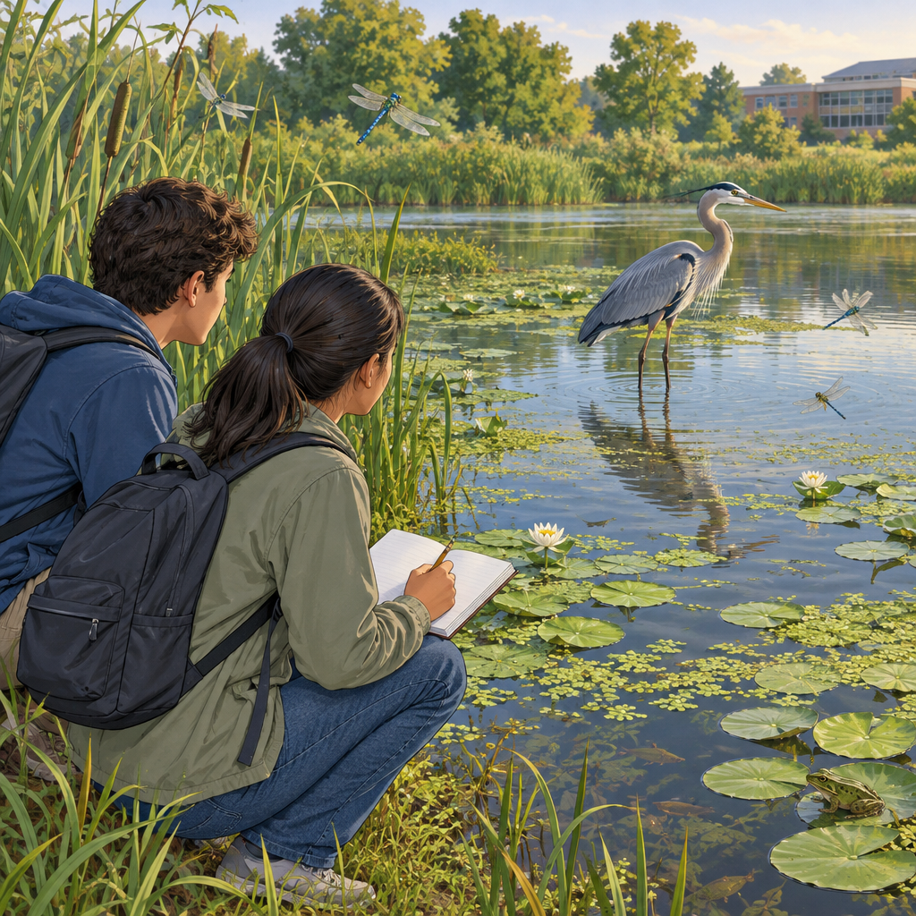
Maya knelt by the pond, notebook open. "Look, Devon, two frog species, same pond, different calls." Devon crouched beside her. "That's their niche thing, right? Splitting up the space so they're not fighting for it." "Exactly. And check this duckweed, it's budding little clones off itself. No mate needed." "Boring way to reproduce," Devon laughed. "Efficient, though. My grandmother's roses do it too, through suckers off the roots, but they also make seeds. Both ways." Devon pointed at a heron wading nearby. "That heron eats fish, keeps the pond balanced. Take it away and everything shifts." "Predator and prey, mutualism, commensalism, parasitism—it's all connected," Maya said, sketching the heron. "So diversity isn't random." "No. It's survival, written into every one of them." Devon smiled. "Even.

Words to know
- niche: The specific role and living space a species occupies within its ecosystem
- asexual reproduction: Reproduction from a single parent, such as budding, producing offspring identical to that parent
- mutualism: A symbiotic relationship where both species benefit
- runners: Horizontal plant stems that create new plants without seeds, a form of asexual reproduction
Curriculum link: Outcome, Outcome, Outcome, Outcome
Listen to the narration

AILI audio story · en · claude-sonnet-5 · 2026-09-17

