The Relay Race
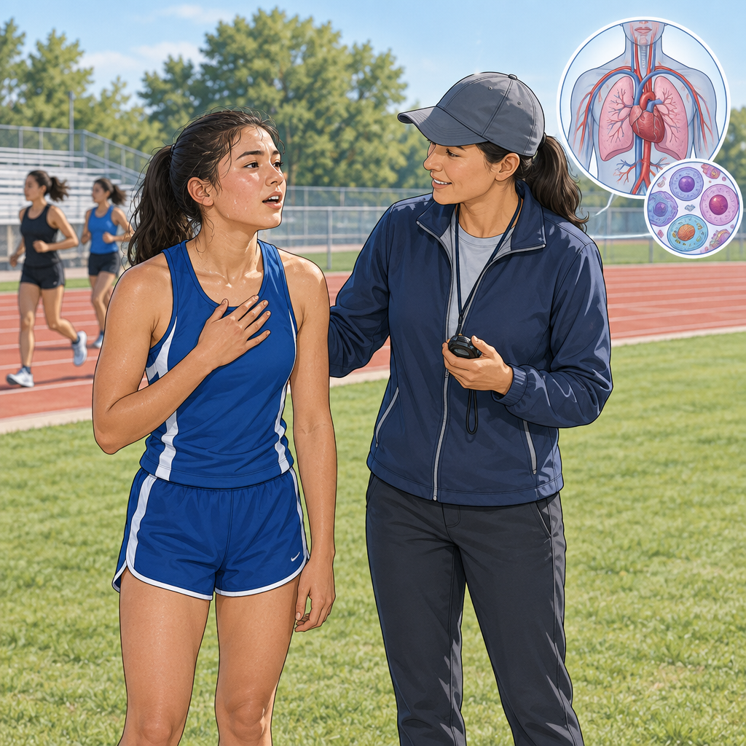
Priya was gasping after the four hundred metre relay. "Why does my heart pound like that?" she asked, hand on her chest.
Coach Dinh grinned. "Your body's a team, just like your relay squad. Right now your muscle cells need more oxygen, so your heart pumps faster and your lungs grab more air."
"So my lungs are like the runner handing off the baton?" Priya asked.
"Exactly. Lungs pass oxygen to your blood, blood carries it to muscle cells, and those cells use it for energy. Skin cells cool you with sweat. Nerve cells send the signal to breathe harder."
"One team, different players," Priya said, catching her breath.
"That's a body system," Dinh said. "Everything balanced, working together."

Words to know
- cell: the basic building block of living things
- system: parts working together for a shared job, like the circulatory system
- stimulus: a change, such as exercise, that the body responds to
- tissue: a group of similar cells working together, such as muscle tissue
Curriculum link: Outcome, Outcome, Outcome, Topic
Listen to the narration

AILI audio story · en · claude-sonnet-5 · 2026-09-17

