Biological Diversity Across the Curriculum
Grade 9 Science, Biology 20 and Biology 30

Slide 1: Biological Diversity
Grade 9 Science: how variety among and within species helps life survive
Sources: Topic
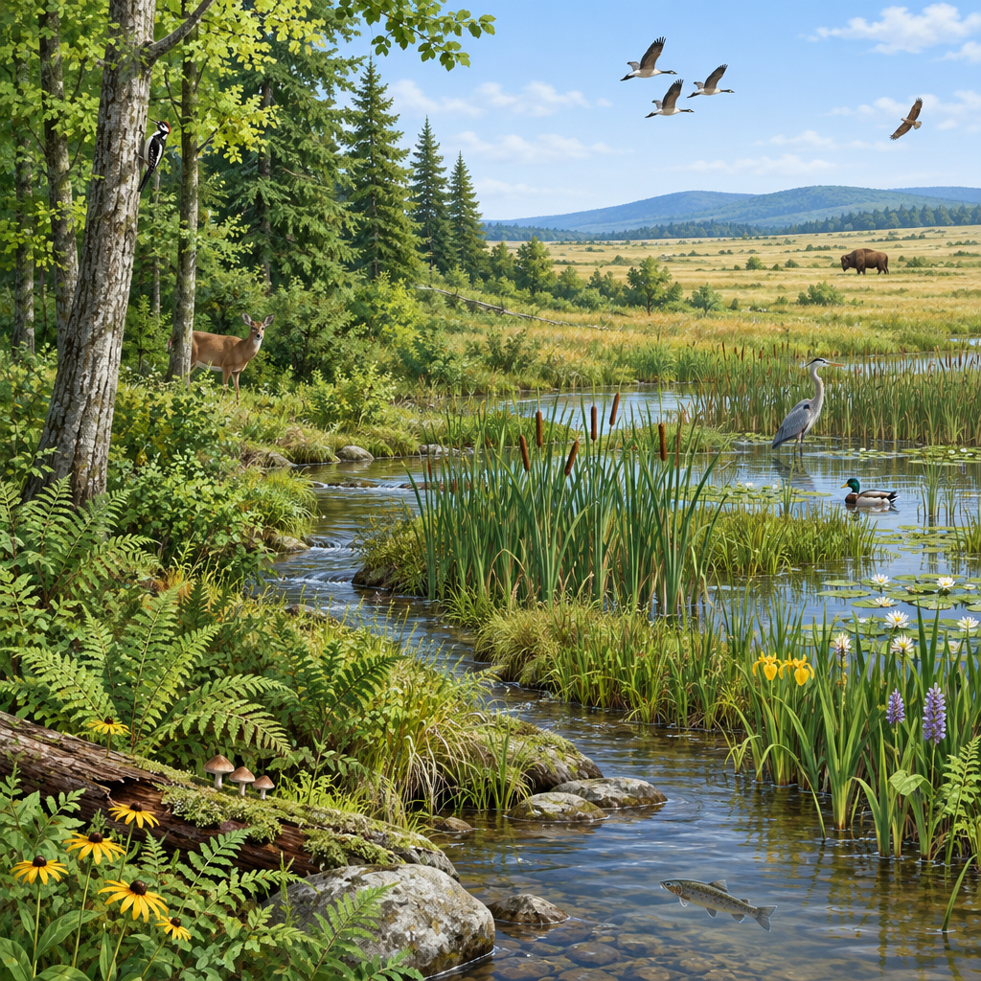
Notes: Introduce the unit: Grade 9 Science Unit A, Biological Diversity. Preview that this deck traces the idea across three curriculum sets: Grade 9 Science, then Biology 20, then Biology 30, showing how the concept deepens over time. Mention focusing questions: what is biological diversity, and what impact does human activity have on it (Topic).

Slide 2: Grade 9 Science: What Is Biological Diversity?
- Biological diversity shows up as the range of species in an environment and as variation within a single species (Topic).
- Diversity is maintained through sexual and asexual reproduction, passed from parents to offspring (Topic).
- Variation among and within species helps organisms survive in a shared ecosystem, such as different bird species using different niches in a park (Outcome).
- Symbiotic relationships link species together and are classified as mutualism, commensalism or parasitism (Outcome).
- Variation helps species survive changing conditions, such as disease resistance or tolerance of harsh environments (Outcome).
Sources: Topic, Outcome
Notes: Checkpoint: ask students to name one example of variation within a species they know (dog breeds, human eye colour) and one example of a niche from a local ecosystem. Support: provide sentence starters for describing variation. Extension: have students research a symbiotic relationship not covered in class and classify it.

Slide 3: Grade 9 Science: Passing Traits to the Next Generation
Reproduction and Inheritance
Sexual and asexual reproduction both transmit species characteristics, including binary fission, budding, spore production and cross-fertilization (Outcome). Offspring traits can match one parent, both parents, fall in between, or differ from both (Outcome). Chromosomes, genes and DNA store genetic information, and meiosis halves genetic material to form sex cells (Outcome).
Selection and Human Impact
Natural and artificial selection both shape which characteristics persist, as seen in bird beak shapes or high milk production in dairy cows (Outcome). Human activity drives extinction and extirpation of species, and strategies like zoo breeding programs, seed banks and protected areas aim to limit diversity loss (Outcome).
Sources: Outcome, Outcome, Outcome
Notes: Formative checkpoint: quick pair share where students distinguish heritable from non-heritable traits (eye colour versus a scar). Support: use a simple parent-offspring trait chart. Extension: ask students to evaluate the limitations of one conservation strategy listed in Outcome.

Slide 4: Biology 20: Ecosystems Support Diversity
- Ecosystem structure: Terrestrial and aquatic ecosystems each have distinct biotic and abiotic characteristics (Outcome).
- Habitats and niches: Layers such as canopy, forest floor, littoral and profundal zones support many organisms (Outcome).
- Classifying organisms: Taxonomy and binomial nomenclature organize species by nutrition mode and morphology (Outcome).
- Populations change: Heritable mutations create variability, and some mutations offer a selective advantage (Outcome).
Sources: Topic, Outcome, Outcome, Outcome, Outcome
Notes: This slide bridges Grade 9 concepts into Biology 20, Unit B, which builds directly on Grade 9 Science Unit A (Topic). Checkpoint: ask students to sort a local ecosystem example (stream, prairie, vacant lot) into biotic and abiotic characteristics (Outcome). Support: provide a two-column sorting sheet. Extension: research one aquatic zone in more depth.

Slide 5: Biology 30: Populations, Gene Pools and Communities
- Community as gene pool: A community is a composite of populations whose individuals contribute to a gene pool that can change over time (Topic).
- Forces of change: Gene pool diversity shifts through natural selection, genetic drift, gene flow, nonrandom mating, bottleneck and founder effects, migration and mutation (Outcome).
- Quantitative tools: Population genetics, including the Hardy-Weinberg principle, and population growth curves let scientists measure change over time (Topic).
- Interactions matter: Individuals interact within and between populations, shaping community dynamics and succession (Topic).
Sources: Topic, Topic, Outcome
Notes: This shows students where Grade 9 diversity concepts lead in senior high biology. Checkpoint: ask students to predict what might happen to a gene pool after a bottleneck event (a wildfire drastically reducing a population). Support: define gene pool with a simple analogy (a bag of coloured marbles). Extension: introduce the Hardy-Weinberg principle name only, noting it will be studied quantitatively later.

Slide 6: Diversity, Traced Across Three Courses
Summary: Grade 9 Science introduces biological diversity as variation among and within species, maintained by reproduction and threatened by human activity (Topic). Biology 20 extends this into ecosystem structure, niches and natural selection (Topic). Biology 30 adds the quantitative study of gene pools and population change over time (Topic).
Question: If a local wetland lost half its plant species tomorrow, which animal species do you think would be affected first, and why?
Sources: Topic, Topic, Topic, Outcome, Outcome
Notes: Use the closing question as an exit ticket or a short discussion. Listen for students connecting species loss to niches, food webs or symbiotic relationships (Outcome). This can connect to Specific Outcome 4, which focuses on identifying impacts of human action on species survival and analyzing related issues for personal and public decision making(Outcome).

AILI presentation · en · claude-sonnet-5 · 2026-09-17

