Fractions and Decimals: Same Number, Different Look
A Grade 4 lesson connecting place value, fractions, and decimal numbers through grids, number lines, and money
Audience: Grade 4 students in an Alberta elementary classroom, working with a classroom teacher.
Grades: Grade 4
Subjects: Mathematics
Time: about 60 minutes
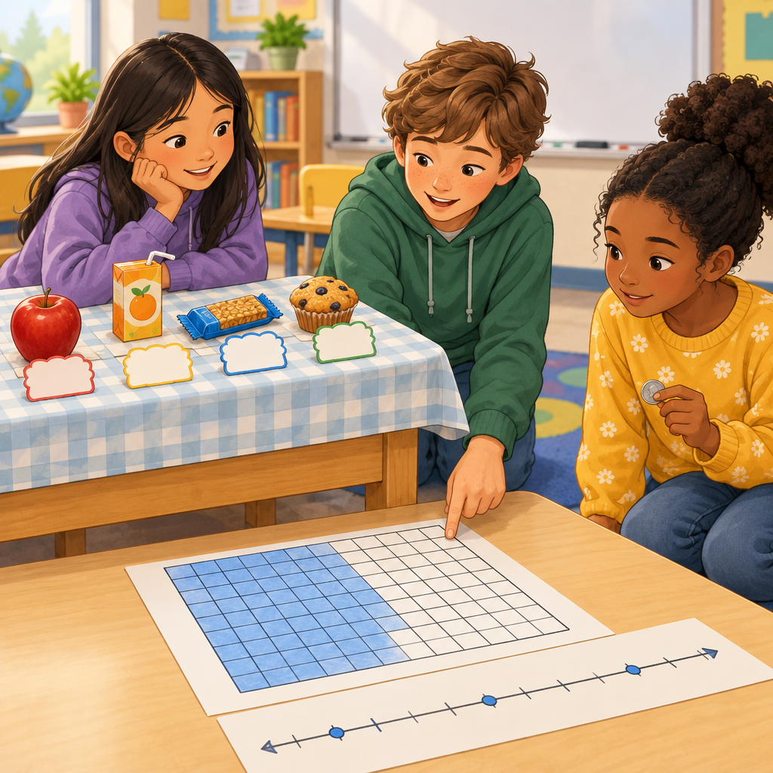

Overview
This lesson helps Grade 4 students connect fractions and decimal numbers using place value. Students explore how tenths and hundredths grids show the same amount as a fraction or a decimal (Skills, Knowledge), then build a place value chart to read, write, and compare decimal numbers (Outcome, Knowledge, Skills). The lesson closes with a real-world money context, where students add and subtract decimal amounts to hundredths using standard algorithms and check their work with estimation (Outcome, Knowledge, Skills).
By the end of the lesson, students should see that a decimal number and a fraction with a denominator of 10 or 100 can represent the exact same point on a number line (Understanding), and that this connection helps make sense of prices, measurements, and other everyday quantities.

Outcomes covered
- Students apply place value to decimal numbers. (Outcome)
Understanding that each decimal place is one-tenth the value of the place to its left lets students read, write, compare, and order decimal numbers confidently, which comes up in money, measurement, and everyday numbers.
- Students add and subtract within 10 000, including decimal numbers to hundredths. (Outcome)
Decimal numbers represent values between natural numbers and can show the separation between wholes and parts, such as dollars and cents.
- Students apply place value to decimal numbers. (Outcome)
Decimal numbers are fractions with denominators of 10, 100, and so on, and patterns in place value are used to read and write these numbers.

Materials
- Whiteboard or chart paper for the place value chart
- 10-by-10 grid handouts or a printed hundred grid for the warm-up
- Number line worksheets (0 to 1, marked at tenths, with room to mark hundredths)
- Small group snack shop price list handout
- Exit ticket handout, one per student
- Pencils and erasers
- Optional: play money or coins for the money activity

Sequence of activities

1. Warm-Up: Tenths and Hundredths Grids (8 min, whole class)
- Draw a 10-by-10 grid (100 small squares) on the board and ask students to shade a strip of 10 squares.
- Ask: "What fraction of the grid is shaded?" (10/100). Ask: "What is another name for one column of 10 squares out of 100?" (1/10).
- Shade 3 more single squares and ask students to name the total shaded amount as a fraction (13/100) and as a decimal (0.13).
- Record on the board: 13/100 = 0.13. Say the number aloud using the word "and" for the decimal point where relevant, e.g., "thirteen hundredths."
- Ask two quick check questions: "How would we write 7/10 as a decimal?" (0.7) and "How would we write 0.05 as a fraction?" (5/100).
This activates prior knowledge of fractions with denominators of 10 and 100 before connecting them to decimal notation (Skills, Knowledge, Understanding). Watch for students who confuse tenths and hundredths columns on the grid; point to the grid lines directly to clarify place value (Knowledge, Knowledge).
Sources: Skills, Knowledge, Understanding, Knowledge, Knowledge

2. Mini-Lesson: Reading and Writing Decimal Place Value (12 min, whole class)
- Draw a place value chart on the board with columns labelled thousands, hundreds, tens, ones, decimal point, tenths, hundredths.
- Write the number 3.47 in the chart, one digit per column, and ask students to say the value of each digit (3 ones, 4 tenths, 7 hundredths).
- Explain that each place has one-tenth the value of the place to its left, so the tenths place is ten times smaller than the ones place, and the hundredths place is ten times smaller than the tenths place (Knowledge).
- Show that 3.40 and 3.4 are the same value because a zero placed to the right of the last digit does not change the value (Knowledge).
- Model reading 3.47 aloud as "three and forty-seven hundredths," pointing out that the word "and" marks the decimal point (Knowledge).
- Show a money example: 5 dollars and 6 cents. Ask students how to write this as a decimal ($5.06) and connect it to the idea that cents can be expressed as a decimal part of a dollar (Skills, Understanding).
- Quick check: write 2.08 on the board and ask three students in turn to identify the value of the tenths digit, the hundredths digit, and to say the number aloud.
This directly builds the knowledge and skills for applying place value to decimal numbers (Outcome, Knowledge, Skills, Knowledge, Skills). Formative checkpoint: listen for correct use of "and" only at the decimal point, not between whole number digits, which is a common error.
Sources: Outcome, Knowledge, Skills, Understanding, Knowledge, Skills

3. Guided Practice: Comparing and Converting (12 min, pairs)
- Hand out a worksheet with number lines from 0 to 1 marked at every tenth.
- In pairs, students plot the following on the number line: 0.3, 3/10, 0.5, 5/10, and 0.75 (subdividing the space between 0.7 and 0.8 into hundredths to locate 0.75).
- Ask pairs to write one equivalent fraction-decimal pair they notice are at the same point (for example, 0.5 and 5/10 land on the same spot).
- Give pairs three comparison problems to solve using <, >, or =: 0.4 ___ 0.25, 7/10 ___ 0.8, 0.60 ___ 0.6.
- Circulate and ask guiding questions such as "Which number has more tenths?" or "Does adding a zero change the value?"
- Review answers as a class: 0.4 > 0.25, 7/10 < 0.8, 0.60 = 0.6.
This activity practises comparing and ordering decimal numbers, expressing relationships with <, >, or =, and relating fractions to their position on the number line (Skills, Skills, Understanding, Skills). Pair a student who is still learning place value with a peer who has a solid grasp, so they can talk through their reasoning together.
Sources: Skills, Skills, Understanding, Skills

4. Application: Snack Shop Money Problems (18 min, small group)
- Give each small group a simple price list for a pretend snack shop, for example: apple $0.75, juice box $1.20, granola bar $0.85, muffin $2.10.
- Groups choose two items and add the prices using the standard algorithm, lining up the decimal points carefully.
- Before adding, each group estimates the sum by rounding each price to the nearest dollar, then checks whether their exact answer is reasonable (Knowledge, Skills).
- Example problem for the class to work through together first: apple ($0.75) plus juice box ($1.20). Estimate: about $1 plus $1 equals $2. Exact: $0.75 + $1.20 = $1.95, which is close to the estimate, so it is reasonable.
- Groups then solve a subtraction problem: if a student pays with a $5.00 bill for the muffin ($2.10), how much change do they get? Estimate first (about $5 minus $2 equals $3), then calculate exactly ($5.00 − $2.10 = $2.90).
- Each group writes one more addition and one more subtraction problem of their own using the price list and trades with another group to solve.
- Bring the class back together to share one problem and answer from each group, checking the standard algorithm was used correctly and the decimal points are aligned.
This activity applies addition and subtraction of decimal numbers to hundredths within a money context, using standard algorithms and estimation to check reasonableness (Outcome, Knowledge, Skills, Understanding). Formative checkpoint: watch that students align decimal points vertically before adding or subtracting; misalignment is the most common error at this stage.
Sources: Outcome, Knowledge, Skills, Understanding

5. Wrap-Up: Exit Ticket and Share-Out (10 min, individual)
- Hand out an exit ticket with three short questions:
a) Write 0.6 as a fraction.
b) Order these from smallest to largest: 0.45, 4/10, 0.5.
c) Add $2.35 + $1.60 and estimate first to check your answer.
- Students complete the exit ticket independently.
- Collect tickets and quickly scan for common errors before students leave.
- Invite two or three students to share one thing they learned today about fractions and decimals, for example connecting a fraction to its decimal form or lining up decimal points when adding.
- Close by reminding students that decimal numbers are just another way to write fractions with denominators of 10 or 100 (Understanding, Knowledge).
Use this exit ticket as the main formative assessment for the lesson, checking place value understanding, fraction-decimal equivalence, ordering, and addition with estimation (Skills, Knowledge, Skills, Knowledge, Skills). Keep tickets to review before the next lesson and regroup students for support or extension accordingly.
Sources: Skills, Understanding, Knowledge, Skills, Knowledge, Skills

Differentiation
Extension
- Ask early finishers to convert decimal numbers with three decimal places, such as 0.125, into fractions and explain their reasoning.
- Challenge students to write their own snack shop word problem involving three items added together, then find the total change from a $10 bill.
- Invite students to explore why 0.5 and 0.50 are equal in value but might look different, and explain this to a partner.
Support
- Provide a pre-filled place value chart with column headings already labelled for students who need a visual anchor.
- Use physical base-10 blocks or fraction strips alongside the grid activity so students can touch and move pieces to represent tenths and hundredths.
- Reduce the Snack Shop activity to one addition problem with smaller, simpler prices (for example, $0.50 and $0.25) for students who need more time with basic decimal addition.
- Allow students to use a hundred grid as a reference tool during the exit ticket.
Inclusive supports
- Read all worksheet instructions aloud and check for understanding before students begin independent work.
- Offer both fraction and decimal versions of key numbers side by side on anchor charts posted in the room.
- Allow students to respond verbally to a teacher or educational assistant instead of writing for the exit ticket if needed.
- Group students intentionally during pair and small group work so that language or processing needs are supported by a peer.

Assessment
Formative. During the mini-lesson, cold-call students to state the value of a specific digit in a decimal number shown on the board (for example, the tenths digit in 3.47).
Look for: Students correctly name the place and value of the digit, showing they understand that each place has one-tenth the value of the place to its left. (Outcome, Knowledge, Skills)
Formative. Circulate during the Guided Practice number line activity and listen to pair discussions when comparing fractions and decimals.
Look for: Students can explain which of two numbers is larger by referring to place value or position on the number line, and correctly use <, >, or = symbols. (Skills, Skills, Understanding)
Formative. Observe small groups during the Snack Shop activity as they add and subtract decimal prices.
Look for: Students align decimal points correctly before calculating, estimate first, and check that their exact answer is close to the estimate. (Outcome, Knowledge, Skills, Understanding)
Summative. Collect the individual exit ticket at the end of the lesson covering fraction-decimal conversion, ordering decimals, and decimal addition with estimation.
Look for: Students correctly write 0.6 as 6/10, order 4/10, 0.45, 0.5 from smallest to largest, and add $2.35 + $1.60 with a reasonable estimate shown. (Skills, Knowledge, Skills, Knowledge)

Vocabulary
- Decimal number: A number that has a whole number part and a fraction part separated by a decimal point, such as 3.47. Decimal numbers are fractions with denominators of 10, 100, and so on.
- Place value: The value of a digit based on its position in a number. In base-10 numbers, each place has one-tenth the value of the place directly to its left.
- Tenths: The first place to the right of the decimal point. One tenth means one part out of ten equal parts of a whole, written as 1/10 or 0.1.
- Hundredths: The second place to the right of the decimal point. One hundredth means one part out of one hundred equal parts of a whole, written as 1/100 or 0.01.
- Equivalent: Having the same value, even if the numbers look different. For example, 0.5 and 5/10 are equivalent because they represent the same point on a number line.
- Estimation: A quick, reasonable guess at an answer, often made by rounding numbers, used to check whether an exact calculated answer makes sense.

For families
- Look for decimal numbers on grocery receipts or price tags together and practise reading them aloud, such as saying $4.25 as four dollars and twenty-five cents.
- Ask your child to explain how a fraction like 3/10 and a decimal like 0.3 can be the same amount.
- Practise mental estimation together before checking a receipt or bill, for example estimating the total cost of a few items before adding the exact prices.

Sources
- Outcome: "Students apply place value to decimal numbers."
- Outcome: "Students add and subtract within 10 000, including decimal numbers to hundredths."
- Knowledge: "For numbers in base-10, each place has one-tenth the value of the place to its left."
- Skills: "Compare and order numbers, including decimal numbers."
- Understanding: "Decimal numbers are fractions with denominators of 10, 100, etc."
- Knowledge: "Estimation can be used to check the reasonableness of a sum or difference."
- Skills: "Solve problems, using addition and subtraction, including problems involving money."
- Understanding: "Standard algorithms for addition and subtraction may be used for any decimal numbers."
- Skills: "Express fractions as decimal numbers and vice versa, limited to denominators that are 10 or 100."
- Knowledge: "Fractions and decimal numbers can represent the same number."
- Understanding: "Fractions and decimal numbers that represent the same number are associated with the same point on the number line."
- Outcome: "Students apply equivalence to the interpretation of fractions."
- Knowledge: "A zero placed to the right of the last digit in a decimal number does not change the value of the number."
- Skills: "Express a monetary value in cents as a monetary value in dollars, using decimal notation."

The content uses everyday classroom, food, and money examples appropriate for Grade 4 students and contains no unsafe, biased, or culturally insensitive material.

AILI detailed pack · en · claude-sonnet-5 · 2026-09-17

