Adding and Subtracting Within 100: Tens, Doubles, and Checking Our Work
A hands-on lesson using tens, doubles, and inverse operations to build number sense to 100
Audience: Grade 2 classroom teachers planning a Mathematics lesson on addition and subtraction within 100.
Grades: Grade 2
Subjects: Mathematics
Time: about 60 minutes
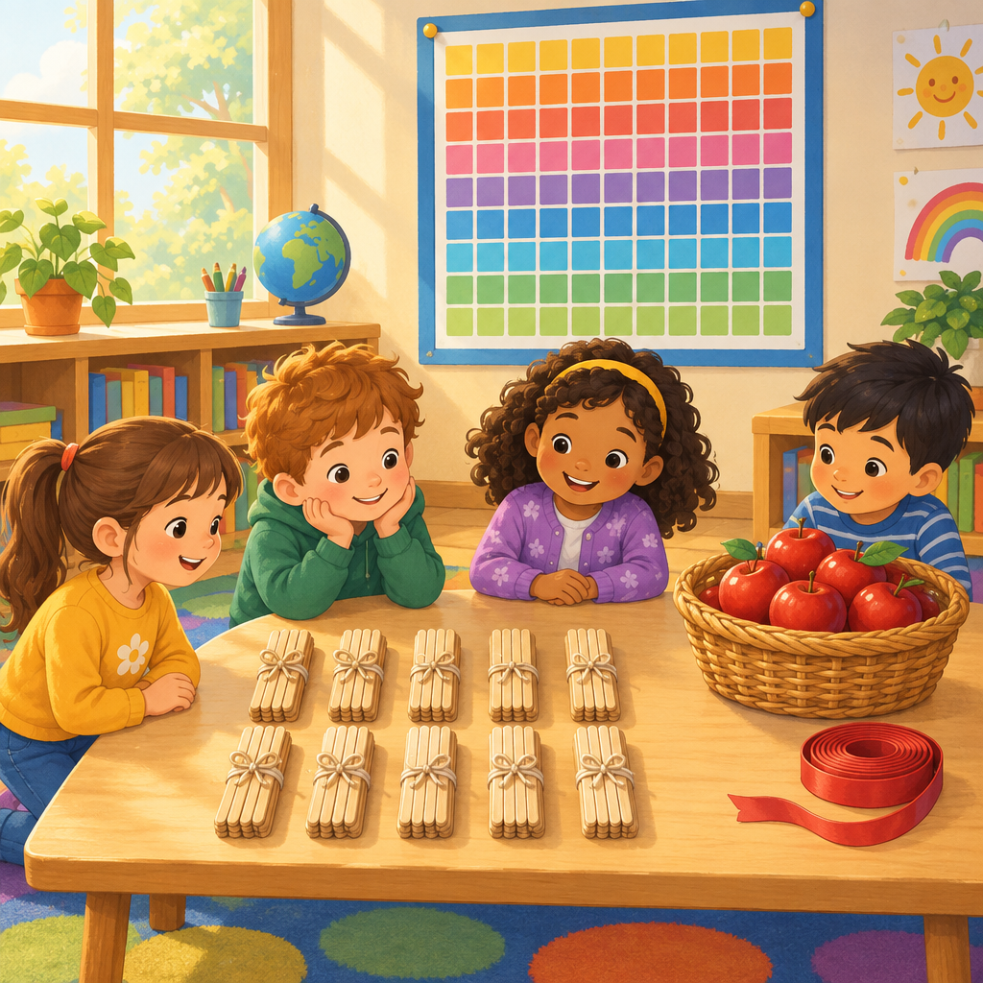

Overview
This lesson helps Grade 2 students investigate addition and subtraction within 100 (Outcome). Students start by warming up basic facts to 10, then explore how 100 can be built from groups of ten in many different ways (Skills, Skills). The heart of the lesson is a strategy station where students practice making tens and using doubles to add two-digit numbers (Knowledge, Knowledge), drawing on ideas from JUMP Math Unit 13 (Resource) and Unit 10 (Resource). Students then find missing numbers and check their work using inverse operations (Skills, Skills), before applying their skills to real story problems about apples and ribbon (Skills, Understanding).
By the end of the lesson, students should feel confident choosing a strategy that fits the numbers in front of them, rather than relying on one method for every problem. The lesson closes with a quick share-out and an exit ticket to guide tomorrow's small group planning."

Outcomes covered
- Students investigate addition and subtraction within 100. (Outcome, Outcome)
This is the focus learning outcome for the lesson, guiding all number work with sums and differences up to 100.
- Recall and apply addition number facts, with addends to 10, and related subtraction number facts. (Skills, Skills)
Quick recall of basic facts frees up thinking space for tackling two-digit addition and subtraction strategies.
- Investigate strategies for addition and subtraction of two-digit numbers, including making multiples of ten and using doubles. (Knowledge, Knowledge)
These strategies let students add and subtract mentally instead of only counting one by one.
- Visualize 100 as a composition of multiples of 10 in various ways, and compose a sum in multiple ways, including with more than two addends. (Skills, Skills)
Seeing 100 as flexible groups of ten builds strong number sense for later place value work.
- Verify a sum or difference, using inverse operations, and determine a missing quantity in a sum or difference within 100. (Skills, Skills)
Checking work with the opposite operation builds confidence and catches mistakes independently.
- Solve problems, using addition and subtraction of countable quantities or measurable lengths. (Skills, Understanding, Skills)
Connecting math to real objects like apples and ribbon shows students why addition and subtraction matter.

Materials
- Hundred chart poster or handout
- Ten bundles of ten straws or craft sticks (or base-ten blocks)
- Small whiteboards and markers for each student
- Missing-number problem cards (prepared in advance, one set per pair)
- Story problem worksheet (apples and ribbon problems)
- Number lines (printed, one per student, for support)
- Exit ticket slips

Sequence of activities

1. Warm-Up: Ten Friends Facts (8 min, whole class)
- Show fingers up to model addends to 10. Ask: what two numbers make 10?
- Call out a number fact, like 6 + 4. Students snap when they know the answer, then say it together.
- Do this for 8 addition facts to 10, then flip to matching subtraction facts (10 − 4, 10 − 6).
- Ask: how does knowing 6 + 4 = 10 help you know 10 − 4 = 6? Take two or three answers.
This checks recall of addition facts with addends to 10 and related subtraction facts (Skills, Skills). Listen for instant recall versus counting on fingers, this tells you who needs more fact practice today.
Sources: Skills, Skills

2. Building 100 with Tens (10 min, whole class)
- Show a hundred chart or ten bundles of straws (10 groups of 10).
- Ask: how many groups of ten make 100? Count together by tens to 100.
- Ask: can we make 100 a different way? Try 5 tens plus 5 tens, then 7 tens plus 3 tens.
- Write each way on the board: 50 + 50 = 100, 70 + 30 = 100, 40 + 40 + 20 = 100.
- Ask: does it matter what order we add the tens in? Test 20 + 40 + 40 and 40 + 20 + 40. Confirm the sum stays the same.
This builds the idea that 100 is made of multiples of ten in many ways (Skills, Skills) and that order of adding does not change the sum, the associative property (Knowledge). Use real ten-bundles if available so students can physically regroup them.
Sources: Knowledge, Skills, Skills

3. Strategy Station: Doubles and Making Tens (15 min, small group)
- Split students into three small groups that rotate through two stations (about 7 minutes each).
- Station A: Making a ten. Give problems like 28 + 5. Ask: how many more does 28 need to reach 30? Move that many from the 5, then add what is left.
- Station B: Doubles. Give problems like 24 + 26. Ask: is there a nearby double? Use 25 + 25 = 50, then adjust by 1 up and 1 down.
- At each station, students solve 4 problems on whiteboards using the strategy, then show a partner.
- Teacher circulates and asks one student per group: how did the strategy help you add faster?
This activity is the core strategy practice for two-digit addition, using making tens and doubles (Knowledge, Knowledge). Suggested problems: Station A: 28+5, 36+7, 45+8, 19+6. Station B: 24+26, 15+17, 33+35, 18+22. Support groups with a number line if they struggle to jump to the nearest ten. This connects to JUMP Math Unit 13 addition strategies (Resource) and Unit 10 using ten to add (Resource).
Sources: Knowledge, Knowledge, Resource, Resource

4. Missing Number Detective (12 min, pairs)
- Pair students up. Give each pair a set of cards with missing-number problems, such as 47 +? = 82, and? − 15 = 30.
- Partner A solves the missing number and explains the strategy out loud.
- Partner B checks the answer using the inverse operation (for example, checking 47 + 35 = 82 by doing 82 − 35 = 47).
- Partners switch roles for the next card.
- Bring the class together and solve one tricky card as a group, showing the check step on the board.
This targets finding a missing quantity in a sum or difference within 100 and verifying with inverse operations (Skills, Skills). Watch for students who guess and check versus those who use a strategy like counting up. Sample cards: 47+?=82,?−15=30, 26+?=60, 90−?=54,?+38=71.
Sources: Skills, Skills

5. Story Problems with Ribbon and Apples (12 min, individual)
- Read aloud: Maya has 34 apples. She picks 27 more. How many apples does she have now?
- Students solve independently on paper, showing their strategy (tens and ones, number line, or doubles).
- Second problem: A ribbon is 100 centimetres long. Sam cuts off 38 centimetres. How long is the ribbon now?
- Students solve and write one sentence answer, like "The ribbon is 62 centimetres long."
- Students trade papers with a neighbour to compare strategies before handing in.
This applies addition and subtraction to countable quantities (apples) and measurable length (ribbon), matching Skills, Understanding, Skills. Look for correct labelling of units in the answer sentence. Answers: 34+27=61 apples; 100−38=62 centimetres.
Sources: Skills, Understanding, Skills

6. Exit Ticket Share-Out (3 min, whole class)
- Ask each student to whisper one strategy they used today to a partner: making a ten, doubles, or counting on.
- Collect exit tickets from the story problem activity as students line up.
Quick formative check before students leave. Sort exit tickets into three piles: solid, developing, needs support, to plan tomorrow's groups.
Sources: Knowledge, Skills

Differentiation
Extension
- Ask students to compose 100 using three or four different addends, then explain why the order does not change the sum (Knowledge, Skills).
- Challenge students to solve missing-number problems with two unknowns hidden in a story, then write their own story problem for a partner to solve (Skills).
Support
- Provide a hundred chart and ten-bundles of straws so students can count and regroup physically instead of only mentally (Skills, Knowledge).
- Reduce numbers in story problems to friendlier amounts, such as 24 + 15 instead of 34 + 27, while keeping the same strategy focus (Skills, Understanding).
Inclusive supports
- Offer whiteboards and markers as an alternative to paper and pencil for students who find writing tiring.
- Allow students to say answers aloud to a partner or teacher instead of writing, for students still building written number skills.
- Use visual ten-frames alongside number lines so students can choose the tool that makes most sense to them.

Assessment
Formative. During the warm-up, teacher listens for instant fact recall versus finger counting on addition facts to 10 and related subtraction facts.
Look for: Student answers within 2 seconds without counting on fingers for at least 6 of 8 facts. (Skills, Skills)
Formative. During strategy stations, teacher asks each group to explain how making a ten or using doubles helped solve a problem.
Look for: Student can name the strategy used and show the jump to the nearest ten or the nearby double on their whiteboard. (Knowledge, Knowledge)
Peer. In Missing Number Detective, partners check each other's answers using the inverse operation.
Look for: Partner correctly redoes the problem with the opposite operation and confirms or corrects the answer. (Skills, Skills)
Summative. Story problem worksheet with apples and ribbon, collected as an exit ticket.
Look for: Both answers are correct (61 apples, 62 centimetres) with a strategy shown and a labelled answer sentence. (Skills, Understanding, Skills)

Vocabulary
- Sum: The answer you get when you add two or more numbers together. For example, the sum of 4 and 6 is 10.
- Addend: A number that gets added to another number. In 4 + 6 = 10, both 4 and 6 are addends.
- Difference: The answer you get when you subtract one number from another. The difference between 10 and 4 is 6.
- Doubles: Adding a number to itself, like 25 + 25. Knowing doubles helps solve nearby problems, like 24 + 26.
- Inverse operation: The opposite operation used to check an answer. Subtraction checks addition, and addition checks subtraction.
- Minuend: The starting number in a subtraction problem, the number you subtract from. In 100 − 38, 100 is the minuend.

For families
- Practice adding two-digit numbers at home using coins or buttons, grouping them into tens to make counting easier.
- Ask your child to explain how they solved a problem out loud. Saying the strategy helps it stick.
- Play a quick game finding two numbers that add to 10, using fingers or small objects around the house.

Sources
- Guiding question: "How can addition and subtraction be interpreted?"
- Outcome: "Students investigate addition and subtraction within 100."
- Knowledge: "The order in which more than two numbers are added does not affect the sum (associative property)."
- Skills: "Visualize 100 as a composition of multiples of 10 in various ways."
- Understanding: "A sum can be composed in multiple ways."
- Knowledge: "Addition and subtraction strategies for two-digit numbers include making multiples of ten and using doubles."
- Skills: "Add numbers up to a sum of 100 and subtract numbers with a maximum minuend of 100."
- Understanding: "Addition and subtraction can represent the sum or difference of countable quantities or measurable lengths."
- Skills: "Recall and apply addition number facts, with addends to 10, and related subtraction number facts."
- Knowledge: "Addition and subtraction strategies for two-digit numbers include making multiples of ten and using doubles."
- Skills: "Compose a sum in multiple ways, including with more than two addends."
- Outcome: "Students investigate addition and subtraction within 100."
- Understanding: "A sum can be composed in multiple ways."
- Resource: "This JUMP Math unit focuses on using various strategies to add within 100."
- Resource: "This JUMP Math unit focuses on using various strategies to subtract within 100."
- Resource: "This JUMP Math unit focuses on addition and subtraction to solve mental math problems."

All activities use everyday classroom objects like straws, apples, and ribbon, and are age-appropriate and culturally respectful for Grade 2 students.

AILI detailed pack · en · claude-sonnet-5 · 2026-09-17

