Enthalpy Changes and Calorimetry
How chemists measure the heat released or absorbed by a reaction, and how those measurements reveal molar enthalpy.
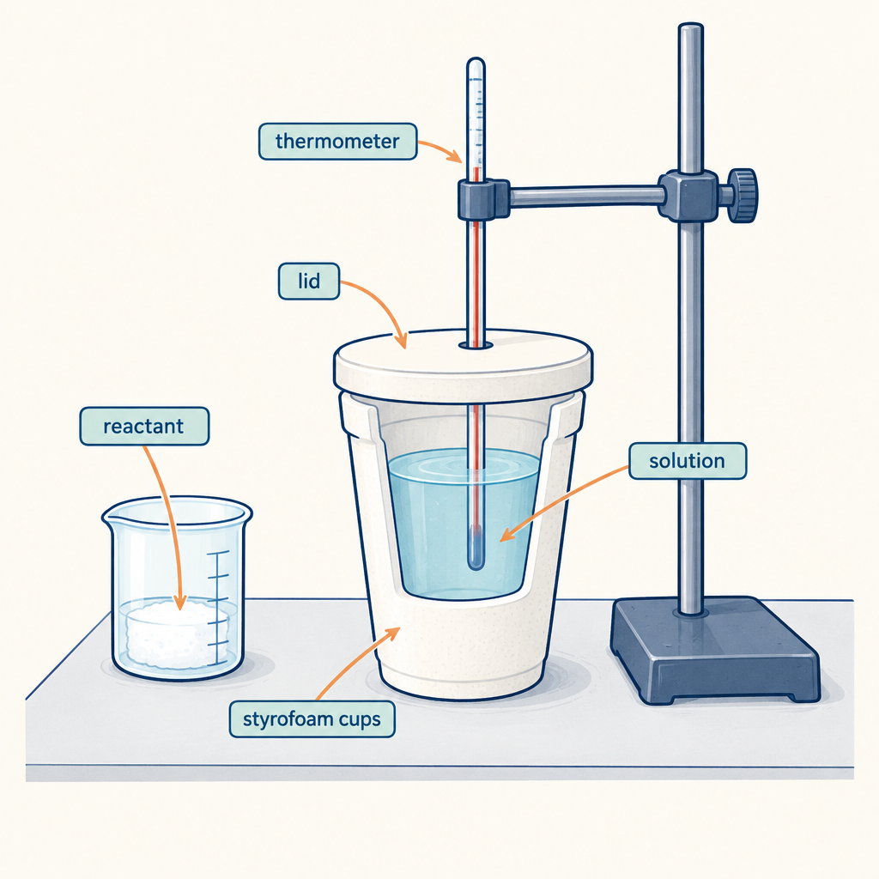

Learning intentions
We are learning to:
- Define enthalpy and molar enthalpy, and explain what ΔH notation communicates about a reaction (Outcome, Outcome).
- Apply Q = mcΔt to calculate heat transfer in a calorimetry experiment (Outcome).
- Use calorimetry data to calculate the molar enthalpy change of a reaction, expressed with correct units and significant digits (Outcome, Outcome).

Success criteria
I can:
- State the meaning of enthalpy and molar enthalpy in my own words.
- Write a ΔH value with the correct sign to show whether a reaction is exothermic or endothermic.
- Calculate q using Q = mcΔt from given mass, specific heat capacity and temperature change.
- Convert a heat value into a molar enthalpy change using moles of reactant, and report the answer in kJ/mol with the correct number of significant digits.

Curriculum alignment
- 30-A1.3k: define enthalpy and molar enthalpy for chemical reactions (Outcome).
- 30-A1.5k: use and interpret ΔH notation to communicate and calculate energy changes (Outcome).
- 30-A1.1k: recall the application of Q = mcΔt to the analysis of heat transfer (Outcome).
- 30-A1.8k: use calorimetry data to determine the enthalpy changes in chemical reactions (Outcome).
- 30-A1.2s: perform calorimetry experiments to determine the molar enthalpy change of chemical reactions, using thermometers or temperature probes appropriately (Outcome).
- 30-A1.4s: use appropriate SI units and significant digits when communicating results (Outcome).
- General Outcome 1: determine and interpret energy changes in chemical reactions (Topic).

Materials
- Whiteboard or projector for worked examples
- Scientific calculators (one per student)
- Handout: guided practice worksheet with the worked example left partially blank for students to fill in
- Handout: independent practice problem set (two problems, printed or projected)
- Exit ticket slips (one per student)
- Optional: a styrofoam cup calorimeter, thermometer, water, and NaOH pellets for a live demonstration during direct instruction, if time and safety protocols allow

Lesson sequence
1. Hook (5 minutes)
Open with this question on the board: "You place a cold pack and a hot pack side by side. Both start a chemical reaction the moment you activate them. One gets warmer, one gets colder. What's actually being measured when we say a pack 'gives off' or 'absorbs' heat?"
Take two or three quick verbal answers. Do not correct yet. Say: "By the end of today you'll be able to calculate exactly how much heat a reaction releases or absorbs, per mole of substance, using data from a simple experiment."
2. Direct instruction (15 minutes)
Write on the board: Enthalpy (H) is the heat content of a system at constant pressure. We can't measure H directly, so we measure the change, ΔH, the enthalpy change of a reaction.
State the sign convention:
- ΔH is negative for an exothermic reaction (heat leaves the system, surroundings warm up).
- ΔH is positive for an endothermic reaction (heat enters the system, surroundings cool down).
Introduce molar enthalpy (ΔH_molar): the enthalpy change per mole of a specified substance in the reaction, expressed in kJ/mol.
Write the heat transfer equation: Q = mcΔt, where:
- Q = heat absorbed or released by the surroundings, in joules
- m = mass of the surroundings (usually water), in grams
- c = specific heat capacity, 4.19 J/(g·°C) for water
- Δt = t_final − t_initial, in °C
Explain the calorimetry logic explicitly: "In a simple calorimeter, the reaction happens in water. Whatever heat the reaction releases, the water absorbs, so Q_water tells us the heat of the reaction with the opposite sign. If the reaction is exothermic, Q_water is positive because the water heats up, but ΔH for the reaction is negative."
Work through this example on the board, narrating each step:
"A student dissolves 5.00 g of NaOH in 100.0 g of water in a calorimeter. The temperature rises from 21.0°C to 33.5°C. Find the molar enthalpy of dissolution of NaOH."
Step 1: Δt = 33.5°C − 21.0°C = 12.5°C
Step 2: Q = mcΔt = (100.0 g)(4.19 J/g°C)(12.5°C) = 5237.5 J = 5.24 kJ
Step 3: The water gained 5.24 kJ, so the reaction released 5.24 kJ. Since the reaction is exothermic, ΔH = −5.24 kJ for this quantity of NaOH.
Step 4: moles of NaOH = 5.00 g ÷ 40.00 g/mol = 0.125 mol
Step 5: ΔH_molar = −5.24 kJ ÷ 0.125 mol = −41.9 kJ/mol
Say: "Notice the answer carries three significant digits because our least precise measurement, the temperature readings, supports three sig figs. Always match your final answer's precision to your data (Outcome)."
3. Guided practice (15 minutes)
Distribute the guided practice worksheet with a second problem, structured but with blanks for students to complete alongside you:
"A 2.50 g sample of magnesium ribbon reacts completely with excess hydrochloric acid in a calorimeter containing 150.0 g of water. The temperature rises from 20.2°C to 34.7°C. Calculate the molar enthalpy of reaction for magnesium, in kJ/mol."
Walk the class through it step by step, calling on different students for each step:
- "What is Δt?" (14.5°C)
- "What is Q?" (Q = 150.0 × 4.19 × 14.5 = 9113.25 J = 9.11 kJ)
- "Is this reaction exothermic or endothermic? How do you know?" (Exothermic; the water temperature rose)
- "What is ΔH for this sample?" (−9.11 kJ)
- "How many moles of Mg reacted?" (2.50 g ÷ 24.31 g/mol = 0.1028 mol)
- "What is the molar enthalpy?" (−9.11 kJ ÷ 0.1028 mol = −88.6 kJ/mol)
Circulate while students fill in their own copy, checking that each student writes the negative sign correctly and carries the right number of significant digits.
4. Independent practice (15 minutes)
Distribute the independent practice problem set. Students work individually or in pairs.
Problem 1: "A student burns 1.15 g of ethanol (C2H5OH, molar mass 46.07 g/mol) under a calorimeter containing 200.0 g of water. The water temperature rises from 22.0°C to 45.6°C. Calculate the molar enthalpy of combustion of ethanol, in kJ/mol."
Expected solution: Δt = 23.6°C; Q = 200.0 × 4.19 × 23.6 = 19 776.8 J = 19.8 kJ; moles = 1.15 ÷ 46.07 = 0.02497 mol; ΔH_molar = −19.8 ÷ 0.02497 = −793 kJ/mol.
Problem 2: "A student mixes 50.0 mL of 1.00 mol/L HCl with 50.0 mL of 1.00 mol/L NaOH in a calorimeter. Assume the combined solution has a density of 1.00 g/mL and a specific heat capacity of 4.19 J/(g·°C). The temperature rises from 20.5°C to 27.0°C. Calculate the molar enthalpy of neutralization, in kJ/mol."
Expected solution: total mass = 100.0 g; Δt = 6.5°C; Q = 100.0 × 4.19 × 6.5 = 2723.5 J = 2.72 kJ; moles HCl = moles NaOH = 0.0500 mol (1:1 ratio, both fully react); ΔH_molar = −2.72 ÷ 0.0500 = −54.5 kJ/mol.
While students work, circulate and check specifically for the sign of ΔH, correct identification of mass (the whole mixed solution in problem 2, not just one reagent), and correct significant digits in the final answer.
5. Consolidation (10 minutes)
Bring the class back together. Ask a student to put the Problem 2 solution on the board and narrate it aloud while classmates check their own work.
Ask: "Why do we say the ΔH belongs to the reaction, not to the water, even though we measured the water's temperature change?" Take one or two answers and confirm: the water is the surroundings; its temperature change tells us how much heat the reaction transferred, and that heat divided by moles gives us the molar enthalpy of the reaction itself (Outcome).
Hand out the exit ticket: "A reaction releases 12.6 kJ of heat when 0.200 mol of reactant is consumed. Write the molar enthalpy as a ΔH value with correct sign and units."
Expected answer: ΔH = −63.0 kJ/mol.

Differentiation
Extension: Ask students who finish early to research the accepted literature value for the molar enthalpy of combustion of ethanol and calculate the percent difference from their Problem 1 answer, then suggest one source of experimental error in a simple calorimeter that would explain the gap (for example, heat loss to the surrounding air rather than all heat transferring to the water). This connects directly to the practical limits of the calorimetry experiments described in 30-A1.2s (Outcome).
Support: Provide a filled-in formula triangle for Q = mcΔt and a step-by-step checklist (find Δt, calculate Q, determine sign, find moles, divide) for students who need a scaffolded procedure. Allow use of a calculator throughout and permit these students to work through Problem 1 only, skipping Problem 2, with the extra time used to complete the guided practice example fully with teacher support.

Assessment
Formative check: collect the exit ticket responses at the end of class.
Look for:
- The correct numeric value (−63.0 kJ/mol)
- A negative sign, showing the student correctly links heat release to an exothermic reaction
- Correct units (kJ/mol, not kJ or J)
- Three significant digits, matching the precision of the given data
Students who omit the negative sign or drop units need a quick reteach of the sign convention and unit habit before moving on to Hess's law calculations in the next lesson (Outcome).

AILI rapid lesson · en · claude-sonnet-5 · 2026-09-17

