The Nervous System: Structure, Function and Control
Central concept: Nervous System

Connections
- Nervous System (comprises) -> Central Nervous System
- Nervous System (comprises) -> Peripheral Nervous System
- Nervous System (contains) -> Neuron
- Nervous System (uses) -> Sensory Receptors
- Central Nervous System (includes) -> Brain Structures
- Peripheral Nervous System (includes) -> Somatic Nervous System
- Peripheral Nervous System (includes) -> Autonomic Nervous System
- Neuron (transmits) -> Action Potential
- Neuron (forms) -> Synapse
- Synapse (uses) -> Neurotransmitters
- Reflex arcs can occur in both the somatic nervous system (e.g., patellar reflex) and the autonomic nervous system (e.g., pupillary reflex).
- Sensory Receptors (initiates) -> Reflex Arc

Notes
- Nervous System: Biological system that controls physiological processes and maintains homeostasis through response to stimuli Topic, Topic
- Central Nervous System: Brain and spinal cord; processes information and coordinates responses Outcome, Outcome
- Peripheral Nervous System: Nerves connecting CNS to body; transmits sensory and motor signals Outcome, Outcome
- Somatic Nervous System: Voluntary control of skeletal muscles and sensory perception Outcome, Outcome
- Autonomic Nervous System: Involuntary control of internal organs and glands Outcome, Outcome
- Neuron: Basic functional unit; transmits electrical and chemical signals Outcome, Outcome
- Action Potential: Electrical signal transmission along neuron; follows all-or-none response Outcome, Outcome
- Synapse: Junction between neurons; uses neurotransmitters for signal transmission Outcome, Outcome
- Neurotransmitters: Chemical messengers such as acetylcholine and norepinephrine; cholinesterase is the enzyme that breaks down acetylcholine after transmission. Outcome, Outcome
- Reflex Arc: Rapid involuntary response pathway; examples include patellar and pupillary reflexes Outcome
- Sensory Receptors: Detect environmental stimuli; include olfactory, taste, proprioceptors, and skin receptors Outcome
- Brain Structures: Cerebral hemispheres, lobes, cerebellum, pons, medulla, hypothalamus regulate functions Outcome, Outcome
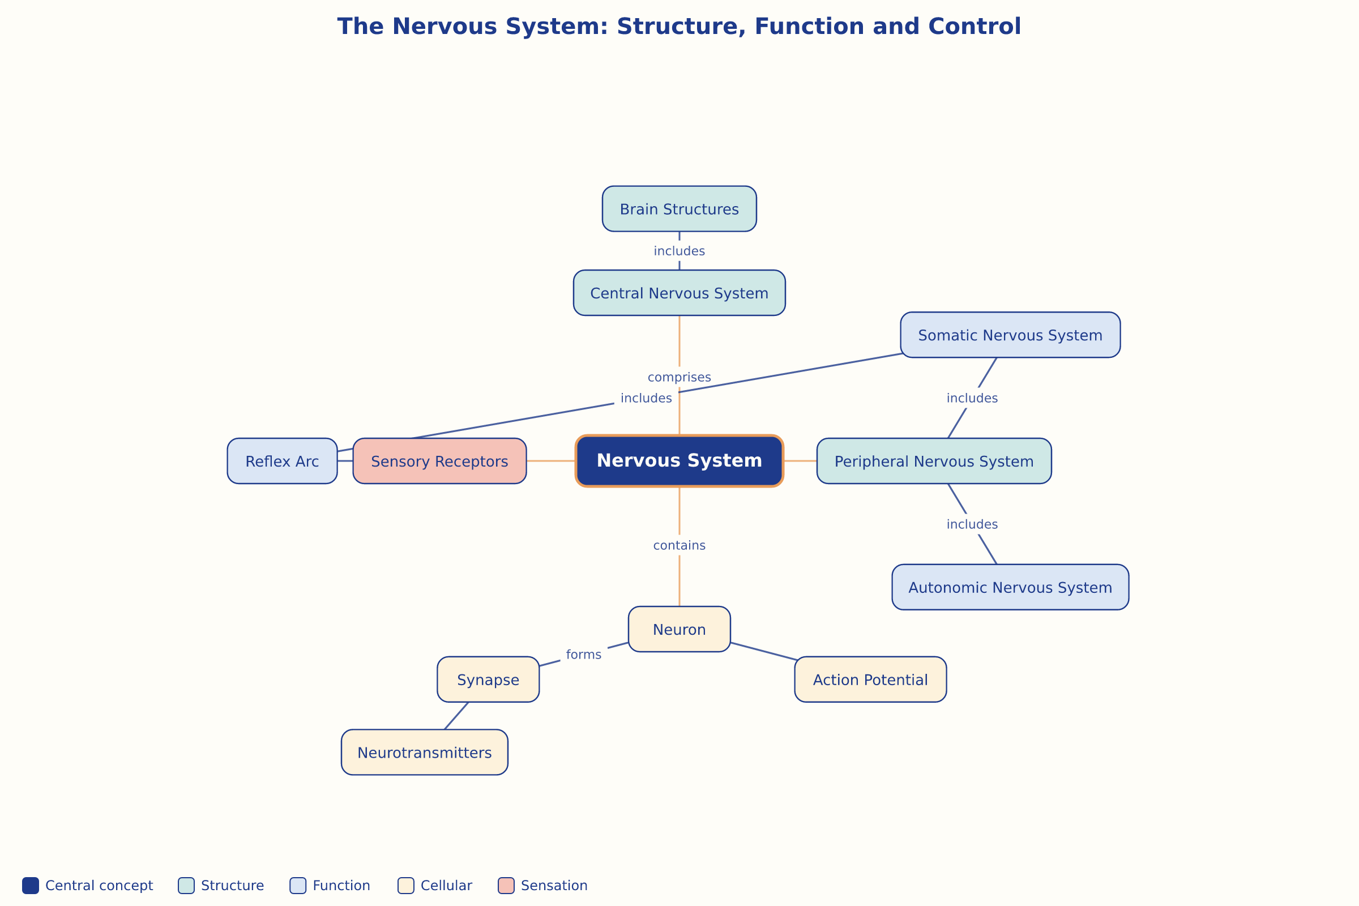

AILI word map · en · claude-haiku-4-5-20251001 · 2026-09-17

