Energy Flow in Technological Systems
Mechanical energy, thermodynamics and efficiency in real technological systems
Audience: Grade 10 Science students in Alberta, ages fifteen to sixteen, working toward Unit B outcomes in preparation for further study in Physics and Chemistry.
Grades: Grade 10
Subjects: Science 10
Time: about 60 minutes
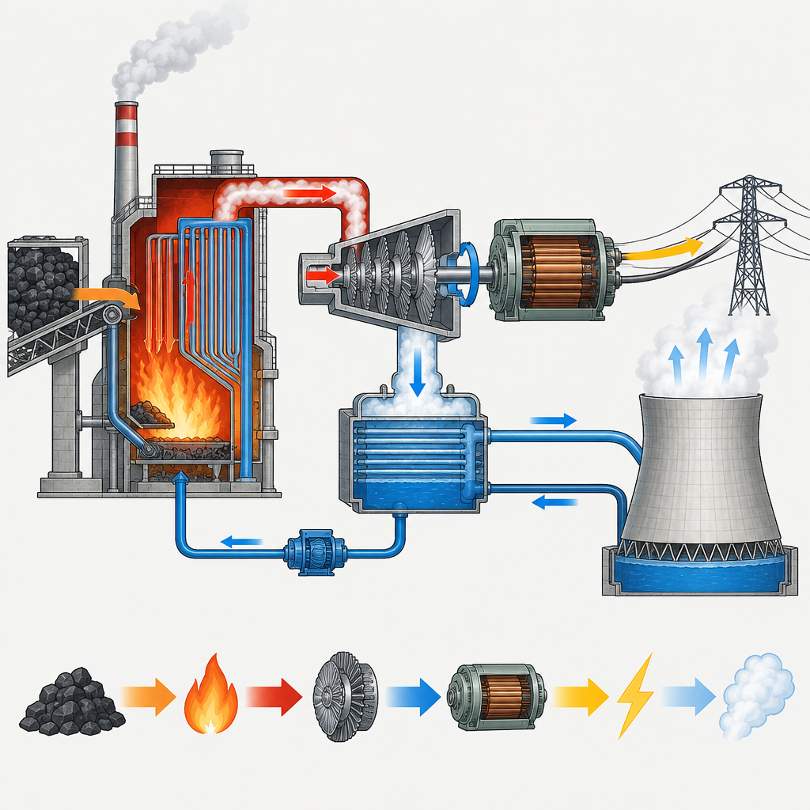

Overview
This lesson opens Unit B: Energy Flow in Technological Systems by connecting observable evidence of energy to the quantitative relationships that describe mechanical energy(Outcome, Outcome, Topic). Students move from a warm-up that surfaces prior knowledge of energy forms, through direct instruction on work, kinetic and potential energy, and efficiency, into a small group activity where they trace energy conversions and losses through a real technological system such as a hydroelectric dam or a refrigerator (Outcome, Outcome).
The lesson closes with a historical connection showing that engines and Indigenous technologies were developed through trial and error before the laws of thermodynamics were formally stated (Outcome, Outcome), and a two-part exit ticket that checks both calculation skill and conceptual understanding of efficiency (Outcome, Outcome). The lesson supports students in analyzing and illustrating how energy exists in a variety of forms and how energy transformation technologies produce measurable changes in motion, shape, or temperature.

Outcomes covered
- Explain and apply concepts used in theoretical and practical measures of energy in mechanical systems. (Outcome)
This outcome gives students the quantitative tools, kinetic and potential energy equations, work, and the joule, needed to analyze energy conversions precisely rather than only qualitatively.
- Identify the processes of trial and error that led to the invention of the engine, and relate the principles of thermodynamics to the development of more efficient engine designs. (Outcome)
Understanding how energy is present through observable physical and chemical changes, and changes in motion, shape or temperature helps students see how the concept of energy developed from practical applications.
- Describe, qualitatively, current and past technologies used to transform energy from one form to another, and that energy transfer technologies produce measurable changes in motion, shape or temperature. (Outcome)
Energy conservation in transformations, such as when an object falls and gravitational potential energy converts to kinetic energy, illustrates how energy is converted from one form to another.

Materials
- Whiteboard or projector for demonstrations and worked examples
- Chart paper and markers, one set per small group
- Printed exit ticket handout, one per student
- Optional: short video clips or physical demonstration materials (elastic band, pot and hot plate or kettle, toy car and ramp)
- Calculators
- Optional printed reference sheet with key formulas (Ep = mgh, W = Fd, Ek = 1/2 mv^2, efficiency formula) for students needing support

Sequence of activities

1. Warm-up: Evidence of Energy and Forms of Energy (8 min, whole class)
- Display three images or short demo clips in sequence: a stretched elastic band released, a pot of water beginning to boil, and a toy car rolling down a ramp and stopping.
- Ask students to record, for each example, what observable change signals that energy is present (change in motion, shape or temperature) (Outcome).
- Cold-call three students to share one observation each. Record responses on the board under the headings Motion, Shape, Temperature.
- Introduce the driving question for the lesson: How does useful energy change as it moves through a technological system, and why is some of it always lost as heat? (Outcome, Topic)
- Briefly list forms of energy that will come up today: kinetic energy, potential energy, and chemical energy, noting that gasoline and glucose store chemical potential energy(Outcome, Outcome).
If demo materials are unavailable, use still photographs or a 90-second video clip instead. Keep this brief; the goal is activating prior knowledge from Grade 7-9 Science (Topic), not teaching new content yet.
Sources: Outcome, Outcome, Outcome, Topic

2. Direct Instruction: Work, Energy and the Two Laws of Thermodynamics (15 min, whole class)
- Define kinetic energy as energy due to motion and potential energy as energy due to relative position or condition; give gravitational potential energy and chemical potential energy (gasoline, ATP, glucose) as examples (Outcome, Outcome).
- Derive the joule from fundamental units starting with W = Fd, showing that a change in energy equals work done on a system: ΔE = W (Outcome).
- Present the two key equations: Ep = mgh and Ek = 1/2 mv^2. Work one numbered example on the board: a 2.0 kg object falls from rest through a height of 5.0 m. Show mgh = Fd = 1/2 mv^2, solve for final speed (answer: v = square root of (2 × 9.8 × 5.0) = about 9.9 m/s), and note that in the absence of resistive forces this conversion needs no extra energy input (Outcome).
- State the first law of thermodynamics (energy is conserved, only transformed) and the second law (in every real conversion some energy disperses as heat, so no conversion is 100% efficient) (Outcome).
- Define efficiency operationally: efficiency = useful energy output divided by total energy input, expressed as a percentage. Explain that useful energy is the form of output the device is designed to deliver, and that the rest becomes waste heat (Outcome).
- Give one applied example: in an automobile engine, chemical potential energy in gasoline converts to kinetic energy, but some also converts to heat; in an incandescent light bulb, electrical energy converts to light, but most converts to heat (Outcome).
Write the derivation of the joule explicitly: N times m = (kg m/s^2)(m) = kg m^2/s^2 = J. Checkpoint question mid-explanation: ask students to predict, before you show the calculation, whether a heavier object dropped from the same height would land faster (Ek depends on both mass and velocity, so this tests understanding of the mgh = 1/2 mv^2 relationship).
Sources: Outcome, Outcome, Outcome

3. Small Group Analysis: Tracing Energy Through a System (15 min, small group)
- Assign each group of three or four students one technological system: a hydroelectric dam, a thermal (coal-burning) power plant, a bicycle coming to a stop, a refrigerator or heat pump, or a permafrost storage pit for food (Outcome, Outcome).
- Each group draws an energy-flow diagram on chart paper showing the sequence of energy forms from input to useful output, labelling where waste heat is lost at each stage (Outcome).
- Groups answer three questions in writing: (a) What is the useful energy output for this device, from a technological perspective? (b) At which stage is the largest energy loss likely to occur, and why? (c) Which law of thermodynamics explains why 100% efficiency is impossible here? (Outcome)
- For groups working on the hydroelectric dam or thermal power plant, add a comparison question: identify one cost, one benefit and one sustainability consideration for the fuel or resource used (Outcome).
- Post diagrams around the room. Each group appoints one member to remain at their poster to explain it during a two-minute gallery walk while other members circulate.
Circulate to check that groups distinguish total energy input from useful energy output, and that waste heat appears explicitly in every diagram, consistent with the second law (Outcome). Prompt groups stuck on the permafrost pit example by asking what forms of energy prevent food from warming, linking to thermal energy transfer concepts from Grade 7 (Topic).
Sources: Outcome, Outcome, Topic

4. History Connection: Engines Before the Laws of Thermodynamics (10 min, whole class)
- Explain that practical heat engines and thermal technologies existed before scientists formulated the laws of thermodynamics, arising instead from trial and error (Outcome).
- Present a brief timeline: early steam engines, James Watt's improvements to engine design, and later refinements such as improved valve designs in car engines (Outcome).
- Introduce Rumford's and Joule's investigations of heat and mechanical work as the observations that eventually led to the formal concept of energy (Outcome).
- Discuss examples of pre-contact First Nations and Inuit technologies that applied thermodynamic principles in tool making, structure design and heating, without formal theory, for example permafrost storage pits and insulated shelter design (Outcome, Outcome).
- Pose a discussion question to the whole class: How is it possible for a working technology to exist before the science that explains it is written down? Take two or three responses and connect them to the day's driving question.
Keep this segment focused on the sequence: observation and trial and error preceded formal theory (Outcome, Outcome). This sets up an appreciation that engineering and Indigenous technological knowledge can precede or run parallel to formalized scientific laws.
Sources: Outcome, Outcome

5. Consolidation: Exit Ticket Calculation and Reflection (12 min, individual)
- Distribute a two-part exit ticket.
- Part A (calculation): A 1500 kg car engine converts 90 000 J of chemical potential energy from gasoline into 27 000 J of useful kinetic energy at the wheels. Calculate the efficiency of this conversion, and state where the remaining energy most likely goes (Outcome, Outcome). Answer: efficiency = 27 000 divided by 90 000 = 0.30, or 30%; the remaining 70% is lost mostly as waste heat through the engine and friction.
- Part B (short answer): Explain, using the first and second laws of thermodynamics, why an automobile engine can never reach 100% efficiency (Outcome).
- Part C (reflection): Name one example from today's lesson, historical or modern, where trial and error produced a working energy technology before scientists fully explained why it worked (Outcome).
- Collect exit tickets as students leave; briefly scan for common misconceptions to address at the start of the next class.
Use this as a formative checkpoint. Watch for students who confuse total input with useful output, or who state that energy is destroyed rather than converted to a non-useful form (Outcome).
Sources: Outcome, Outcome, Outcome

Differentiation
Extension
- Ask students who finish early to research and calculate the efficiency of a real hydroelectric dam or wind turbine using published input and output power figures, then compare it to the automobile example from the exit ticket (Outcome).
- Challenge advanced students to derive the joule from fundamental SI units independently on paper before the teacher presents the derivation, then compare their derivation to the class version (Outcome).
- Have students who grasp the material quickly extend their group's energy-flow diagram to include a second law of thermodynamics annotation explaining specifically why the largest loss stage occurs there (Outcome).
Support
- Provide a partially completed energy-flow diagram template with some stages pre-labelled for groups who need a scaffold during the small group analysis activity (Outcome).
- Give struggling students the efficiency formula and the automobile worked example side by side as a reference sheet before they attempt the exit ticket calculation (Outcome, Outcome).
- Pair students who need support with a stronger peer during the small group activity, and assign them the role of recorder to keep them engaged with the content while writing (Outcome).
Inclusive supports
- Assess student understanding of energy concepts through observation of physical and chemical changes, and changes in motion, shape or temperature.
- Use consistent, simple diagram symbols across all board work and printed materials so students using visual supports or translation tools can follow the energy-flow sequence.
- Allow extra processing time for the direct instruction segment by pausing after each equation is introduced before moving to the next.

Assessment
Formative. Mid-lesson checkpoint question during direct instruction: predict whether a heavier object dropped from the same height lands with a different speed, before the teacher shows the mgh = 1/2 mv^2 calculation.
Look for: Students correctly reason that final speed depends on height and g, not on mass, showing they understand the relationship mgh = Fd = 1/2 mv^2 rather than memorizing it superficially. (Outcome)
Formative. Group energy-flow diagrams and written answers produced during the small group analysis activity, reviewed during teacher circulation and the gallery walk.
Look for: Diagrams correctly show a sequence of energy forms with waste heat losses labelled at each stage, and written answers correctly identify the useful energy output and cite the relevant law of thermodynamics. (Outcome)
Summative. Exit ticket with a calculation involving energy transformations and a short-answer explanation referencing energy conservation.
Look for: Correct efficiency calculation of 30%, a coherent explanation that references energy conservation and unavoidable heat loss, and an accurate named example from the lesson's historical content. (Outcome, Outcome, Outcome)

Vocabulary
- Kinetic energy: Energy due to motion, quantified as Ek = 1/2 mv^2.
- Potential energy: Energy due to relative position or condition; gravitational potential energy is defined as work done against gravity, Ep = mgh. Chemical energy stored in substances such as glucose, ATP or gasoline is also a form of potential energy.
- Work: Energy expended when the speed of an object is increased, or when an object is moved against an opposing force, calculated as W = Fd. A change in a system's energy equals the work done on it: ΔE = W.
- First law of thermodynamics: Energy is conserved in any process: it is transformed from one form to another, but the total amount does not change.
- Second law of thermodynamics: In every real energy conversion, some energy disperses as heat that cannot be fully recovered as useful work, which is why heat engines and other devices are never 100% efficient.
- Efficiency: A quantitative measure of the useful work or energy output of a device compared to the total energy put into it, often expressed as a percentage.
- Useful energy: The form of energy output that a technological device is designed to deliver, as distinct from the portion of input energy converted to non-useful forms such as waste heat.

For families
- Ask your student to explain, in their own words, why a car engine or a light bulb always produces some heat as a by-product, even though that heat is not the intended job of the device.
- Look together at an appliance at home, such as a kettle or a refrigerator, and ask your student to describe the energy conversions taking place inside it.
- Encourage your student to notice examples of trial-and-error technology in daily life, such as tools or building designs, and discuss how these might have developed before the underlying science was fully understood.

Sources
- Outcome: "relate gravitational potential energy to work done using Ep= mgh and W = Fd and show that a change in energy is equal to work done on a system: Δ E = W"
- Outcome: "identify the processes of trial and error that led to the invention of the engine, and relate the principles of thermodynamics to the development of more efficient engine designs"
- Outcome: "explain, quantitatively, efficiency as a measure of the "useful" work compared to the total energy put into an energy conversion process or device"
- Outcome: "define, compare and contrast scalar and vector quantities"
- Outcome: "analyze and illustrate how the concept of energy developed from observation of heat and mechanical devices"
- Topic: "Students investigating mechanical energy conversions and transfers in systems will recognize that while energy is conserved, useful energy diminishes with each conversion."
- Resource: "This module introduces concepts such as motion, work, forms of energy, energy conversions, and the laws of thermodynamics, supported by inquiry-based labs and problem-solving investigations."

All examples, demonstrations and images in this lesson use standard classroom materials and technical diagrams appropriate for Grade 10 students, with no hazardous procedures and respectful, accurate treatment of Indigenous technological knowledge.

AILI detailed pack · en · claude-sonnet-5 · 2026-09-17

