Cells and Systems (Grade 8)
Central concept: Cells and Systems

Connections
- Cells and Systems (studies) -> Living Things
- Cells and Systems (built from) -> Cell as Unit
- Cells and Systems (organizes into) -> Tissues and Organs
- Cells and Systems (includes) -> Human Body Systems
- Living Things (share) -> Common Functions
- Cell as Unit (compares) -> Single vs Multicelled
- Cell as Unit (distinguishes) -> Plant vs Animal Cells
- Cell as Unit (exchanges via) -> Diffusion and Osmosis
- Tissues and Organs (made of) -> Cell as Unit
- Human Body Systems (depends on) -> Organ Roles
- Human Body Systems (built from) -> Specialized Cells
- Human Body Systems (shows) -> Response to Stimuli
- Organ Roles (contain) -> Specialized Cells

Notes
- Cells and Systems: Living things are organized as systems, from cells to organs, that carry out life functions (Topic). Topic
- Living Things: Investigated using the concept of system to describe structure and function (Outcome, Outcome). Outcome, Outcome
- Cell as Unit: The cell is the basic unit of life (Outcome, Outcome). Outcome, Outcome
- Single vs Multicelled: Compares organisms like an amoeba and a grizzly bear (Outcome, Outcome). Outcome, Outcome
- Plant vs Animal Cells: Distinguished by features such as cell wall versus cell membrane (Outcome, Outcome). Outcome, Outcome
- Diffusion and Osmosis: Gases and liquids move into and out of cells based on concentration differences (Outcome, Outcome). Outcome, Outcome
- Tissues and Organs: Cells contribute to tissues and organs in plant and animal structures (Outcome, Outcome, Topic). Outcome, Outcome, Topic
- Common Functions: Different organisms meet similar needs, like food gathering, in varied ways (Outcome, Outcome). Outcome, Outcome
- Human Body Systems: Respiration, circulation, digestion, excretion and sensory awareness systems (Outcome). Outcome
- Organ Roles: Individual organs and tissues support healthy body function, such as lungs exchanging gases (Outcome). Outcome
- Specialized Cells: Nerve, muscle, blood, skin and bone cells each support healthy body function (Outcome). Outcome
- Response to Stimuli: Body functions change in response to conditions, such as heart rate during exercise (Outcome, Topic). Outcome, Topic
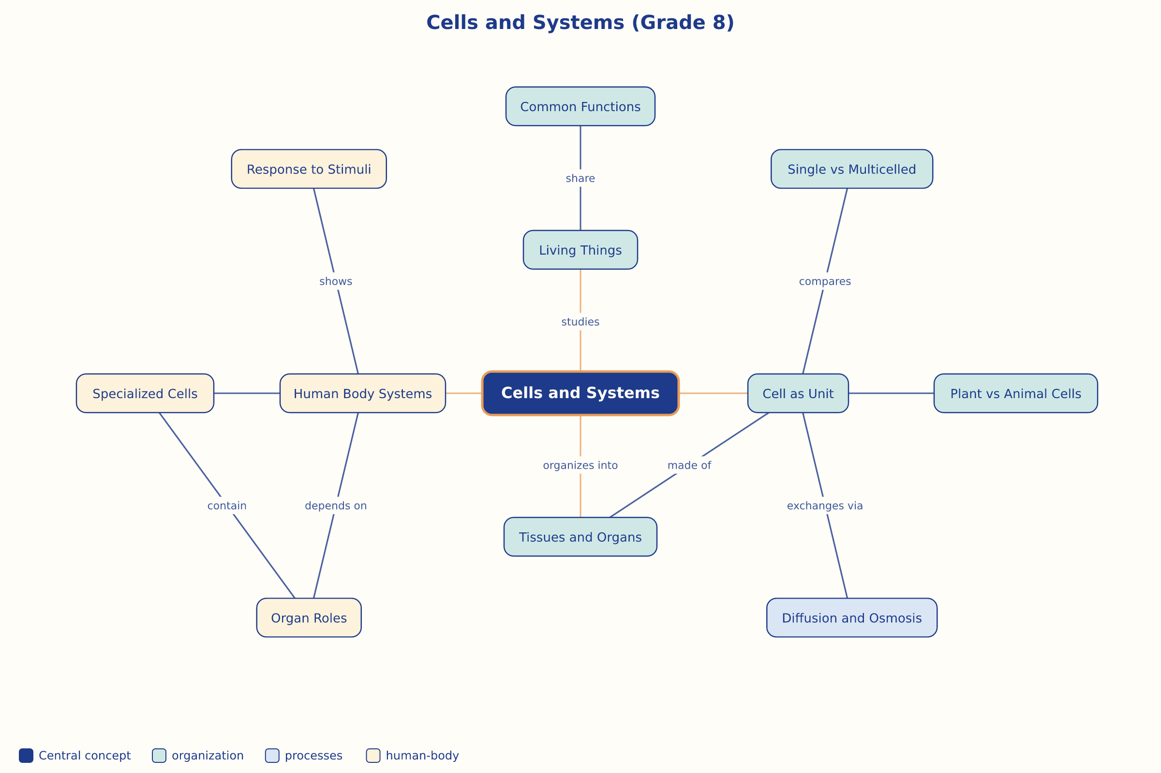

AILI word map · en · claude-sonnet-5 · 2026-09-17

