The Particle Model of Matter
Discover the tiny moving particles that explain why solids, liquids, and gases behave so differently.
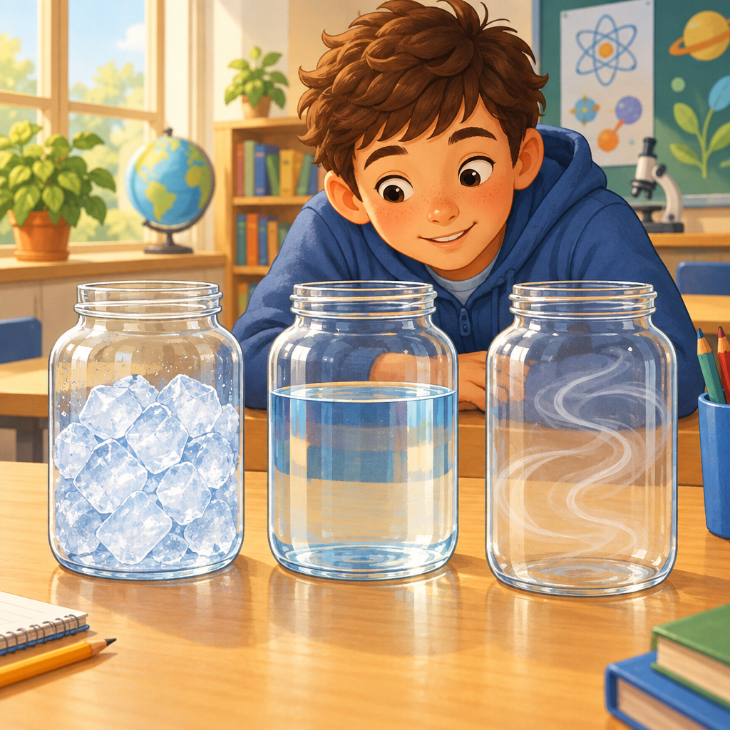

Learning intentions
We are learning to:
- Explain that all matter is made of tiny moving particles with spaces between them.
- Describe how particles are arranged and how they move in solids, liquids, and gases.
- Relate the strength of attractive forces between particles to the state of matter.

Success criteria
I can:
- Say the three main ideas of the particle model of matter.
- Draw particles for a solid, a liquid, and a gas, and explain the difference between my drawings.
- Explain whether attractive forces are strongest or weakest in each state of matter.

Curriculum alignment
- Guiding question on explaining states of matter using the particle model (Guiding question, Guiding question)
- Learning outcome: investigate the particle model in relation to solids, liquids, and gases (Outcome, Outcome)
- Knowledge: particles are always moving, have space between them, and are arranged differently in each state (Knowledge, Knowledge, PDF p.1)
- Skills: represent states of matter using the particle model, and relate particle movement and arrangement to state (Skills, Skills)
- Understanding: the particle model explains particle behaviour, and particle movement and arrangement affect physical properties (Understanding, Understanding, Understanding, Understanding)

Materials
- Three clear containers or jars (one with ice cubes, one with water, one empty to represent air)
- Chart paper or whiteboard divided into three columns labelled Solid, Liquid, Gas
- Small pom-poms, marbles, or dried beans (about 30 per group of four students) to model particles
- Small paper plates or trays, one per group, to act as a "container" boundary
- Student science notebooks or a printed particle-drawing worksheet with three blank boxes
- Access to Resource (video) and a way to play it for the class

Lesson sequence
1. Hook (5 minutes)
Show the three containers: ice, water, and the empty jar labelled "air." Ask the class:
"These three jars all hold matter. What is different about them, and what might be exactly the same about them, even though you can't see it?"
Take two or three quick answers. Do not correct yet. Write their guesses on the board under the heading "What we think." Say: "By the end of today, we're going to find out what's really going on inside all three of these jars, and it's smaller than anything you've ever seen."
2. Direct instruction (10 minutes)
Introduce the particle model of matter. Say:
"Scientists use an idea called the particle model of matter to explain why solids, liquids, and gases act so differently. It has three big ideas. Say them with me: all matter is made of small particles, particles are always moving, and particles have spaces between them" (PDF p.1, Knowledge).
Draw three simple boxes on the board labelled Solid, Liquid, Gas. Explain each one using this script:
"In a solid, like an ice cube, the particles are packed close together and they vibrate in place. They jiggle, but they don't travel around. That's why a solid keeps its shape" (Knowledge).
"In a liquid, like water, the particles have small spaces between them and they can slide past each other. That's why water can pour and take the shape of its container" (Knowledge).
"In a gas, like the air around us, the particles are spread far apart and they zoom around in every direction. That's why a gas spreads out to fill any space it's in" (Knowledge).
Then introduce attractive forces: "Particles pull on each other a little, like a weak magnet. This pull is called an attractive force. It is strongest in solids, where particles are packed tight, and weakest in gases, where particles are far apart" (Knowledge, Skills).
Play Resource (about 2 to 3 minutes) to show particle movement in each state. After the video, ask: "Which state did you see moving the fastest? Which one barely moved at all?"
3. Guided practice (10 minutes)
Put students into groups of four. Give each group a plate (the "container") and about 30 pom-poms or beans (the "particles"). Guide the whole class through three rounds together:
Round 1, Solid: "Push your particles tightly together in the middle of the plate. Now gently tap the table so they jiggle a tiny bit, but keep them from spreading apart. That's a solid."
Round 2, Liquid: "Now spread your particles out a little so there are small gaps, and slide them around each other with your finger, but keep them mostly together on the plate. That's a liquid."
Round 3, Gas: "Now spread your particles all over the plate with big gaps between them, and imagine them flying in all directions. That's a gas."
Circulate and ask groups: "Which round had the strongest pull between your particles? Which round had the weakest?" (Answer: strongest in the solid round, weakest in the gas round, Skills.)
4. Independent practice (10 minutes)
Students return to their seats and complete a particle-drawing task in their notebooks or on the worksheet. Instructions:
"Draw three boxes labelled Solid, Liquid, and Gas. In each box, draw dots to show how particles are arranged. Underneath each box, write one sentence describing how the particles move and one sentence describing how strong the attractive force is."
Give this sentence starter for students who want it: "In a ______, the particles are ______ and they ______. The attractive force is ______."
While students work, check in with individuals who look unsure and ask: "Tell me about your gas box. Why are the dots so far apart?"
5. Consolidation (5 minutes)
Bring the class back together. Point to the three original jars (ice, water, air) from the hook. Ask:
"Now that you know the particle model, what would you add to your first answer? What's happening inside each of these three jars right now?"
Take a few responses and confirm the key idea: "All three jars have particles that are always moving and have spaces between them (Knowledge, PDF p.1). What changes from jar to jar is how close together the particles are, how they move, and how strong the pull is between them" (Skills, Understanding).
Close with an exit question written on the board for students to answer verbally as they line up: "In one sentence, tell me the difference between how particles behave in a solid and how they behave in a gas."

Differentiation
Extension: Ask students to predict what happens to the particle arrangement when the ice in the jar melts, and to explain the change using the words "attractive force" and "particle movement." Students can also research and describe what happens to particles when a liquid boils and becomes a gas, connecting to Resource.
Support: Provide pre-drawn boxes with a few dots already placed correctly in the solid box as a model. Allow students to use only the sentence starters rather than composing full original sentences. Pair students with a partner for the pom-pom activity so they can talk through each round together before drawing.

Assessment
Formative check: Collect or observe the particle drawings from independent practice. Look for three things: dots in the solid box are close together and evenly spaced, dots in the liquid box have small gaps and touch in places, and dots in the gas box are spread far apart across the whole box. Check that each written sentence correctly matches movement (vibrating, sliding, zooming) and attractive force (strongest, medium, weakest) to the right state (Knowledge, Skills). Students who reverse the strength of attractive forces (for example, saying gas has the strongest pull) need a quick one-on-one reteach using the pom-pom plate before the next lesson.

AILI rapid lesson · en · claude-sonnet-5 · 2026-09-17

