Addition and Subtraction Within 100
Central concept: Addition and Subtraction Within 100

Connections
- Addition and Subtraction Within 100 (builds on) -> Number Facts
- Addition and Subtraction Within 100 (uses) -> Addition and Subtraction Strategies
- Addition and Subtraction Within 100 (includes) -> Compose a Sum
- Addition and Subtraction Within 100 (represents) -> Represent Quantities
- Addition and Subtraction Strategies (includes) -> Making Multiples of Ten
- Addition and Subtraction Strategies (includes) -> Using Doubles
- Compose a Sum (shows) -> Order Does Not Matter
- Compose a Sum (applies to) -> Visualize 100
- Addition and Subtraction Within 100 (checks) -> Verify Using Inverse
- Addition and Subtraction Within 100 (solves) -> Find Missing Quantity
- Represent Quantities (leads to) -> Solve Real Problems
- Number Facts (facilitates) -> Addition and Subtraction Strategies

Notes
- Addition and Subtraction Within 100: Grade 2 students investigate how to add and subtract numbers up to 100. Outcome
- Number Facts: Addition facts with addends to 10 and related subtraction facts. Skills
- Addition and Subtraction Strategies: Strategies for two-digit numbers include making tens and using doubles. Knowledge, Knowledge
- Making Multiples of Ten: A key strategy for adding and subtracting two-digit numbers. Knowledge, Knowledge
- Using Doubles: A strategy where you add a number to itself or use near-doubles. Knowledge, Knowledge
- Compose a Sum: A sum can be made in multiple ways, including with more than two addends. Understanding, Skills
- Order Does Not Matter: The order in which more than two numbers are added does not change the sum. Knowledge, Knowledge
- Represent Quantities: Addition and subtraction show the sum or difference of countable items or lengths. Understanding, Understanding
- Verify Using Inverse: Check a sum or difference by using the opposite operation. Skills
- Find Missing Quantity: Determine a missing number in an addition or subtraction sentence. Skills
- Visualize 100: See 100 as made up of tens in different ways. Skills, Skills
- Solve Real Problems: Use addition and subtraction to solve problems with objects or lengths. Skills
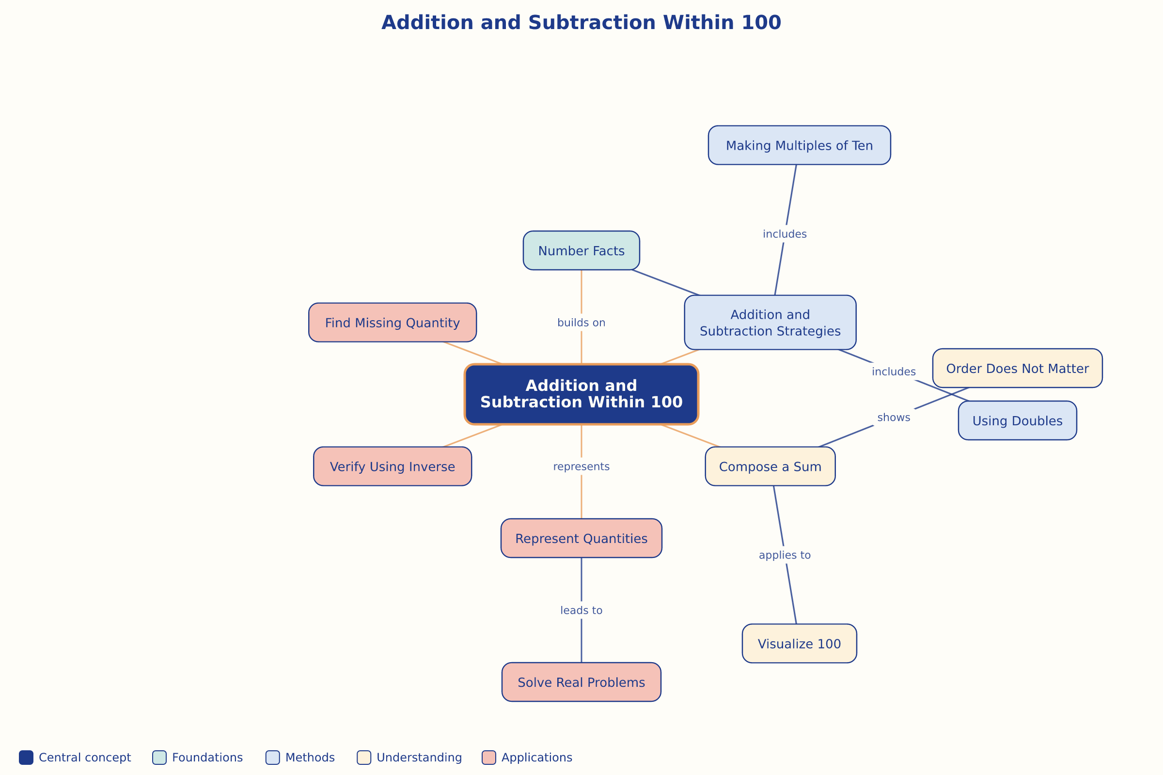

AILI word map · en · claude-haiku-4-5-20251001 · 2026-09-17

