The Great Apple Basket Puzzle
Mia is packing apples for a picnic. She uses addition and subtraction facts within 100 to check her baskets are full, just like students do when they investigate addition and subtraction within 100 (Outcome). This game uses the idea that a sum can be made in more than one way (Understanding) and that the order of adding numbers does not change the total (Knowledge).

The puzzle
Mia has three baskets of apples.
All three baskets together hold exactly 100 apples.
Basket A holds 30 apples.
Basket B holds 40 apples.
Basket C holds a mystery number of apples.
Question one: How many apples are in Basket C?
Question two: Mia checks her answer a different way. She adds Basket C first, then Basket A, then Basket B. Does she still get 100 apples in total? Explain why, in one sentence.
Question three: Use subtraction to prove your answer for Basket C is correct.
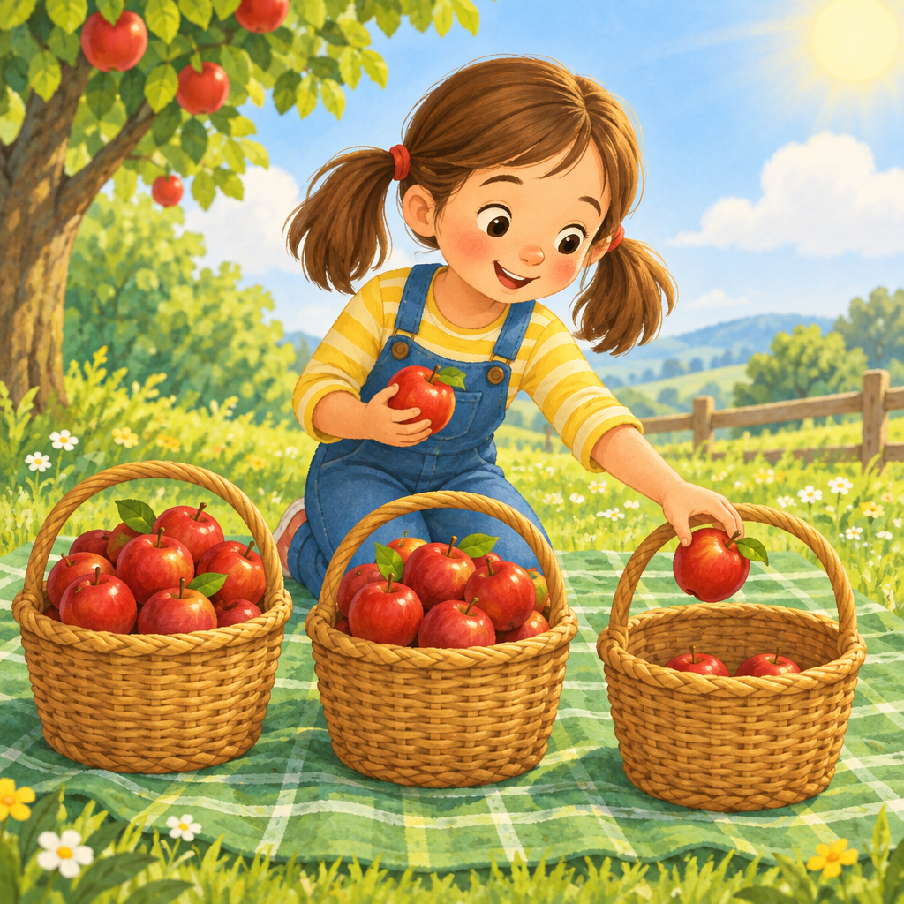

Hints
Hint one: Start by adding the two baskets you already know. Think about how close that gets you to 100.
Hint two: Find the difference between 100 and the total of Basket A and Basket B. That difference is the missing number.
Hint three: 30 + 40 = 70. Now ask yourself, what number added to 70 makes 100?

Answer key
Basket C holds 30 apples.
Reasoning: Basket A and Basket B together hold 30 + 40 = 70 apples. Since all three baskets must total 100 apples, Basket C holds 100 − 70 = 30 apples (Skills, Skills).
Question two answer: Yes, the total is still 100 apples. Changing the order of the addends does not change the sum (commutative property), and changing which pair you add first does not change the sum either (associative property), so Mia still gets 100 apples.
Question three check: 30 + 40 + 30 = 100. Using the inverse operation, 100 − 30 − 40 = 30, which matches the missing number in Basket C (Skills).

AILI game · en · claude-sonnet-5 · 2026-09-17

