Cells and Systems
Central concept: Living Things

Connections
- Living Things (made of) -> Cells
- Cells (form) -> Tissues
- Tissues (form) -> Organs
- Organs (form) -> Body Systems
- Cells (includes) -> Plant Cells
- Cells (includes) -> Animal Cells
- Living Things (can be) -> Single-Celled Organisms
- Living Things (can be) -> Multicelled Organisms
- Living Things (show) -> Structure and Function
- Cells (undergo) -> Transport Processes
- Body Systems (enable) -> Response to Stimuli
- Living Things (display) -> Response to Stimuli

Notes
- Living Things: Organisms with diverse structures and functions that respond to their environment Topic
- Cells: Basic unit of life; all living things are made of cells Outcome
- Tissues: Groups of similar cells that work together to perform a function Outcome
- Organs: Structures made of tissues that perform specific functions in the body Outcome
- Body Systems: Groups of organs working together for major functions like respiration and circulation Outcome
- Plant Cells: Cells with cell walls and other structures distinct from animal cells Outcome
- Animal Cells: Cells with cell membranes but no cell walls Outcome
- Single-Celled Organisms: Living things made of one cell that performs all life functions Outcome
- Multicelled Organisms: Living things made of many cells working together in organized systems Outcome
- Structure and Function: How an organism's parts are designed to perform specific roles Outcome
- Transport Processes: Movement of gases and liquids into and out of cells through diffusion and osmosis Outcome
- Response to Stimuli: How organisms and body systems react to internal and external changes Outcome
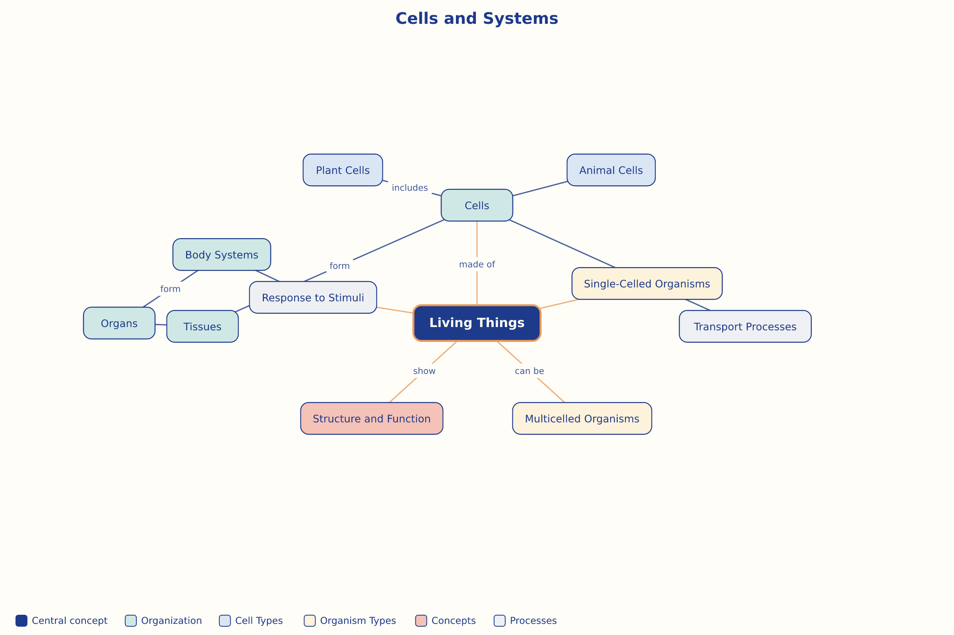

AILI word map · en · claude-haiku-4-5-20251001 · 2026-09-17

