Addition and Subtraction Within 100 (Grade 2)
Central concept: Addition & Subtraction to 100

Connections
- Addition & Subtraction to 100 (explores) -> Composing 100
- Composing 100 (uses) -> Multiples of Ten
- Addition & Subtraction to 100 (shows) -> Many Ways to Sum
- Many Ways to Sum (relies on) -> Associative Property
- Addition & Subtraction to 100 (builds on) -> Number Facts
- Number Facts (supports) -> Two-Digit Strategies
- Addition & Subtraction to 100 (requires) -> Recall Facts to 10
- Addition & Subtraction to 100 (includes) -> Add/Subtract to 100
- Add/Subtract to 100 (checked by) -> Inverse Operations
- Add/Subtract to 100 (leads to) -> Missing Quantity
- Addition & Subtraction to 100 (applies to) -> Real-World Problems
- Real-World Problems (uses) -> Add/Subtract to 100

Notes
- Addition & Subtraction to 100: Students investigate addition and subtraction within 100. Outcome
- Composing 100: Visualize 100 as made of multiples of 10. Skills
- Multiples of Ten: 100 can be built from groups of ten in many ways. Skills
- Many Ways to Sum: A sum can be composed in multiple ways, even with more than two addends. Understanding, Understanding
- Associative Property: Order of adding more than two numbers does not change the sum. Knowledge, Knowledge
- Number Facts: Familiar addition and subtraction facts help build strategies. Knowledge, Knowledge
- Two-Digit Strategies: Strategies include making multiples of ten and using doubles. Knowledge, Knowledge
- Recall Facts to 10: Recall and apply addition facts with addends to 10 and related subtraction facts. Skills, Skills
- Add/Subtract to 100: Add to a sum of 100 and subtract with a maximum minuend of 100. Skills, Skills
- Inverse Operations: Verify a sum or difference using inverse operations. Skills, Skills
- Missing Quantity: Determine a missing number in a sum or difference within 100. Skills, Skills
- Real-World Problems: Addition and subtraction represent sums or differences of countable quantities or measurable lengths. Understanding, Understanding
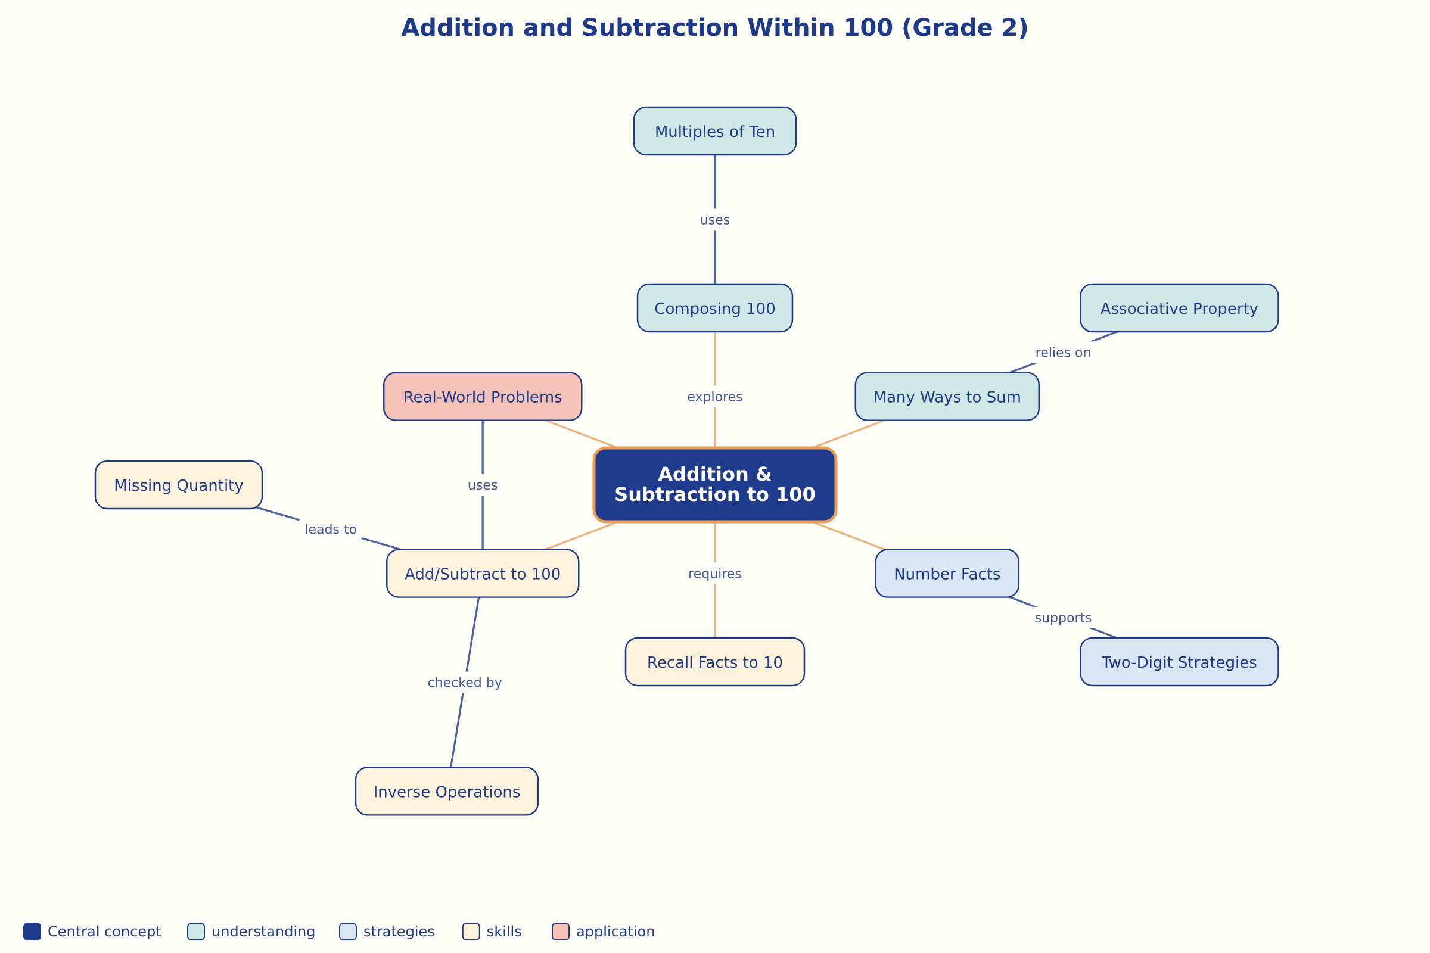

AILI word map · en · claude-sonnet-5 · 2026-09-17

