Shapes and Their Attributes
A Grade 2 Geometry adventure with sides, vertices, and faces

Slide 1: Shapes and Their Attributes
Grade 2 Geometry: exploring sides, vertices, and faces
Sources: Outcome
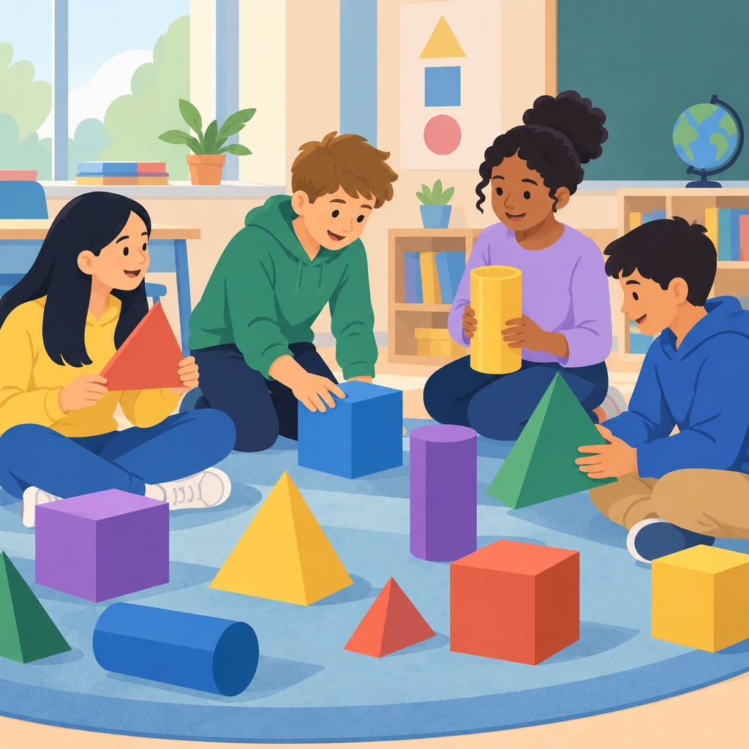
Notes: Introduce the unit by asking students to name shapes they see around the classroom. Set the stage for the geometry organizing idea: shapes are defined and related by geometric attributes.

Slide 2: What Makes a Shape a Shape?
- Sides are the straight edges of a shape.
- Vertices are the corners where sides meet.
- Faces or surfaces are the flat or curved parts of a shape.
- Flat (2D) shapes have sides that are straight line segments.
- Solid (3D) shapes have faces that can be 2D shapes, like a square face on a cube.
Sources: Knowledge, Knowledge
Notes: Learning intention: I can name the geometric attributes of a shape. Success criteria: I can point to and count sides, vertices, and faces on a shape. Materials: pattern blocks, 3D solids (cube, cone, cylinder, sphere). Timing: 10 minutes. Formative checkpoint: ask students to hold up a shape and name one attribute. Support: give sentence starters (This shape has ___ sides). Extension: ask students to compare a 2D and 3D shape's attributes.

Slide 3: Sorting Shapes by Attributes
- Count the sides: Sort shapes into groups with 3 sides, 4 sides, or more.
- Count the vertices: Sort shapes by how many corners they have.
- Compare faces: Sort 3D shapes by the flat shapes you see on their faces.
- Name the rule: Explain in words how you sorted your shapes.
Sources: Skills
Notes: Learning intention: I can sort shapes using two attributes and explain my rule. Success criteria: I can sort a set of shapes and tell a partner my sorting rule. Materials: mixed shape cards or blocks. Timing: 15 minutes, work in pairs. Formative checkpoint: listen for students using attribute language (sides, vertices, faces) when explaining their rule. Support: provide a sorting mat with two labeled columns. Extension: ask students to sort by two attributes at once, such as number of sides and number of vertices.

Slide 4: Building Bigger Pictures from Shapes
A single shape can be made of smaller shapes put together. Artists and builders use this idea to create pictures and designs from simple shapes like triangles, squares, and circles.
- Look at a picture and find the shapes hiding inside it.
- Combine shapes to build a new design.
- Follow verbal instructions to recreate a shape picture.
Sources: Skills, Understanding, Understanding
Notes: Learning intention: I can see a shape as a combination of other shapes. Success criteria: I can create a picture using at least three different shapes and describe the shapes I used. Materials: pattern blocks or paper cutouts, glue, paper. Timing: 15 minutes. Formative checkpoint: check that students can name each shape used in their design. Support: provide a template outline to fill with shapes. Extension: have students describe their design aloud so a partner can recreate it from memory.

Slide 5: Shapes on the Move: Slides, Turns, and Flips
- Slide (translation): The shape moves straight in one direction without turning.
- Turn (rotation): The shape spins around a point but stays the same size.
- Flip (reflection): The shape mirrors over a line, like looking in a mirror.
- Attributes stay the same: No matter how a shape moves, its sides, vertices, and faces do not change.
Sources: Knowledge, Skills, Understanding
Notes: Learning intention: I can describe how a shape moves and know its attributes stay the same. Success criteria: I can identify a slide, turn, or flip and explain that the shape's sides and vertices did not change. Materials: pattern blocks, mirrors, grid paper. Timing: 15 minutes. Formative checkpoint: show a shape before and after a move and ask students to name the move and confirm the attributes are unchanged. Support: use physical blocks students can move by hand. Extension: ask students to find examples of slides, turns, or flips in artwork or patterns around the school.

Slide 6: Shapes Are All Around Us
Summary: Every shape has geometric attributes: sides, vertices, and faces or surfaces. We can sort shapes by these attributes, build new pictures from smaller shapes, and move shapes through slides, turns, and flips without changing what makes them that shape.
Question: Can you find a shape in your classroom, describe its sides and vertices, and show how it would look if you turned it upside down?
Sources: Outcome, Understanding, Understanding
Notes: Wrap-up discussion. Revisit the essential question: how can shape influence perception of space? Invite students to share one new thing they learned about shape attributes. Use this as an exit-ticket prompt or a think-pair-share.

AILI presentation · en · claude-sonnet-5 · 2026-09-17

