The State Detective
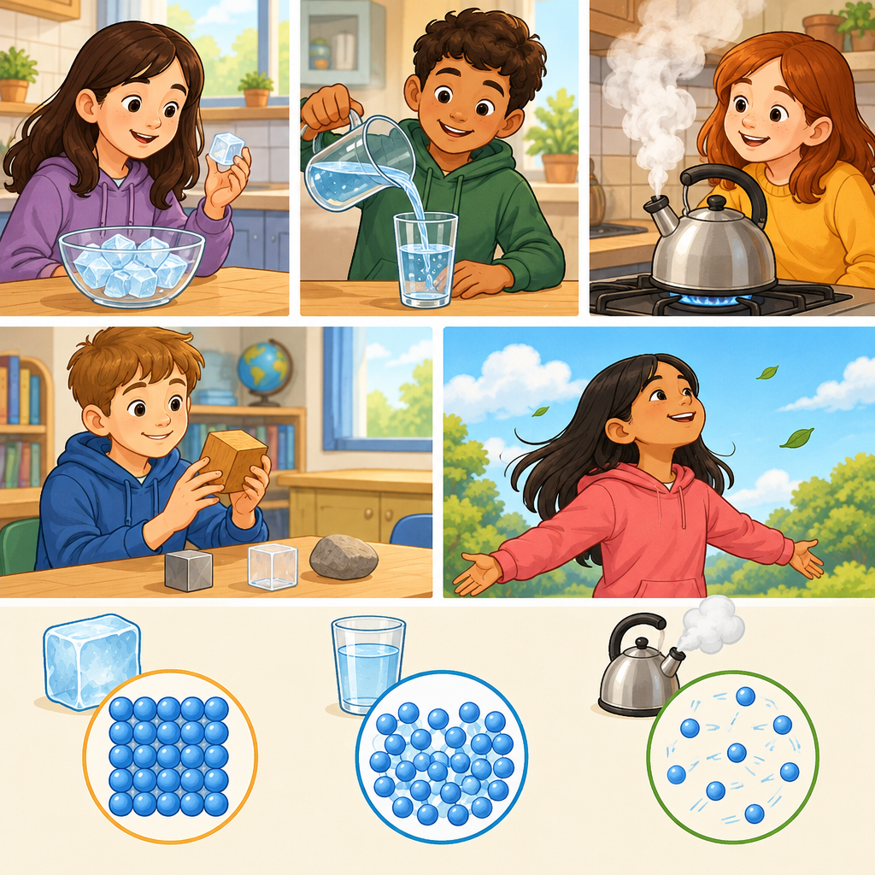
Understanding the particle model of matter helps us explain why solids, liquids and gases behave the way they do (Knowledge, Understanding). This game asks you to use what you know about how particles move and arrange themselves to solve a mystery about three mystery substances.

The puzzle
Three mystery substances sit on a table in front of you. You cannot see inside them, but you know the particle model of matter and you can make observations.
Substance A holds its shape. When you squeeze it hard, it does not get smaller.
Substance B takes the shape of its container. When you squeeze it in a syringe, it gets noticeably smaller.
Substance C takes the shape of its container. When you squeeze it in a syringe, it barely gets smaller at all.
Which substance is a solid, which is a liquid, and which is a gas? Explain your answer using what you know about how particles are arranged and how they move in each state of matter.

Hints
Hint 1: Think about how close together the particles are in each state of matter. Which state has particles that are far apart?
Hint 2: In a solid, particles vibrate but stay in one place. In a liquid, particles can slide past each other. In a gas, particles move freely in all directions with large spaces between them. Which substance's behaviour matches which state?
Hint 3: Compressibility is how much a substance shrinks when you squeeze it. Gases compress easily because there is plenty of empty space between particles. Liquids compress very little because particles are already close together. Solids do not compress because particles are held tightly in place.

Answer key
Substance A is a solid. Substance B is a gas. Substance C is a liquid.
Reasoning:
Substance A holds its shape and cannot be compressed. In a solid, particles are close together and vibrate in place (Knowledge). They are held by strong attractive forces and cannot move freely, so the shape stays fixed and squeezing does it no good.
Substance B compresses noticeably when squeezed. In a gas, particles are separated by large spaces and move constantly in all directions (Knowledge). When you squeeze a gas, you push those particles closer together, so the gas takes up less space. This is easy to do because there is so much empty space to begin with.
Substance C takes the shape of its container but barely compresses. In a liquid, particles are separated by some spaces and can slide past each other (Knowledge). The particles are already fairly close, so squeezing does not reduce the volume much. Liquids are much harder to compress than gases but much easier to compress than solids.

AILI game · en · claude-haiku-4-5-20251001 · 2026-09-17

