Maya's Market
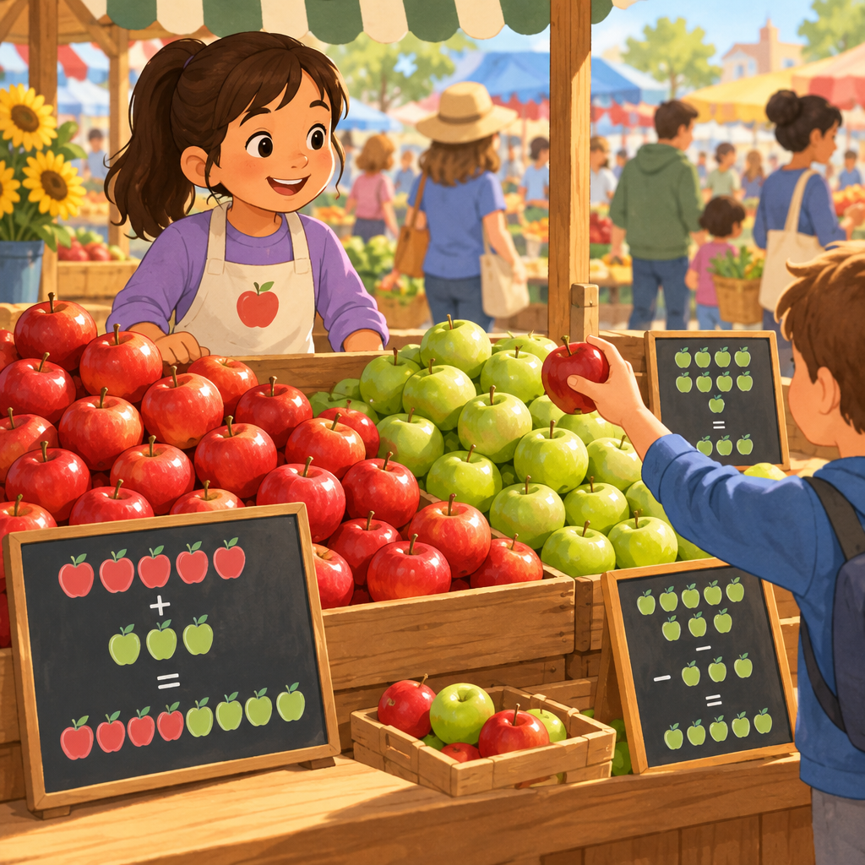
Maya helped at her grandmother's market stall on Saturday morning. She counted out the apples. There were thirty-five red ones and twenty-two green ones. How many apples altogether? Maya added thirty-five plus twenty-two. She made a group of ten green apples first. Now she had forty-five plus twelve. That made fifty-seven apples in total. At lunchtime, a customer bought nineteen apples. Maya subtracted nineteen from fifty-seven. She counted back by tens. Fifty-seven minus ten was forty-seven. Forty-seven minus nine was thirty-eight. Thirty-eight apples remained on the stall. Grandmother smiled. You are a natural mathematician, she said. Maya felt proud.

Words to know
- subtract: take away a number from another number to find the difference
- altogether: the total when you put numbers together
- compose: put together to make a whole
- difference: the answer when you subtract one number from another
Curriculum link: Guiding question, Outcome, Details
Listen to the narration

AILI audio story · en · claude-haiku-4-5-20251001 · 2026-09-17

