Addition and Subtraction Within 100
Building strategies for two-digit sums and differences up to 100
Audience: Grade 2 students in an Alberta elementary classroom, ages 7 to 8
Grades: Grade 2
Subjects: Mathematics
Time: about 60 minutes
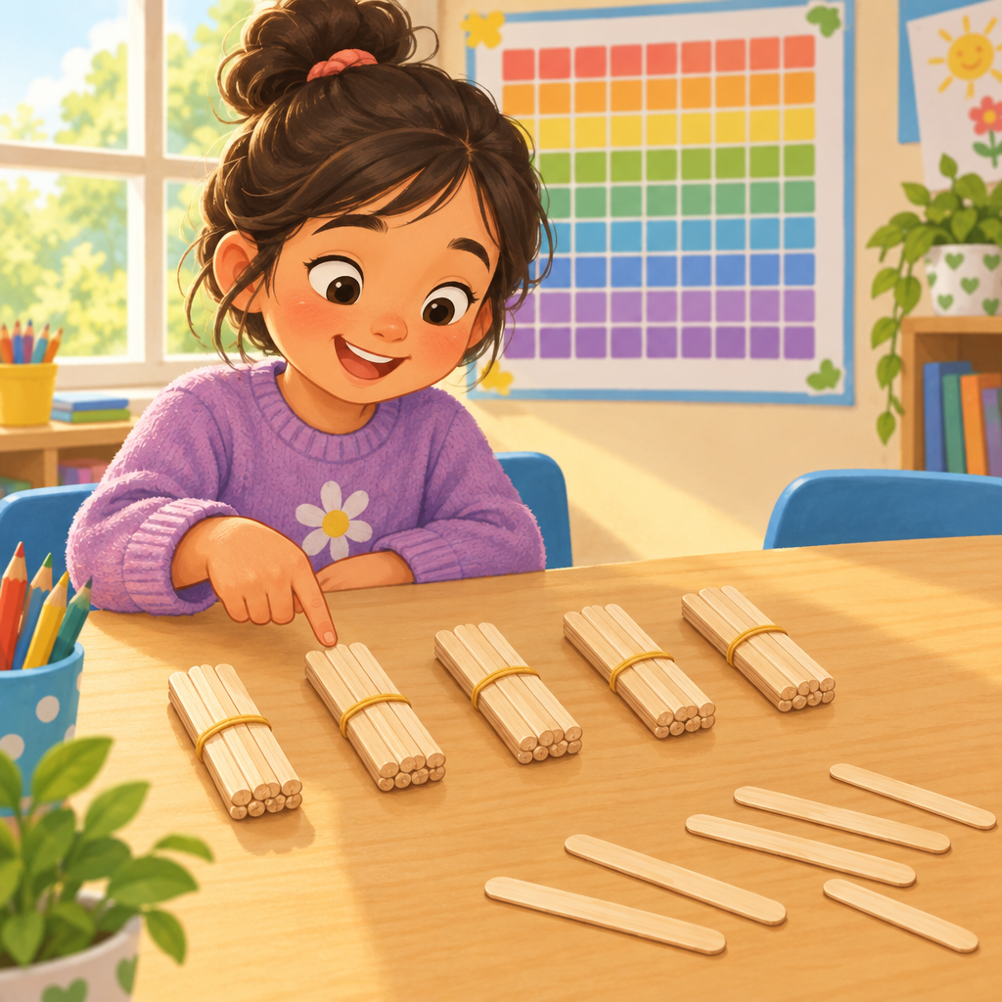

Overview
Today students investigate addition and subtraction within 100, the central focus of this Grade 2 lesson (Outcome). They build on facts to 10, explore how 100 is made of tens in different ways, and learn strategies like making a ten and using doubles for two-digit problems (Skills, Knowledge, Skills). Students practise verifying answers with inverse operations and solving story problems about countable objects and measurable lengths, connecting math to real situations (Understanding, Skills, Understanding). The lesson closes with an individual exit ticket so the teacher can check understanding of both computation and strategy (Skills, Knowledge).

Outcomes covered
- Students investigate addition and subtraction within 100. (Outcome, Outcome)
This is the core learning outcome for the lesson: building fluent, flexible strategies for two-digit addition and subtraction that students will use across math and daily life (Outcome, Outcome).
- Recall and apply addition number facts, with addends to 10, and related subtraction number facts. (Skills, Skills)
Quick recall of facts to 10 is the foundation for every two-digit strategy taught today, from making a ten to using doubles (Skills, Skills).
- Investigate strategies for addition and subtraction of two-digit numbers, including making multiples of ten and using doubles. (Knowledge, Skills, Skills, Knowledge)
Naming and practising specific strategies gives students tools they can choose from instead of relying only on counting one by one (Knowledge, Skills, Skills, Knowledge).
- Add numbers up to a sum of 100 and subtract numbers with a maximum minuend of 100. (Skills, Skills)
This states the exact number range students must work within, matching the two-digit problems used throughout the lesson (Skills, Skills).
- Verify a sum or difference, using inverse operations. (Skills, Skills)
Checking work with the opposite operation builds accuracy and number sense, and is practised directly in the partner activity (Skills, Skills).
- Determine a missing quantity in a sum or difference, within 100, in a variety of ways. (Skills, Skills)
Solving for a missing part, not just a total, deepens understanding of the relationship between addition and subtraction (Skills, Skills).
- Solve problems, using addition and subtraction of countable quantities or measurable lengths. (Skills, Understanding, Skills, Understanding)
Applying addition and subtraction to real contexts, like marbles and ribbon, shows students why these operations matter outside the worksheet (Skills, Understanding, Skills, Understanding).
- Visualize 100 as a composition of multiples of 10 in various ways, and compose a sum in multiple ways, including with more than two addends. (Skills, Skills)
Seeing 100 as a flexible collection of tens supports mental math and connects to the associative property explored in the mini-lesson (Skills, Skills).
- The order in which more than two numbers are added does not affect the sum (associative property). (Knowledge, Knowledge)
Understanding that addition order does not change the total helps students combine numbers in the easiest order for mental math (Knowledge, Knowledge).

Materials
- Ten-frame flash cards (values 1 to 9)
- Ten bundles of ten straws or ten ten-rods (base-ten blocks)
- Loose counters or base-ten ones blocks
- A metre-long piece of string marked in centimetres
- Hundred charts, one per pair
- Missing-number cards, ten per pair (addition and subtraction sentences within 100)
- Small whiteboards and markers or exit ticket slips
- Chart paper or whiteboard for teacher modelling

Sequence of activities

1. Warm-Up: Ten-Frame Fact Flash (8 min, whole class)
- Show a ten-frame card with dots (for example, 6 dots) for three seconds, then hide it.
- Ask: "How many dots? How many more to make 10?"
- Students show the missing part on fingers or whiteboards.
- Repeat with five different ten-frame cards (values 3, 5, 7, 8, 9).
- Ask one related subtraction question each time, such as "10 take away 6 is what?"
- Praise fast, accurate answers and quietly note anyone who struggles with facts to 10.
This warm-up rehearses addition facts to 10 and related subtraction facts, which are the building blocks for two-digit strategies (Skills, Skills). Keep pace brisk. If most students hesitate, slow down and use real objects instead of flash cards.
Sources: Skills, Skills

2. Mini-Lesson: Building 100 with Tens and a Doubles Trick (12 min, whole class)
- Hold up ten bundles of ten straws (or ten ten-rods). Count by tens to 100 together.
- Ask: "What are two ways to make 100 using tens?" Collect answers such as 60 + 40 or 30 + 30 + 40.
- Write on the board: 10 + 10 + 10 + 10 + 10 + 10 + 10 + 10 + 10 + 10 = 100. Show that adding them in a different order, like 40 + 60, still equals 100.
- Explain: "The order we add numbers does not change the total. This is called the associative property."
- Introduce the doubles trick: show 30 + 30 = 60 on the board. Ask, "If I know 30 + 30 = 60, how does that help me solve 30 + 32?" Guide students to see 30 + 32 = 30 + 30 + 2 = 62.
- Model one two-digit addition problem, 34 + 25, using a strategy of making a ten: 34 + 6 = 40, then 40 + 19 = 59.
- Model one subtraction problem, 52 − 20, by counting back by tens: 52, 42, 32.
This directly teaches that 100 is composed of multiples of ten in various ways, the associative property, and the making-ten and doubles strategies named in the curriculum (Knowledge, Skills, Understanding, Knowledge, Skills, Knowledge). Use real ten-rods or straw bundles so students see the quantity, not just the numeral. Watch for students who add digits without regrouping; redirect them to the tens rods.
Sources: Knowledge, Skills, Understanding, Knowledge, Skills, Knowledge

3. Partner Practice: Missing Number Race (15 min, pairs)
- Give each pair a set of ten cards, each showing an addition or subtraction sentence with a missing number, such as 45 + __ = 70 or 80 − __ = 35.
- Partner A picks a card and solves it using cubes, a hundred chart, or the making-ten strategy from the mini-lesson.
- Partner B checks the answer using the inverse operation. For example, for 45 + 25 = 70, Partner B checks with 70 − 25 = 45.
- Partners swap roles for the next card.
- Continue until all ten cards are solved and checked.
- Pairs raise hands if they disagree on an answer; the teacher circulates to help them reason it out together.
This activity targets finding a missing quantity in a sum or difference and verifying with the inverse operation, both named skills in the curriculum (Skills, Skills). Provide a hundred chart and base-ten blocks for pairs who need a visual model. For strong pairs, include cards with a missing addend among three numbers to connect back to the associative property (Knowledge, Knowledge).
Sources: Skills, Skills, Knowledge, Knowledge

4. Story Problems: Counting Marbles and Measuring String (15 min, small group)
- Put students in groups of three or four at a table with counters and a metre-long piece of string marked in centimetres.
- Read Problem 1 aloud: "Amir has 38 marbles. He finds 27 more. How many marbles does he have now?"
- Groups solve using counters or a number line, then record the number sentence 38 + 27 = 65.
- Read Problem 2: "A ribbon is 82 cm long. Mai cuts off 45 cm to make a bow. How much ribbon is left?"
- Groups measure and act out the cut on the string, then record 82 − 45 = 37.
- Each group shares one strategy they used with the whole class.
- Ask: "Did anyone use tens and ones separately? Did anyone count up instead?" Highlight different valid strategies.
These problems show addition and subtraction representing both countable quantities (marbles) and measurable lengths (ribbon), matching Skills, Understanding, Skills, Understanding. Groups needing support can use base-ten blocks instead of mental strategies. Extend confident groups with a three-step problem, such as adding a third marble amount, to revisit the associative property (Knowledge).
Sources: Skills, Understanding, Skills, Understanding, Knowledge

5. Wrap-Up: Show What You Know (10 min, individual)
- Give each student a small whiteboard or exit ticket slip.
- Ask them to solve two problems: 56 + 38 = __ and 90 − 64 = __.
- Ask them to write one sentence explaining the strategy they used, such as "I made a ten" or "I counted back by tens."
- Collect whiteboards or slips as students leave the carpet.
- Read two or three student strategies aloud (with permission) to celebrate different ways of solving the same problem.
This exit ticket checks recall of two-digit addition and subtraction strategies within 100 and gives evidence for the day's learning outcome (Skills, Skills, Knowledge, Knowledge). Use results to plan tomorrow's small-group instruction.
Sources: Skills, Skills, Knowledge, Knowledge

Differentiation
Extension
- Challenge students to compose 100 using three or more addends and show two different combinations, connecting to the associative property (Knowledge, Skills).
- Give three-step story problems that combine an addition and a subtraction within the same context, such as marbles found then given away (Understanding, Understanding).
- Ask students to invent their own missing-number card for a partner to solve and verify (Skills, Skills).
Support
- Provide base-ten blocks or straw bundles for every problem so students can see tens and ones physically instead of working only with numerals (Skills, Skills).
- Use a printed hundred chart for counting on or back by tens and ones during subtraction problems (Skills).
- Reduce the missing-number cards to single-digit-friendly totals, such as 30 + __ = 50, before moving to full two-digit problems (Skills).
Inclusive supports
- Pair students with mixed strategy strengths so peer explanations happen in accessible, informal language.
- Allow whiteboards, verbal answers, or physical manipulatives as alternatives to written responses on the exit ticket.
- Keep instructions short and repeat them with a visual demonstration for students who benefit from multiple modes of input.

Assessment
Formative. During the Ten-Frame Fact Flash, watch which students answer addition and subtraction facts to 10 quickly and accurately.
Look for: Correct, fast answers without finger counting show fact fluency; slow or incorrect answers show a need for more practice with facts to 10 (Skills, Skills). (Skills, Skills)
Formative. During Partner Practice, listen for students explaining how they used the inverse operation to check an answer.
Look for: Students correctly use subtraction to check an addition answer, or addition to check a subtraction answer, showing understanding of verification (Skills, Skills). (Skills, Skills)
Summative. Exit ticket with two two-digit addition and subtraction problems and a written strategy sentence.
Look for: Correct sums and differences within 100, plus a named strategy such as making a ten or using doubles, show the day's learning outcome was met (Outcome, Knowledge, Skills, Skills, Knowledge). (Outcome, Knowledge, Skills, Skills, Knowledge)
Peer. Partners check each other's missing-number cards using the inverse operation before moving to the next card.
Look for: Students catch and correct a partner's error, or confirm the answer is right, showing shared understanding of verifying sums and differences (Skills, Skills). (Skills, Skills)

Vocabulary
- Sum: The answer you get when you add numbers together. For example, the sum of 34 and 25 is 59 (Understanding, Understanding).
- Difference: The answer you get when you subtract one number from another. For example, the difference between 82 and 45 is 37 (Skills).
- Associative property: A rule that says the order you add three or more numbers does not change the total sum (Knowledge, Knowledge).
- Inverse operation: An opposite operation used to check an answer. Subtraction checks addition, and addition checks subtraction (Skills, Skills).
- Making a ten: A strategy where you break apart a number to complete a ten first, which makes adding or subtracting easier (Knowledge, Knowledge).
- Minuend: The starting number in a subtraction problem, the number you subtract from. In 82 − 45, the minuend is 82 (Skills).

For families
- Practise making ten with your child using coins, buttons, or pasta pieces at home.
- Ask your child to count bundles of ten household items, like ten spoons, and tell you how many tens make 100.
- When you measure something together, like a table or a piece of string, ask your child to add or subtract the lengths in centimetres.

Sources
- Guiding question: "How can addition and subtraction be interpreted?"
- Outcome: "Students investigate addition and subtraction within 100."
- Knowledge: "The order in which more than two numbers are added does not affect the sum (associative property)."
- Skills: "Visualize 100 as a composition of multiples of 10 in various ways."
- Understanding: "A sum can be composed in multiple ways."
- Knowledge: "Addition and subtraction strategies for two-digit numbers include making multiples of ten and using doubles."
- Skills: "Add numbers up to a sum of 100 and subtract numbers with a maximum minuend of 100."
- Understanding: "Addition and subtraction can represent the sum or difference of countable quantities or measurable lengths."
- Skills: "Verify a sum or difference, using inverse operations."
- Knowledge: "Familiar addition and subtraction number facts facilitate addition and subtraction strategies."
- Skills: "Compose a sum in multiple ways, including with more than two addends."
- Understanding: "A sum can be composed in multiple ways."
- Understanding: "Addition and subtraction can represent the sum or difference of countable quantities or measurable lengths."
- Knowledge: "The order in which more than two numbers are added does not affect the sum (associative property)."
- Guiding question: "How can addition and subtraction be interpreted?"

All activities use everyday classroom objects and familiar contexts, are appropriate for seven and eight year olds, and contain no unsafe or culturally sensitive content.

AILI detailed pack · en · claude-sonnet-5 · 2026-09-17

