The Calorimetry Puzzle
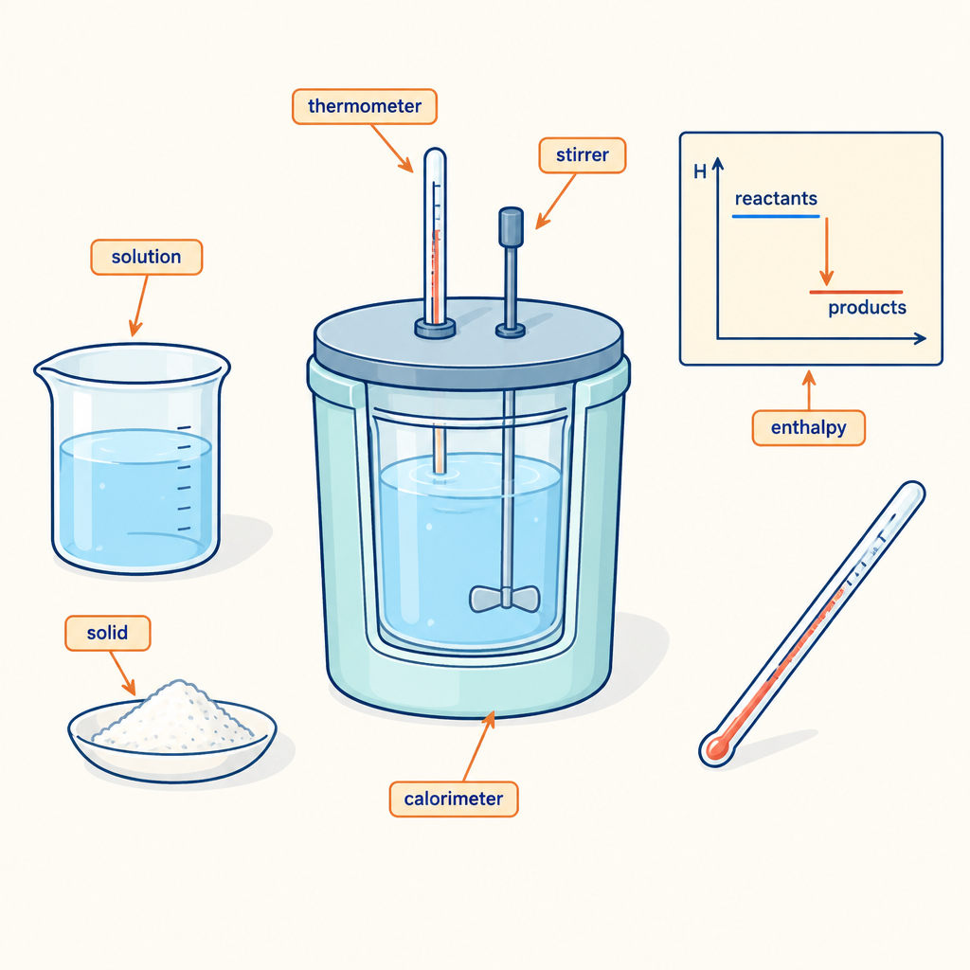
This brain teaser applies the heat transfer equation Q = mcΔt (Outcome, Outcome) and the definition of enthalpy for a chemical reaction (Outcome, Outcome) to a calorimetry data set, matching the way calorimetry data are used to determine enthalpy changes in the Chemistry 30 program (Outcome). The scenario mirrors the type of energy transfer measurement described in the nut-combustion calorimetry investigation (Resource) and connects to General Outcome 1, determining and interpreting energy changes in chemical reactions (Topic).

The puzzle
A student burns a small sample of fuel under a calorimeter containing 200.0 g of water. The water temperature rises from 21.5°C to 46.5°C. The specific heat capacity of water is 4.18 J/(g·°C).
The fuel sample has a molar mass of 46.0 g/mol, and the student burns 0.230 g of it during the trial.
Using ΔH notation, is the enthalpy change for this reaction, per mole of fuel burned, positive or negative? Calculate the molar enthalpy of combustion for this fuel, in kJ/mol, and state whether the reaction is exothermic or endothermic.
Assume no heat is lost to the surroundings or absorbed by the calorimeter itself.

Hints
Hint 1: Start by finding the heat absorbed by the water, Q, using Q = mcΔt. Remember that Δt means the change in temperature, final minus initial.
Hint 2: Once you have Q in joules, convert it to kilojoules, then find the number of moles of fuel burned using the mass of fuel and its molar mass.
Hint 3: Divide the heat released (in kJ) by the number of moles of fuel burned to get the molar enthalpy. Since the water gained heat, the fuel must have released it, so the sign of ΔH for the reaction should be negative.

Answer key
Step 1: Calculate Δt for the water.
Δt = 46.5°C − 21.5°C = 25.0°C
Step 2: Calculate Q, the heat absorbed by the water.
Q = mcΔt
Q = (200.0 g)(4.18 J/(g·°C))(25.0°C)
Q = 20 900 J
Q = 20.9 kJ
Step 3: Calculate the moles of fuel burned.
n = mass ÷ molar mass
n = 0.230 g ÷ 46.0 g/mol
n = 0.00500 mol
Step 4: Calculate the molar enthalpy of combustion.
ΔH = −Q ÷ n
ΔH = −20.9 kJ ÷ 0.00500 mol
ΔH = −4180 kJ/mol
The negative sign shows that the reaction releases energy to the surroundings, so the reaction is exothermic. The water absorbed the heat given off by the burning fuel, which is why the water's temperature rose while the fuel's chemical energy decreased.

AILI game · en · claude-sonnet-5 · 2026-09-17

