The Onion Under the Microscope
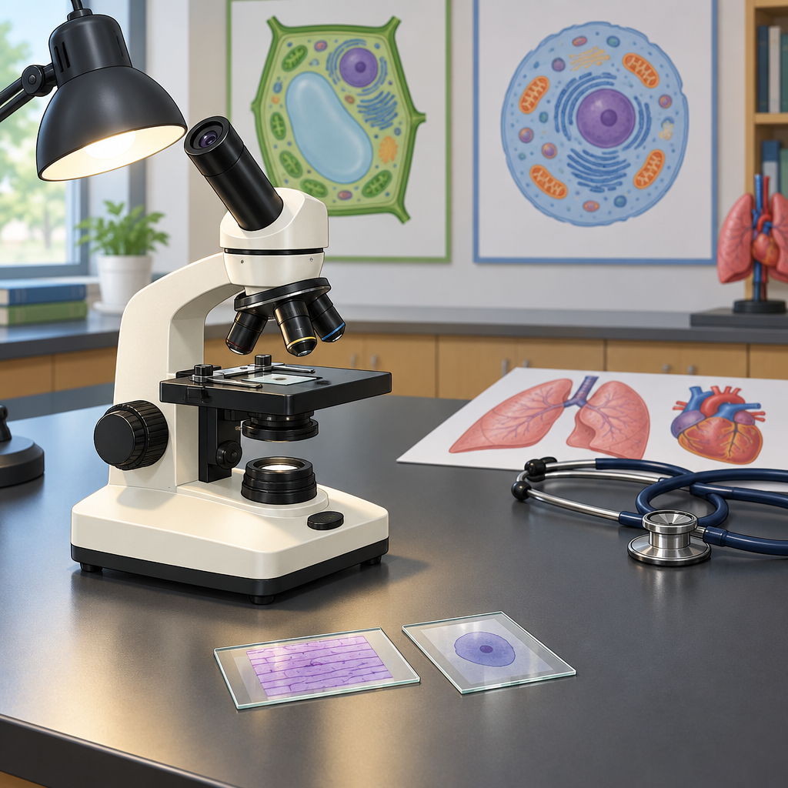
Priya slid the onion slice under the microscope. "Boxes," she said. "Look, tiny brick walls." "That's cell walls," said Tariq, checking his cheek cell slide beside her. "Mine's got no wall, just a squishy membrane. Plant versus animal." Ms. Okafor leaned in. "Both are basic units of life. One cell, or trillions, working together." Priya thought about her grandmother's garden. "So an amoeba and my grandma's poplar tree are both just cells doing their job?" "Exactly. Single-celled or multicelled, everything alive is built the same way, just organized differently." Tariq raised his hand. "Why does my heart race after gym, though?" "Your cells need more oxygen fast," said Ms. Okafor. "Blood carries it through your circulatory system, lungs pull it.

Words to know
- cell membrane: the thin covering around an animal cell that controls what moves in and out
- cell wall: the rigid outer layer that gives plant cells their boxy shape and support
- diffusion: the movement of gases or liquids from an area of higher concentration to lower concentration
- system: a group of parts, like organs or cells, working together to perform a function
- circulatory system: the body system that moves blood, oxygen and nutrients around the body
Curriculum link: Outcome, Outcome, Outcome, Outcome, Outcome, Topic
Listen to the narration

AILI audio story · en · claude-sonnet-5 · 2026-09-17

