Oxidation-Reduction Reactions
Chemistry 30, Unit B: Electrochemical Changes, General Outcome 1
Audience: Grade 12 Chemistry 30 students preparing for the diploma examination and post-secondary science programs
Grades: 12
Subjects: Chemistry 30, Science
Time: about 180 minutes
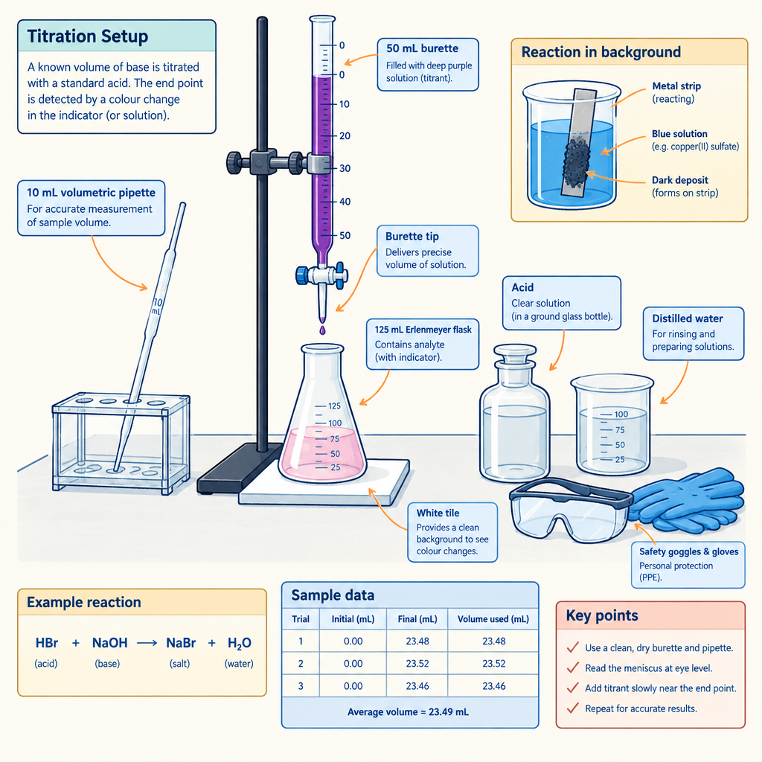

Overview
This unit pack covers General Outcome 1 of Unit B: Electrochemical Changes, in which students explain the nature of oxidation-reduction reactions (Topic). Four linked lessons move from operational and theoretical definitions of oxidation and reduction (Outcome, Outcome) through the use of a standard reduction potential table to predict spontaneity (Outcome, Outcome), balancing redox equations in acidic and neutral solutions (Outcome), and stoichiometric calculations for redox titrations (Outcome). Students distinguish redox reactions from other reaction types using half-reactions and oxidation numbers (Outcome) and rank oxidizing and reducing agents from empirical evidence (Outcome, Outcome).
Laboratory work anchors the theory. Students design a metal reactivity investigation and account for safe handling, storage and disposal of materials with reference to WHMIS and consumer product labelling (Outcome), perform a permanganate titration with correct equipment (Outcome), and communicate equations and titration answers in numeric, symbolic, graphical and linguistic form (Outcome). Applications connect the chemistry to corrosion prevention by physical coatings and cathodic protection (Outcome), to electron transfer in living and nonliving systems (Outcome, Outcome), and to industrial redox processes with intended and unintended consequences (Outcome). Timings total 180 minutes and assume a block schedule or four consecutive periods.

Outcomes covered
- Explain the nature of oxidation-reduction reactions. (Topic)
This general outcome frames the whole unit and sets the standard for diploma-level explanation of electron transfer.
- 30-B1.1k define oxidation and reduction operationally and theoretically. (Outcome)
Operational definitions describe what is observed in the lab; theoretical definitions describe electron transfer. Diploma questions require both.
- 30-B1.2k define oxidizing agent, reducing agent, oxidation number, half-reaction, disproportionation. (Outcome)
These five terms are the working vocabulary for every redox calculation and explanation in the unit.
- 30-B1.3k differentiate between redox reactions and other reactions, using half-reactions and/or oxidation numbers. (Outcome)
Classifying a reaction correctly determines whether a reduction potential table or an acid-base approach applies.
- 30-B1.4k identify electron transfer, oxidizing agents and reducing agents in redox reactions that occur in everyday life, in both living systems and nonliving systems; i.e., corrosion. (Outcome, Outcome)
Links formal notation to respiration, photosynthesis and rusting.
- 30-B1.5k compare the relative strengths of oxidizing and reducing agents, using empirical data. (Outcome)
Students build a reduction table from their own observations before relying on the printed data booklet table.
- 30-B1.6k predict the spontaneity of a redox reaction, based on standard reduction potentials, and compare their predictions to experimental results. (Outcome)
Prediction followed by comparison is the core assessment pattern in this unit.
- 30-B1.7k write and balance equations for redox reactions in acidic and neutral solutions by using half-reaction equations obtained from a standard reduction potential table, developing simple half-reaction equations from information provided about redox changes, and assigning oxidation numbers, where appropriate, to the species undergoing chemical change. (Outcome)
Balanced redox equations supply the mole ratio needed for every titration calculation.
- 30-B1.8k perform calculations to determine quantities of substances involved in redox titrations. (Outcome)
Redox titration stoichiometry appears in both the written and numerical-response sections of the diploma examination.
- 30-B1.1sts explain how the goal of technology is to provide solutions to practical problems, including describing the methods and devices used to prevent corrosion; i.e., physical coatings and cathodic protection. (Outcome)
Corrosion control on Alberta pipelines and bridges is an applied use of the reduction table.
- 30-B1.2sts explain that technological problems often require multiple solutions that involve different designs, materials and processes and that have both intended and unintended consequences. (Outcome)
Industrial redox processes such as pulp bleaching and water treatment carry trade-offs students must weigh.
- 30-B1.1s formulate questions about observed relationships and plan investigations, including designing an experiment to determine the reactivity of various metals and describing procedures for the safe handling, storage and disposal of materials used in the laboratory, with reference to WHMIS and consumer product labelling information. (Outcome)
Experimental design and WHMIS documentation are assessed skills, not optional preliminaries.
- 30-B1.2s conduct investigations into relationships among observable variables, selecting and correctly using the appropriate equipment to perform a redox titration experiment and using a standard reduction potential table as a tool when considering the spontaneity of redox reactions and their products. (Outcome)
Burette technique and correct use of the data booklet table are hands-on requirements of the course.
- 30-B1.3s analyze data and apply mathematical and conceptual models to develop and assess possible solutions, including evaluating data from an experiment to derive a simple reduction table. (Outcome)
Deriving a reduction table from evidence shows how the printed table was constructed.
- 30-B1.4s work collaboratively in addressing problems and apply the skills and conventions of science in communicating information and ideas, selecting and using appropriate numeric, symbolic, graphical and linguistic modes of representation to communicate equations for redox reactions and answers to problems related to redox titrations. (Outcome)
Diploma marking rewards correct notation, significant digits and units alongside the numerical answer.

Materials
- Alberta Chemistry Data Booklet with the table of standard reduction potentials
- Well plates or small test tubes, test tube racks
- Metal strips: copper, zinc, lead, magnesium (cleaned with emery paper)
- 0.10 mol/L solutions of copper(II) nitrate, zinc nitrate, lead(II) nitrate, magnesium nitrate
- 0.0200 mol/L potassium permanganate solution
- Iron(II) ammonium sulfate solution of unknown concentration (approximately 0.10 mol/L)
- 1.0 mol/L sulfuric acid
- 50 mL burettes, burette clamps, retort stands, 10 mL volumetric pipettes, pipette bulbs, 125 mL Erlenmeyer flasks, wash bottles, white tile or paper
- Safety goggles, aprons, nitrile gloves
- WHMIS labels and Safety Data Sheets for permanganate, sulfuric acid and metal nitrate solutions
- Waste containers labelled for heavy metal solutions and for acidified manganese waste
- Steel nails, one galvanized nail, one painted nail, one nail wrapped with magnesium ribbon, one nail wrapped with copper wire
- Petri dishes, agar, phenolphthalein and potassium hexacyanoferrate(III) indicator solution for the corrosion demonstration
- Calculators, graph paper or spreadsheet access

Sequence of activities

1. Lesson 1: Defining Oxidation and Reduction, and Sorting Redox from Non-Redox (45 min, whole class)
- Learning intention posted: I can define oxidation and reduction operationally and theoretically (Outcome), use the terms oxidizing agent, reducing agent, oxidation number, half-reaction and disproportionation correctly (Outcome), and decide whether a given reaction is a redox reaction (Outcome).
- Success criteria: I state both an operational and a theoretical definition for oxidation; I assign oxidation numbers to every element in a formula; I write two half-reactions that add to the net equation; I justify a redox or non-redox classification with evidence from oxidation numbers.
- Demonstration (8 min). Place a cleaned strip of zinc in 0.10 mol/L copper(II) nitrate on the document camera. Students record observations: the blue colour fades, a red-brown deposit coats the zinc, the solution warms slightly. Ask for an operational definition based only on these observations, then for the theoretical definition in terms of electron loss and gain (Outcome).
- Direct instruction (12 min). Write the two half-reactions on the board:
Zn(s) → Zn2+(aq) + 2 e− (oxidation)
Cu2+(aq) + 2 e− → Cu(s) (reduction)
Net: Zn(s) + Cu2+(aq) → Zn2+(aq) + Cu(s)
Name zinc the reducing agent because it supplies electrons and is oxidized; name Cu2+ the oxidizing agent because it accepts electrons and is reduced (Outcome).
- Oxidation number rules (10 min). Review the rules and apply them to worked examples. Answers: in MnO4−, oxygen is −2 and manganese is +7; in Cr2O7 2−, chromium is +6; in H2O2, oxygen is −1; in S4O6 2−, sulfur averages +2.5, which is acceptable as an average value.
- Sorting task (10 min). Post six equations. Students assign oxidation numbers and classify each. Answers:
(a) 2 Na(s) + Cl2(g) → 2 NaCl(s): redox, sodium 0 to +1, chlorine 0 to −1.
(b) HCl(aq) + NaOH(aq) → NaCl(aq) + H2O(l): not redox, no oxidation number changes.
(c) AgNO3(aq) + NaCl(aq) → AgCl(s) + NaNO3(aq): not redox, precipitation only.
(d) CH4(g) + 2 O2(g) → CO2(g) + 2 H2O(g): redox, carbon −4 to +4, oxygen 0 to −2.
(e) Cl2(g) + 2 OH−(aq) → Cl−(aq) + ClO−(aq) + H2O(l): redox and a disproportionation, chlorine goes from 0 to both −1 and +1 (Outcome).
(f) CaCO3(s) → CaO(s) + CO2(g): not redox.
- Everyday redox (5 min). Students identify the oxidizing and reducing agents in cellular respiration, C6H12O6(s) + 6 O2(g) → 6 CO2(g) + 6 H2O(l), where oxygen is the oxidizing agent and glucose the reducing agent, and in rusting, 4 Fe(s) + 3 O2(g) → 2 Fe2O3(s), where iron is oxidized and oxygen is reduced (Outcome, Outcome).
- Exit ticket: classify Zn(s) + 2 HCl(aq) → ZnCl2(aq) + H2(g) and name both agents. Answer: redox, zinc is the reducing agent, H+ is the oxidizing agent.
Common error: students call the substance oxidized the oxidizing agent. Insist on the sentence frame "X is oxidized, therefore X is the reducing agent." Keep the zinc and copper(II) nitrate demonstration running through the period so the deposit is obvious by the exit ticket. Collect metal-ion waste in the labelled heavy metal container rather than the sink (Outcome).
Sources: Topic, Outcome, Outcome, Outcome, Outcome, Outcome, Outcome

2. Lesson 2: Metal Reactivity Investigation and Deriving a Reduction Table (50 min, small group)
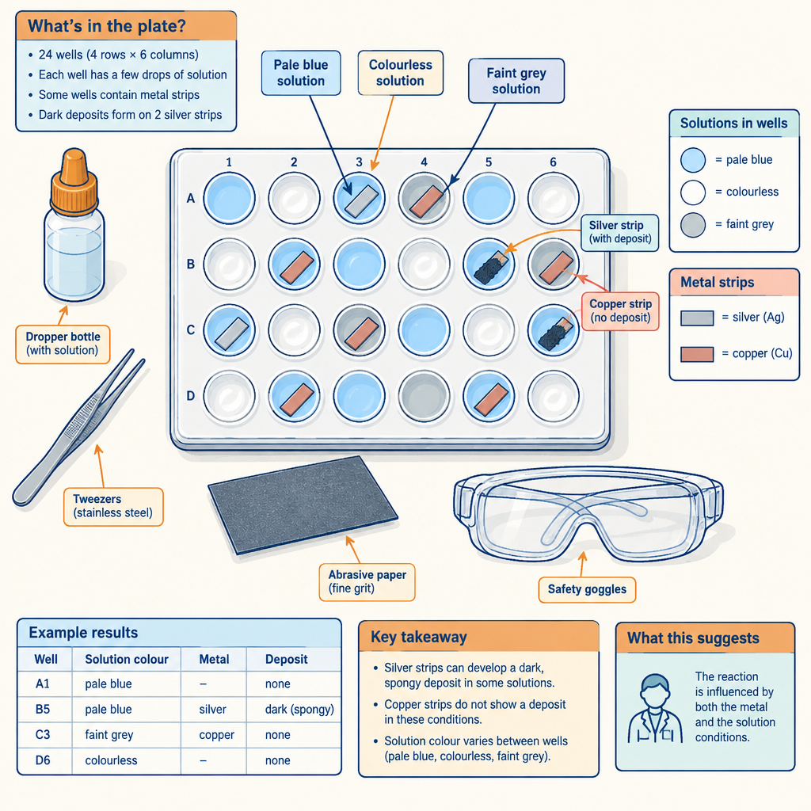
- Learning intention: I can design and carry out an experiment to determine the reactivity of various metals (Outcome), rank oxidizing and reducing agents from empirical data (Outcome), and derive a simple reduction table from my results (Outcome).
- Safety and WHMIS briefing (8 min). Groups locate the SDS for lead(II) nitrate and copper(II) nitrate, record the WHMIS pictograms, and write one sentence each on safe handling, storage and disposal for the solutions they will use, along with the consumer product label information for the emery paper and any commercial cleaner used (Outcome). No solution enters the drain; all waste goes to the heavy metal container.
- Planning (7 min). Each group of three writes a testable question, for example: which of magnesium, zinc, lead and copper is the strongest reducing agent? Groups state the manipulated variable (identity of metal and ion), the responding variable (evidence of reaction), and at least two controlled variables (solution concentration 0.10 mol/L, contact time, metal surface preparation). Teacher approves plans before any chemicals are distributed.
- Performing (15 min). Using a well plate, groups place one drop of each of the four 0.10 mol/L metal ion solutions in each row and add a small cleaned piece of each metal to each column, giving a 4 by 4 grid with four blanks on the diagonal. Record evidence of reaction: a dark or coloured deposit, loss of colour, gas, temperature change.
- Recording (5 min). Groups build a results table with a check mark for reaction and a dash for no reaction. Expected results: magnesium reacts with Zn2+, Pb2+ and Cu2+; zinc reacts with Pb2+ and Cu2+; lead reacts with Cu2+; copper reacts with none of them.
- Analyzing (10 min). Groups order the metal ions from strongest to weakest oxidizing agent: Cu2+ > Pb2+ > Zn2+ > Mg2+, and the metals from strongest to weakest reducing agent: Mg > Zn > Pb > Cu (Outcome). They write the four reduction half-reactions in this order to form their own reduction table (Outcome).
- Comparison (5 min). Groups compare their derived table with the standard reduction potential table in the data booklet. Expected standard reduction potentials: Cu2+ + 2 e− → Cu at +0.34 V, Pb2+ + 2 e− → Pb at −0.13 V, Zn2+ + 2 e− → Zn at −0.76 V, Mg2+ + 2 e− → Mg at −2.37 V. Students state one limitation of their data, such as slow reactions that appear to be no reaction within the observation window, or surface oxide layers on magnesium (Outcome).
Pre-clean the metal strips or provide emery paper; an oxide coating on magnesium and zinc is the most common cause of false negatives. Lead(II) nitrate requires gloves and careful disposal; substitute tin(II) chloride if lead is restricted in your division. If a group reports copper reacting with Zn2+, check whether they mistook a dirty strip for a deposit. Formative checkpoint: circulate and ask each group to justify one ranking using a specific observation rather than the data booklet.
Sources: Outcome, Outcome, Outcome, Outcome

3. Lesson 3: Predicting Spontaneity and Balancing Redox Equations (45 min, pairs)
- Learning intention: I can predict the spontaneity of a redox reaction from standard reduction potentials and compare the prediction to experimental results (Outcome), and I can write and balance redox equations in acidic and neutral solutions (Outcome).
- Spontaneity method (10 min). Teacher models the five-step procedure: list all entities present, identify the strongest oxidizing agent (highest on the reduction table, leftmost side) and the strongest reducing agent (lowest, rightmost side), write the reduction and oxidation half-reactions, balance electrons, and calculate the cell potential as E(cathode) minus E(anode). A positive value predicts a spontaneous reaction.
- Worked example (7 min). A solution containing Cu2+ and Ag+ is added to solid zinc. Strongest oxidizing agent is Ag+ at +0.80 V; strongest reducing agent is Zn(s) at −0.76 V.
2 Ag+(aq) + 2 e− → 2 Ag(s)
Zn(s) → Zn2+(aq) + 2 e−
Net: Zn(s) + 2 Ag+(aq) → Zn2+(aq) + 2 Ag(s), E° = 0.80 − (−0.76) = +1.56 V, spontaneous.
- Comparison to evidence (5 min). Pairs return to the Lesson 2 data table and confirm that every reaction they observed corresponds to a positive calculated cell potential, and that copper with Zn2+ gives E° = −0.76 − 0.34 = −1.10 V, consistent with no observed reaction (Outcome).
- Balancing in acidic solution, half-reaction method (13 min). Model the oxidation of iron(II) by permanganate in acidic solution (Outcome):
MnO4−(aq) + 8 H+(aq) + 5 e− → Mn2+(aq) + 4 H2O(l)
Fe2+(aq) → Fe3+(aq) + e−
Multiply the iron half-reaction by 5 and add:
MnO4−(aq) + 8 H+(aq) + 5 Fe2+(aq) → Mn2+(aq) + 4 H2O(l) + 5 Fe3+(aq)
Check that atoms and charge balance: left charge is −1 + 8 + 10 = +17; right charge is +2 + 15 = +17.
- Guided practice (10 min). Pairs balance three equations and verify charge.
(a) Cr2O7 2−(aq) + Fe2+(aq) in acidic solution. Answer: Cr2O7 2− + 14 H+ + 6 Fe2+ → 2 Cr3+ + 7 H2O + 6 Fe3+.
(b) Zinc metal reacting with acidified dichromate. Answer: Cr2O7 2− + 14 H+ + 3 Zn → 2 Cr3+ + 7 H2O + 3 Zn2+.
(c) Develop a half-reaction from information: a student reports that colourless SO3 2−(aq) is converted to SO4 2−(aq) in neutral solution. Answer: SO3 2−(aq) + H2O(l) → SO4 2−(aq) + 2 H+(aq) + 2 e−, an oxidation of sulfur from +4 to +6 (Outcome).
- Checkpoint question for the class: state whether acidified permanganate will oxidize chloride ion to chlorine, given E° for Cl2 + 2 e− → 2 Cl− is +1.36 V and for MnO4− + 8 H+ + 5 e− → Mn2+ + 4 H2O is +1.51 V. Answer: yes, E° = 1.51 − 1.36 = +0.15 V, spontaneous, which is why hydrochloric acid is not used to acidify permanganate titrations.
Require the data booklet on every desk; students who memorize the order of the table instead of reading it lose marks on unfamiliar couples. Watch for pairs who multiply the half-reaction coefficients but forget to multiply the electrons. The chloride checkpoint sets up the choice of sulfuric acid in Lesson 4, so do not skip it. Students who finish early can balance the disproportionation of Cl2 in basic conditions and identify it by name (Outcome).
Sources: Outcome, Outcome, Outcome, Outcome

4. Lesson 4: Redox Titration, Corrosion Technology and Industrial Applications (40 min, small group)
- Learning intention: I can perform a redox titration with the correct equipment (Outcome), calculate the quantity of substance from titration data (Outcome), communicate the result with correct notation, units and significant digits (Outcome), and explain corrosion prevention and industrial redox applications (Outcome, Outcome).
- Set-up (5 min). Groups rinse a 50 mL burette with 0.0200 mol/L potassium permanganate, mount it on a retort stand with a burette clamp, pipette 10.00 mL of the iron(II) solution into a 125 mL Erlenmeyer flask using a volumetric pipette and bulb, and add about 10 mL of 1.0 mol/L sulfuric acid. Sulfuric acid is used rather than hydrochloric acid for the reason established in Lesson 3.
- Titration (12 min). Titrate to the first persistent faint pink endpoint, which is self-indicating. Discard the first rough trial, then complete three trials that agree within 0.2 mL. Record initial and final burette readings to 0.01 mL in a prepared data table (Outcome).
- Calculation (10 min). Worked example using an average titre of 8.20 mL.
Balanced equation: MnO4− + 8 H+ + 5 Fe2+ → Mn2+ + 4 H2O + 5 Fe3+ (Outcome).
Moles MnO4− = 0.0200 mol/L × 0.00820 L = 1.64 × 10^−4 mol.
Moles Fe2+ = 5 × 1.64 × 10^−4 mol = 8.20 × 10^−4 mol.
Concentration of Fe2+ = 8.20 × 10^−4 mol ÷ 0.01000 L = 0.0820 mol/L, reported to three significant digits (Outcome, Outcome).
- Communication (3 min). Each group submits the balanced equation in symbolic form, the data in a table, the calculation with units carried through, and one sentence in words stating the concentration and its uncertainty source (Outcome).
- Corrosion stations (5 min). Circulate past four prepared petri dishes set up the previous day: a bare steel nail, a galvanized nail, a painted nail, and a nail wrapped with magnesium ribbon, each in agar with phenolphthalein and hexacyanoferrate(III) indicator. Expected results: blue colour around the bare nail shows Fe2+ formation; the galvanized, painted and magnesium-protected nails show little or no blue, with pink around the magnesium showing cathodic protection. Students name the physical coating methods and the cathodic protection method and explain each with half-reactions (Outcome, Outcome).
- Industrial discussion and closure (5 min). Groups take one process from pulp and paper bleaching, textile dyeing, municipal water treatment with chlorine or ozone, and food processing with antioxidants, and state the intended consequence and one unintended consequence, for example chlorination that disinfects drinking water while forming trihalomethane by-products (Outcome). Each group reports in one sentence.
Prepare the agar corrosion dishes at least 24 hours in advance. Permanganate stains skin and clothing; require gloves and have sodium thiosulfate on hand. Acidified manganese waste goes to its own labelled container (Outcome). Common calculation errors: inverting the 5 to 1 ratio, and using the burette volume in millilitres without converting to litres. Accept answers between roughly 0.075 and 0.090 mol/L depending on the stock solution you prepare, and report the accepted value at the end so students can calculate percent error.
Sources: Outcome, Outcome, Outcome, Outcome, Outcome, Outcome, Outcome, Outcome

Differentiation
Extension
- Ask students to balance a redox equation in basic solution by first balancing in acidic solution and then adding hydroxide to both sides, and to explain why the course focuses on acidic and neutral conditions (Outcome).
- Assign a back-titration problem: excess acidified permanganate is added to a hydrogen peroxide sample and the excess is titrated with iron(II). Students calculate the mass of peroxide present (Outcome).
- Have students research the reduction potentials involved in impressed-current cathodic protection on an Alberta pipeline and compare it with sacrificial anode protection (Outcome).
- Ask students to evaluate a published industrial process, such as chlorine dioxide bleaching in pulp mills, against an alternative such as oxygen delignification, and argue which trade-off set is preferable (Outcome).
Support
- Provide a laminated oxidation number rules card and a half-reaction balancing checklist with the steps in order (Outcome).
- Give a partially completed results grid for the metal reactivity investigation so students record observations rather than construct the table format (Outcome).
- Supply the balanced titration equation and a mole-ratio flow chart so students practise the calculation before they must derive the equation themselves (Outcome).
- Pair students who struggle with data booklet navigation with a peer for the spontaneity practice, and highlight the relevant rows of the reduction table in advance (Outcome).
- Offer a sentence frame for definitions: "Operationally, oxidation is observed when... Theoretically, oxidation is the loss of electrons by..." (Outcome).
Inclusive supports
- Read SDS and WHMIS information aloud and provide a pictogram key with plain-language descriptions for students with reading difficulties (Outcome).
- Allow spreadsheet entry of titration data for students whose handwriting or fine motor control makes a burette reading table difficult, and pair them with a partner who operates the stopcock (Outcome).
- Colour-blind students may not distinguish the faint pink permanganate endpoint; pair them with a partner for endpoint calls and provide a white tile with strong lighting.
- Accept oral explanation in place of written explanation for the corrosion station and industrial application tasks (Outcome, Outcome).
- Post the learning intention and success criteria in writing and keep them visible for the full lesson.

Assessment
Formative. Lesson 1 exit ticket: classify Zn(s) + 2 HCl(aq) → ZnCl2(aq) + H2(g) as redox or non-redox, assign oxidation numbers, and name the oxidizing and reducing agents.
Look for: Student identifies zinc changing from 0 to +2 and hydrogen from +1 to 0, names zinc as the reducing agent and H+ as the oxidizing agent, and states both an operational and a theoretical justification. (Outcome, Outcome, Outcome)
Formative. Teacher approval of each group's experimental design before chemicals are distributed in Lesson 2, including the WHMIS and disposal statements.
Look for: Plan names a testable question, one manipulated and one responding variable, at least two controlled variables, and correct handling, storage and disposal procedures referenced to WHMIS pictograms and product labels. (Outcome)
Formative. Circulating check during Lesson 3: each pair states whether a named reaction is spontaneous and shows the cell potential calculation.
Look for: Pair reads the correct couples from the standard reduction potential table, computes E° as cathode minus anode, and links a positive value to a spontaneous reaction observed in the Lesson 2 data. (Outcome, Outcome)
Summative. Lab report on the metal reactivity investigation: derived reduction table, comparison with the data booklet values, and a statement of two limitations of the data.
Look for: Metals ranked Mg > Zn > Pb > Cu as reducing agents with each ranking tied to a specific observation, half-reactions written correctly, and limitations identified such as oxide coatings or slow kinetics. (Outcome, Outcome)
Summative. Redox titration submission: balanced equation, data table with burette readings to 0.01 mL, full calculation with units, and the concentration of the iron(II) solution reported to the correct number of significant digits.
Look for: Equation balanced for atoms and charge, three concordant trials within 0.2 mL, mole ratio of 5 Fe2+ to 1 MnO4− applied correctly, and the answer expressed in mol/L with a stated source of uncertainty. (Outcome, Outcome, Outcome, Outcome)
Summative. Short written response: explain how galvanizing, painting and a magnesium sacrificial anode each protect steel, using half-reactions, and identify the oxidizing and reducing agents in rusting.
Look for: Student distinguishes physical coatings from cathodic protection, writes the oxidation of iron and the reduction of oxygen, and explains why magnesium is oxidized in preference to iron using the reduction table. (Outcome, Outcome, Outcome)
Peer. Group exchange of the industrial application statements from Lesson 4; each group critiques another group's identification of intended and unintended consequences.
Look for: Critique names at least one consequence the original group missed and refers to the redox chemistry of the process rather than general environmental language. (Outcome, Outcome)
Self. End-of-unit self-check against the success criteria, with students rating their confidence on assigning oxidation numbers, balancing in acidic and neutral solutions, predicting spontaneity, and completing titration calculations.
Look for: Student identifies at least one specific outcome to review and names the practice problem type they will use. (Outcome, Outcome, Outcome)

Vocabulary
- Oxidation: Operationally, the change observed when a substance reacts with oxygen, loses mass as a metal electrode, or produces a characteristic colour change in a test. Theoretically, the loss of electrons by an entity, shown by an increase in oxidation number (Outcome).
- Reduction: Operationally, the change observed when a metal deposits on an electrode or a coloured ion such as MnO4− is decolourized. Theoretically, the gain of electrons by an entity, shown by a decrease in oxidation number (Outcome).
- Oxidizing agent: The entity that accepts electrons in a redox reaction and is itself reduced. Example: MnO4− in acidified solution (Outcome).
- Reducing agent: The entity that supplies electrons in a redox reaction and is itself oxidized. Example: Zn(s) in a zinc and copper(II) cell (Outcome).
- Oxidation number: A signed number assigned to an atom in a formula using a set of rules, used to track electron transfer. In MnO4−, oxygen is −2 and manganese is +7 (Outcome).
- Half-reaction: An equation showing only the oxidation or only the reduction, with electrons written explicitly. Example: Fe2+(aq) → Fe3+(aq) + e− (Outcome).
- Disproportionation: A redox reaction in which one entity is both oxidized and reduced. Example: Cl2(g) + 2 OH−(aq) → Cl−(aq) + ClO−(aq) + H2O(l), where chlorine goes from 0 to −1 and to +1 (Outcome).
- Standard reduction potential: The voltage assigned to a reduction half-reaction relative to the standard hydrogen electrode, tabulated in the data booklet and used to predict spontaneity (Outcome, Outcome).
- Spontaneous redox reaction: A reaction in which the oxidizing agent sits above the reducing agent on the standard reduction potential table, giving a positive cell potential (Outcome).
- Redox titration: A volumetric analysis in which a solution of known concentration of an oxidizing or reducing agent is added to a measured sample until the equivalence point, used to determine the quantity of the unknown (Outcome, Outcome).
- Cathodic protection: A corrosion prevention method in which a more easily oxidized metal, such as magnesium, is connected to the structure so that it is oxidized instead of the iron (Outcome).
- Physical coating: A corrosion barrier such as paint, oil or a zinc galvanizing layer that separates the metal from oxygen and water (Outcome).

For families
- Ask your student to explain what happens inside a rusting car panel or a dying battery using the words oxidizing agent and reducing agent. Explaining aloud is one of the fastest ways to find gaps before a diploma examination (Outcome).
- The Alberta Chemistry Data Booklet is permitted on the diploma examination. Encourage your student to practise with it open rather than memorizing the reduction table (Outcome).
- Redox titration questions carry several steps. Suggest your student work in units throughout, litres and moles per litre rather than millilitres, since most lost marks come from conversion errors rather than chemistry errors (Outcome, Outcome).
- Household examples are worth discussing: bleach, hydrogen peroxide and the antioxidants listed on food labels are all redox chemistry, as is the galvanized coating on outdoor hardware (Outcome, Outcome).

Sources
- Topic: "Students will explain the nature of oxidation-reduction reactions."
- Outcome: "design an experiment to determine the reactivity of various metals"
- Outcome: "select and use appropriate numeric, symbolic, graphical and linguistic modes of representation to communicate equations for redox reactions and answers to problems related to redox titrations"
- Outcome: "30-B1.7k write and balance equations for redox reactions in acidic and neutral solutions"
- Outcome: "30-B1.3k differentiate between redox reactions and other reactions, using half-reactions and/or oxidation numbers"
- Outcome: "30-B1.1k define oxidation and reduction operationally and theoretically"
- Outcome: "analyze redox reactions used in industry and commerce, such as pulp and paper, textiles, water treatment and food processing"
- Outcome: "30-B1.5k compare the relative strengths of oxidizing and reducing agents, using empirical data"
- Outcome: "describe the methods and devices used to prevent corrosion; i.e., physical coatings and cathodic protection"
- Outcome: "30-B1.2k define oxidizing agent, reducing agent, oxidation number, half-reaction, disproportionation"
- Outcome: "30-B1.8k perform calculations to determine quantities of substances involved in redox titrations."
- Outcome: "use a standard reduction potential table as a tool when considering the spontaneity of redox reactions and their products"
- Outcome: "evaluate data from an experiment to derive a simple reduction table"
- Outcome: "30-B1.4k identify electron transfer, oxidizing agents and reducing agents in redox reactions that occur in everyday life"
- Outcome: "30-B1.6k predict the spontaneity of a redox reaction, based on standard reduction potentials, and compare their predictions to experimental results"
- Outcome: "in both living systems (e.g., cellular respiration, photosynthesis) and nonliving systems; i.e., corrosion"

The content is written at Chemistry 30 level for students aged fifteen to eighteen, includes WHMIS-referenced handling and disposal procedures for every chemical used, and contains no culturally insensitive material.

AILI detailed pack · en · claude-opus-5 · 2026-09-17

