The Particle Model of Matter
All matter is made of tiny moving particles with spaces between them.
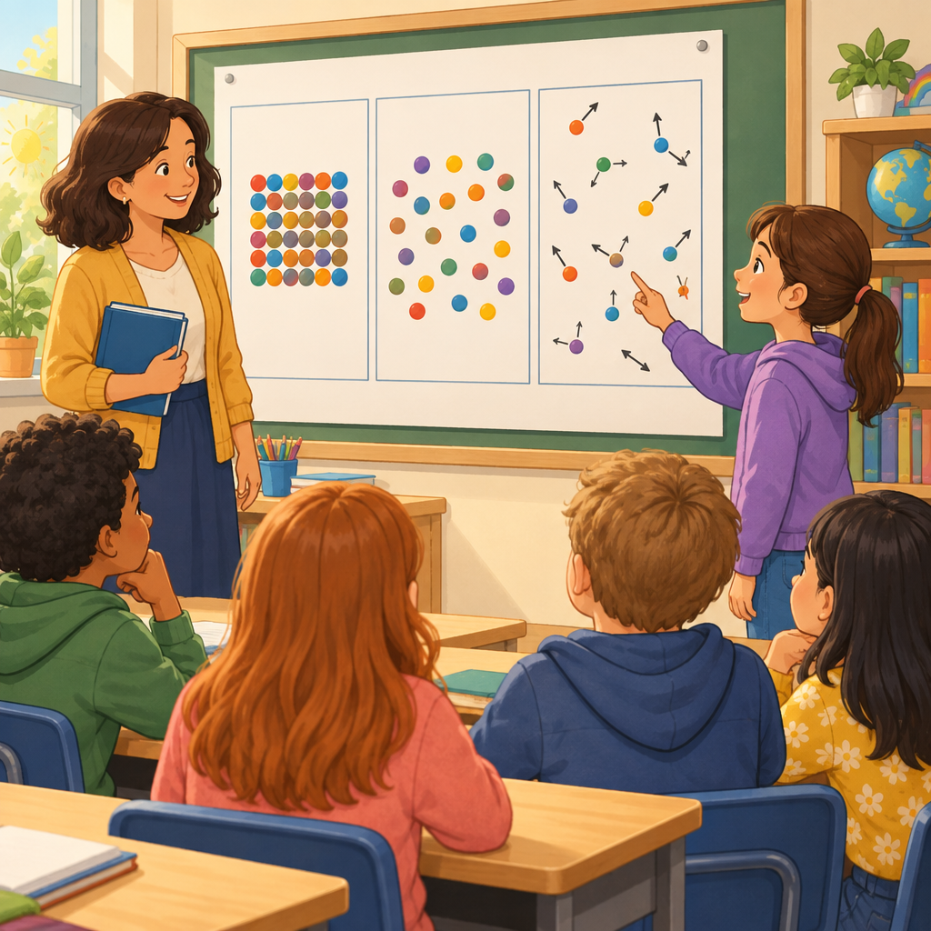

Learning intentions
We are learning to explain the states of matter using the particle model (Outcome).

Success criteria
I can describe how particles are arranged and move in solids, liquids, and gases (Skills).
I can explain how attractive forces affect particles in different states of matter (Skills).
I can represent solids, liquids, and gases using a particle model diagram (Skills).

Curriculum alignment
Aligns to Outcome, Knowledge, Skills, Understanding, Understanding.

Materials
Per student or pair:
- A copy of the particle model diagram template (three empty boxes labelled Solid, Liquid, Gas)
- Coloured pencils or markers
- Small objects to observe: a wooden block, a cup of water, an inflated balloon
- Optional: magnifying glass
Per class:
- Large poster or whiteboard showing the three states of matter
- A container of water and a syringe (or bicycle pump) to demonstrate compressibility

Lesson sequence
1. Hook (5 minutes)
Show the class three objects: a wooden block, a cup of water, and an inflated balloon. Hold them up one at a time and ask:
"What do all three of these things have in common?"
Allow students to respond. Guide them toward the idea that they are all made of matter. Then ask:
"Why does the block feel hard and keep its shape, but the water flows and takes the shape of the cup, and the air in the balloon spreads out to fill the whole balloon?"
Tell students that today they will learn a secret about matter that explains all of these differences. The secret is about particles so tiny we cannot see them.
2. Direct instruction (12 minutes)
Introduce the particle model of matter. Explain:
"Everything around us is made of tiny particles. These particles are so small we cannot see them with our eyes, but scientists use a model to help us understand how they work. A model is a way of thinking about something we cannot see directly."
Write on the board or display:
All matter is made up of small particles.
Particles of matter are always moving.
Particles of matter have spaces between them.
Read each statement aloud and explain:
"Particles are the smallest pieces of matter. Think of them like building blocks. Just as you can build different shapes with blocks, particles build everything around us."
"Even though particles look still to us, they are always moving. In a solid, they vibrate in place, like you bouncing up and down on the same spot. In a liquid, they move around and slide past each other. In a gas, they zoom around very fast in all directions."
"There are spaces between particles. In a solid, the particles are packed very close together, so the spaces are tiny. In a liquid, there are bigger spaces between particles. In a gas, there are huge spaces between particles, which is why gas spreads out so much."
Now explain attractive forces:
"Particles pull on each other. This pull is called an attractive force. In a solid, the attractive forces are very strong, so particles stay close together and vibrate in place. In a liquid, the attractive forces are weaker, so particles can move around. In a gas, the attractive forces are very weak, so particles spread out and move freely" (Knowledge).
3. Guided practice (15 minutes)
Draw three large boxes on the board or display them on a poster. Label them Solid, Liquid, and Gas.
Work with the class to draw the particle model for each state.
For the solid box, draw about 12 small circles packed closely together. Add small arrows pointing in different directions to show vibration. Say:
"In a solid, particles are close together and vibrate in place. The attractive forces are strong, so they stay where they are."
For the liquid box, draw about 10 circles with more space between them. Add arrows showing particles moving and sliding past each other. Say:
"In a liquid, particles have more space between them. They can move and slide past each other, which is why liquid can flow and change shape."
For the gas box, draw about 6 circles spread far apart. Add arrows pointing in many directions showing fast movement. Say:
"In a gas, particles are far apart and moving very fast in all directions. The attractive forces are weak, so particles spread out as much as they can."
Now ask students to explain what they see:
"Why does a solid keep its shape?" (Particles are close together and vibrate in place.)
"Why can a liquid flow and change shape?" (Particles can slide past each other.)
"Why does a gas spread out to fill a container?" (Particles are far apart and move in all directions.)
Demonstrate compressibility (optional but powerful). Fill a syringe with water and try to push the plunger. It will not move much. Then fill a syringe with air and push the plunger. The air compresses easily. Ask:
"Why can we squeeze the air but not the water?" (In a gas, there are large spaces between particles, so they can be pushed closer together. In a liquid, particles are already close, so there is little room to compress.)
4. Independent practice (6 minutes)
Give each student or pair the particle model diagram template with three empty boxes.
Instruct students to draw the particle model for solids, liquids, and gases in their boxes. They should:
- Draw particles (circles or dots) in each box
- Show the spacing between particles
- Add arrows to show movement
- Label each state
Circulate and ask students to explain their drawings:
"Tell me about your solid. How are the particles arranged? How are they moving?"
"Why did you draw the gas particles so far apart?"
5. Consolidation (2 minutes)
Bring the class back together. Ask three students to share their diagrams and explain one thing they drew.
Ask the whole class:
"If I told you a material is hard and keeps its shape, what would the particle model look like?" (Particles close together, vibrating in place.)
"If I told you a material spreads out to fill any container, what would the particle model look like?" (Particles far apart, moving in all directions.)
Close by saying:
"The particle model helps us understand why matter behaves the way it does. When you see a solid, a liquid, or a gas, you can now think about the particles inside and how they are moving and arranged."

Differentiation
Extension
Ask students to predict what happens to particles when matter changes state. For example:
"If we heat ice, it melts into water. What do you think happens to the particles? Do they stay the same distance apart, or do they move differently?"
Challenge students to draw the particle model for ice, water, and water vapour and explain how the particles change.
Introduce the term "density" in relation to particles: "If two objects have the same volume but different masses, which one has particles packed more tightly together?" Have students predict which would be denser.
Support
Provide a partially completed particle model diagram where some particles are already drawn. Ask students to add the remaining particles and arrows.
Use physical models: have students stand in a circle (gas), then move closer together and move slowly (liquid), then stand very close and vibrate in place (solid). This helps kinesthetic learners understand particle arrangement and movement.
Pair students with a stronger reader or speaker to discuss the diagrams together.
Focus on one state of matter at a time rather than all three at once.

Assessment
Formative check: Particle model representation
During independent practice, observe students' diagrams and ask each student or pair one of these questions:
"Show me where the particles are closest together. Why did you draw them that way?"
"Which state of matter has particles moving the fastest? How can you show that in your drawing?"
"In your liquid, the particles have spaces between them. Can they still flow and change shape? Why?"
What to look for:
- Solids show particles close together with small vibration arrows
- Liquids show particles with moderate spacing and movement arrows showing sliding motion
- Gases show particles far apart with arrows pointing in many directions
- Student can explain the connection between particle arrangement and the properties of each state (Understanding)
- Student uses the term "attractive forces" or describes particles "pulling" or "sticking" to each other
If a student draws all three states with the same particle spacing or movement, pause and ask: "In a gas, do particles have more space or less space than in a solid?" Guide them to revise their drawing.

AILI rapid lesson · en · claude-haiku-4-5-20251001 · 2026-09-17

