The Cashew Test
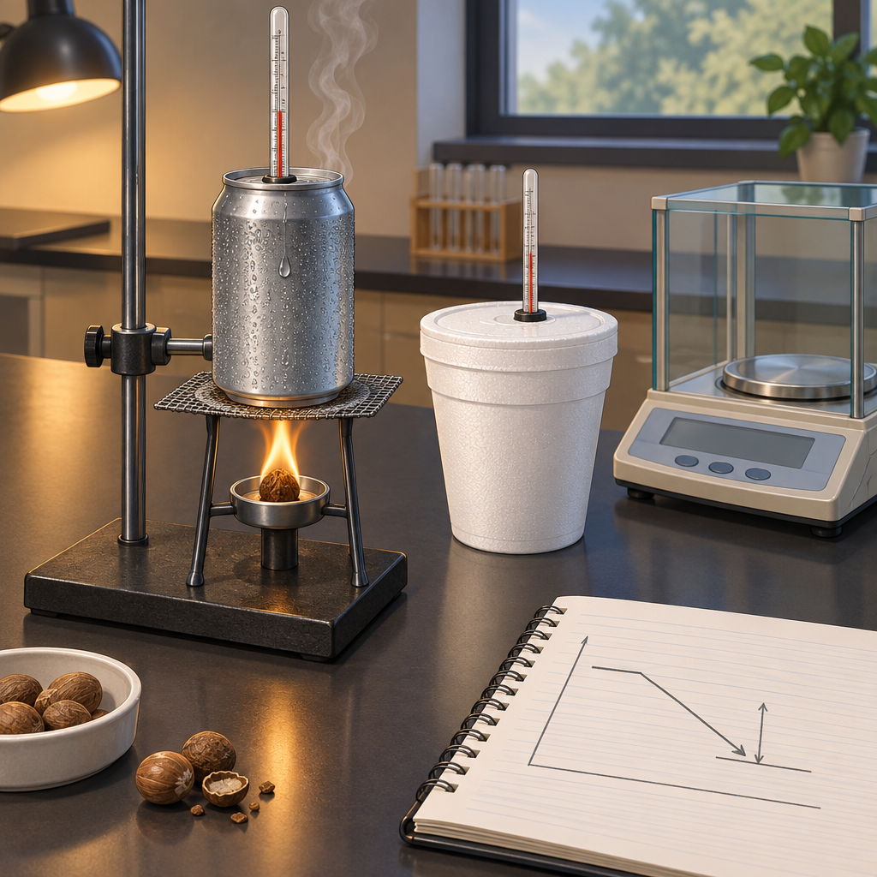
Priya clamped a cashew under a soda can of water and lit it with a match. "Watch the thermometer," she told Devon. "That's our whole lab." The flame flickered orange under the can. Water climbed from 21°C to 34°C. "Thirteen degrees," Devon said, scribbling. "Now we use Q equals mcΔt." He multiplied the mass of water, its specific heat capacity, and the temperature change. "That's the heat absorbed by the water," Priya said. "Same amount left the cashew, so the enthalpy change for the combustion is that value with a negative sign — ΔH is negative because the reaction is exothermic." "That's the total heat released — divide by the mass burned for energy per gram, or by the moles burned for the molar enthalpy." Devon frowned at his polystyrene cup calorimeter from last week. "Ours read low. Heat escaped before we measured it." "Every calorimeter loses heat to the surroundings, so we always measure less than the true value. That's why we need to account for calorimeter error in our calculations."

Words to know
- Enthalpy (H): The heat content of a system at constant pressure; ΔH is the enthalpy change during a reaction.
- Molar enthalpy: The enthalpy change per mole of substance reacted or produced.
- Q = mcΔt: Formula relating heat transferred (Q) to mass (m), specific heat capacity (c), and temperature change (Δt).
- Calorimetry: The experimental technique used to measure heat transfer during a physical or chemical process.
- Exothermic: A reaction that releases heat energy to its surroundings, giving a negative ΔH.
Curriculum link: Outcome, Outcome, Outcome, Outcome, Resource, Resource
Listen to the narration

AILI audio story · en · claude-sonnet-5 · 2026-09-17

