The Nervous System: From Neuron to Reflex Arc
Neurons, synapses, CNS and PNS structures, and reflex arcs
Audience: Grade 12 Biology 30 students preparing for diploma examination content in Unit A: Nervous and Endocrine Systems
Grades: Grade 12
Subjects: Biology
Time: about 60 minutes
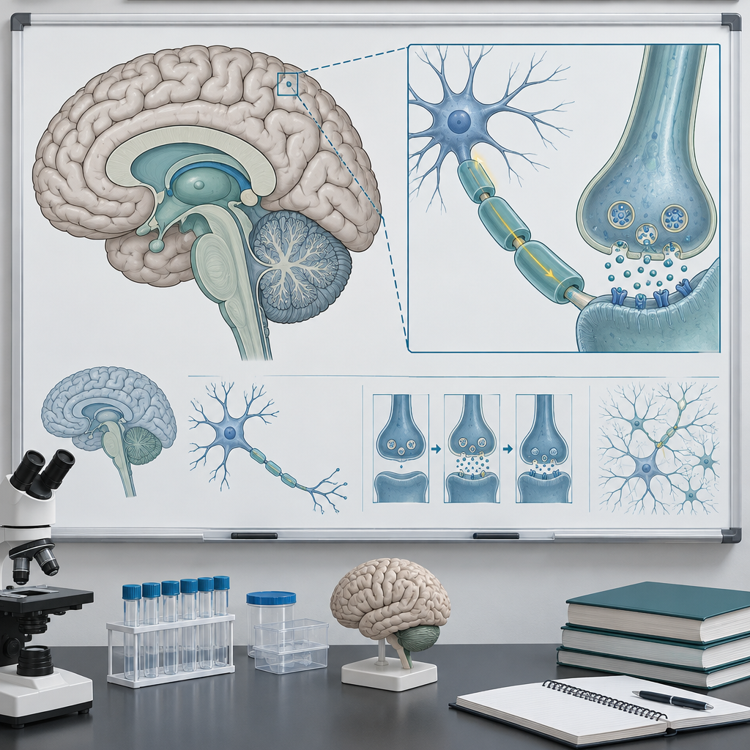

Overview
This lesson starts Biology 30 Unit A on the nervous system. It moves from single cells to the whole system (Topic). Students first study how one neuron makes and sends an action potential. They learn how that signal crosses a synapse. The synapse uses acetylcholine and norepinephrine. They learn how cholinesterase stops the signal (Outcome, Outcome). The lesson then moves to organs and systems. Students label key parts of the central and peripheral nervous systems. They link each part to its job. This job is voluntary or involuntary control (Outcome, Outcome). The lesson ends with a case study on reflex arcs. It uses the patellar and pupillary reflexes as examples. It also covers other sensory receptors. These sense the body's environment and position. (Outcome, Outcome).
This lesson lays groundwork for the nervous and endocrine systems. It shows how they work together. It uses the stress response as an example. This response involves the adrenal gland. (Outcome).

Outcomes covered
- Students will explain how the nervous system controls physiological processes. (Topic)
This general outcome frames the entire unit and situates today's lesson on neurons, the CNS and PNS, and reflex arcs within the broader theme of how the body maintains equilibrium with its environment.
- 30-A1.1k describe the general structure and function of a neuron and myelin sheath, explaining the formation and transmission of an action potential, including all-or-none response and intensity of response; the transmission of a signal across a synapse; and the main chemicals and transmitters involved, i.e., norepinephrine, acetylcholine and cholinesterase (Outcome, Outcome)
Understanding action potentials and synaptic transmission at the cellular level is the foundation for explaining how the nervous system controls physiological processes.
- 30-A1.2k identify the principal structures of the central and peripheral nervous systems and explain their functions in regulating the voluntary (somatic) and involuntary (autonomic) systems of the human organism; i.e., cerebral hemispheres and lobes, cerebellum, pons, medulla oblongata, hypothalamus, spinal cord, sympathetic and parasympathetic nervous systems, and the sensory-somatic nervous system (Outcome, Outcome)
Locating these structures and linking each to a specific function allows students to reason about how the nervous system controls physiological processes.
- 30-A1.3k describe, using an example, the organization of neurons into nerves and the composition and function of reflex arcs; e.g., the patellar reflex, the pupillary reflex (Outcome)
Reflex arcs demonstrate how the spinal cord can produce a rapid, protective response independent of conscious brain processing, illustrating the practical survival value of nervous system organization.
- 30-A1.6k explain other ways that humans sense their environment and their spatial orientation in it; e.g., olfactory receptors, proprioceptors, taste receptors, receptors in the skin (Outcome)
Recognizing the range of sensory receptor types beyond vision and hearing completes students' picture of how the nervous system monitors both the external world and the body's own position.

Materials
- Blank diagram handouts of a multipolar neuron and a chemical synapse
- Blank sagittal brain diagram handouts
- CNS/PNS branching schematic handouts (sensory-somatic and autonomic divisions)
- Reflex arc case cards (patellar reflex and pupillary reflex)
- Rulers, one per pair, for the reaction-time activation activity
- Reaction-time reference conversion table (drop distance to milliseconds)
- Projector or whiteboard for labelled answer keys
- Exit ticket handout, one per student

Sequence of activities

1. Activation: Reflex Speed Challenge and Prior Knowledge Check (8 min, pairs)
- In pairs, one student drops a ruler vertically and the other catches it with thumb and forefinger without warning. Record the catch distance and convert to reaction time using the reference table provided.
- Repeat three times, then discuss: was the motion voluntary or involuntary, and which pathway (eye → brain → skeletal muscle) had to be completed before you could catch the ruler? Compare this to the much faster spinal reflex arc examined later.
- As a class, brainstorm on the board every nervous system term students already know from Biology 20 (Unit D: Human Systems), sorting terms loosely into "structures" and "functions."
- Teacher frames the lesson: today's work explains how a nerve impulse forms, crosses a synapse, and travels through CNS and PNS structures to produce both voluntary responses, such as the ruler catch just tested, and much faster involuntary reflexes such as the patellar reflex.
The ruler drop measures voluntary visual reaction time, which is processed by the brain and is therefore not a reflex; use it as a contrast case for the true spinal reflex arc (patellar reflex) taught in Activity 4. Keep this brief and diagnostic; do not correct misconceptions yet, just note them for later reference. Aligns to Topic, Outcome.
Sources: Topic, Outcome

2. Direct Instruction: Neuron Structure, the Action Potential, and Synaptic Transmission (15 min, whole class)
- Present a labelled diagram of a multipolar neuron (dendrites, cell body, axon hillock, axon, myelin sheath, nodes of Ranvier, axon terminals). Ask students to identify the function of each part from memory before revealing labels.
- Explain resting potential (approximately −70 mV, maintained by the sodium-potassium pump) and depolarization, using a graph of membrane potential versus time to trace an action potential from threshold to repolarization.
- Introduce the all-or-none response: once threshold is reached, the action potential fires at full amplitude regardless of stimulus strength; intensity of a stimulus is instead coded by the frequency of action potentials and the number of neurons firing, not by the size of any single impulse.
- Explain saltatory conduction along myelinated axons via the nodes of Ranvier and contrast this with continuous conduction along unmyelinated fibres.
- Diagram a chemical synapse. Trace the sequence: action potential arrives at the axon terminal, calcium influx triggers vesicle fusion, neurotransmitter (acetylcholine) is released into the synaptic cleft, binds receptors on the postsynaptic membrane, and is then broken down by cholinesterase to terminate the signal. Contrast acetylcholine with norepinephrine as transmitters used in different parts of the nervous system.
- Worked example: pose the question, "If a poison blocked cholinesterase, what would happen to muscle contraction, and why?" Model the answer: acetylcholine would remain in the synaptic cleft, continuously stimulating the postsynaptic membrane, producing sustained muscle contraction or spasm because the signal cannot be terminated.
- Formative check: cold-call three students to state, in their own words, one part of the action potential-to-synapse sequence in order, building the full sequence collectively on the board.
This directly addresses Outcome and Outcome, which are duplicate wording of the same outcome (30-A1.1k). Emphasize the distinction between all-or-none firing and graded stimulus intensity, a common diploma exam misconception. Ensure students can name norepinephrine, acetylcholine and cholinesterase specifically, as these are named in the outcome.
Sources: Outcome, Outcome

3. Structured Notes and Diagram Labelling: CNS and PNS Organization (15 min, individual)
- Distribute a blank diagram of a sagittal brain section and a schematic of the CNS/PNS branching organization (CNS: brain and spinal cord; PNS: sensory-somatic and autonomic, with autonomic further split into sympathetic and parasympathetic).
- Students label the cerebral hemispheres and at least one lobe, cerebellum, pons, medulla oblongata, hypothalamus and spinal cord on the brain diagram, writing one function beside each structure (e.g., medulla oblongata: regulates heart rate and breathing; cerebellum: coordinates balance and fine motor movement; hypothalamus: maintains homeostasis and links nervous and endocrine control).
- On the branching schematic, students correctly place sympathetic nervous system (fight-or-flight: increases heart rate, dilates pupils, redirects blood to skeletal muscle) and parasympathetic nervous system (rest-and-digest: slows heart rate, stimulates digestion) as antagonistic divisions of the autonomic nervous system, and the sensory-somatic nervous system as the voluntary division controlling skeletal muscle.
- Teacher circulates, checking that each label includes both a correct structure name and its function, not just the name.
- Quick pair-check: students trade papers with a neighbour and verify three labels against the projected answer key.
This activity is the core coverage of Outcome and Outcome (identical wording, 30-A1.2k). Watch for students confusing the pons and medulla oblongata, and for students describing the hypothalamus only as a brain part rather than linking it to homeostatic regulation, which matters for the later endocrine unit (Outcome).
Sources: Outcome, Outcome

4. Applied Case Study: The Reflex Arc and Sensory Receptors (15 min, small group)
- In groups of three or four, students receive a case card describing the patellar reflex (knee-jerk) and diagram the five components of a reflex arc in order: sensory receptor, sensory (afferent) neuron, integration centre in the spinal cord, motor (efferent) neuron, effector (quadriceps muscle).
- Groups answer: why does the patellar reflex not require input from the cerebral hemispheres, and what survival advantage does this give the response time? Model answer: the reflex arc is completed at the spinal cord, bypassing the brain, so the muscle contracts before conscious sensation of the tap even registers, allowing a faster protective response.
- Groups repeat the exercise for the pupillary reflex, identifying the receptor (photoreceptors in the retina), the integration centre in the midbrain/brainstem, and the effector (iris muscles controlling pupil diameter), and explain its function in protecting the retina from excessive light.
- Extend to other senses: groups list one example each of olfactory receptors, proprioceptors, taste receptors and receptors in the skin, and state briefly what stimulus each detects and how this supports the body's overall sense of its environment and spatial orientation.
- One group per case reports back to the class in 30 seconds, and the teacher confirms or corrects the reflex arc sequence on the board.
This covers Outcome (reflex arcs, 30-A1.3k) and Outcome (other senses, 30-A1.6k). If time is short, assign the pupillary reflex and the additional receptor list as the exit task instead of full group report-back. Note that structures of the eye and ear (Outcome, Outcome) are not the focus of today's lesson and are reserved for a subsequent lesson on special senses.
Sources: Outcome, Outcome

5. Consolidation: Exit Ticket and Preview of Endocrine Interaction (7 min, individual)
- Students complete a three-question exit ticket: (a) sequence the events of an action potential and synaptic transmission from stimulus to termination by cholinesterase; (b) name the CNS structures responsible for regulating heart rate and breathing, and one structure responsible for balance; (c) describe the five components of a reflex arc using the pupillary or patellar reflex as the example.
- Teacher previews the link to the endocrine system: the hypothalamus connects nervous and hormonal control, as in the stress response involving the adrenal gland, which the next lesson will examine in detail.
- Collect exit tickets on the way out as a formative check for tomorrow's planning.
Exit ticket responses should be scanned before the next class to identify which of Outcome, Outcome, or Outcome needs re-teaching. The stress and adrenal gland preview connects forward to Outcome without requiring students to master endocrine content today.
Sources: Outcome, Outcome, Outcome, Outcome

Differentiation
Extension
- Ask students to research and explain why multiple sclerosis, a demyelinating disease, slows or blocks saltatory conduction, and predict which reflexes or functions would be affected first.
- Have students compare the speed and duration of nervous system signalling (fast, brief action potentials) with endocrine hormone signalling (slower, longer-lasting) as a bridge to Outcome, using the stress response and adrenal gland as the example.
- Challenge students to draw a full autonomic nervous system diagram showing antagonistic sympathetic and parasympathetic effects on at least four organs, beyond the heart and pupil examples covered in class.
Support
- Provide a partially completed brain diagram with some structures pre-labelled, so students focus their effort on the remaining structures and on writing functions.
- Give a fill-in-the-blank version of the action potential and synapse sequence with a word bank of key terms (depolarization, threshold, acetylcholine, cholinesterase, vesicle, receptor).
- Pair students strategically during the reflex arc case study so a stronger reader can support a student who needs help decoding the case card text.
Inclusive supports
- Offer the neuron and brain diagrams in both print and enlarged-font digital format for students with visual processing needs.
- Allow verbal response options for the exit ticket for students who find handwriting under time pressure a barrier.
- Use consistent, uncluttered diagram templates with adequate white space around labelling lines to support students with fine motor or attention difficulties.

Assessment
Formative. The lesson starts with a ruler-drop reflex activity. Then the class brainstorms ideas. Look for: The teacher notes the terms and misconceptions students share. This helps set the pace for the direct instruction that follows. (Topic)
Formative. The teacher cold-calls students during direct instruction. Students order the action potential and synapse steps. Look for: Students state the steps in order. These steps are depolarization, threshold, all-or-none firing, neurotransmitter release, receptor binding, and cholinesterase breakdown. They correctly use the terms acetylcholine and norepinephrine. (Outcome, Outcome)
Formative. Students check each other's CNS/PNS labelling diagrams.
Look for: Labels name the correct structures. These are cerebral hemispheres, cerebellum, pons, medulla oblongata, hypothalamus, and spinal cord. Each structure has one correct sentence about its job. (Outcome, Outcome)
Formative. Small groups report back on the patellar and pupillary reflex arc case study.
Look for: Groups correctly order all five reflex arc components. They explain why the response skips conscious brain processing. (Outcome)
Formative. A three-question exit ticket covers three topics. These are action potential and synapse order, CNS structures for heart rate, breathing, and balance, and reflex arc parts.
Look for: Written answers show the correct order. They show correct structure-function pairs. They show correct reflex arc order with a named example. (Outcome, Outcome, Outcome)

Vocabulary
- Action potential: A rapid, temporary reversal of membrane potential along a neuron's axon, triggered once a stimulus reaches threshold; it follows an all-or-none pattern, meaning it fires at full strength or not at all, while stimulus intensity is instead encoded by impulse frequency.
- All-or-none response: The principle that an action potential, once threshold is reached, always fires with the same maximum amplitude regardless of how strong the triggering stimulus was.
- Synapse: The junction between two neurons, or between a neuron and an effector, where a chemical neurotransmitter such as acetylcholine crosses the synaptic cleft to transmit the signal to the next cell.
- Cholinesterase: An enzyme that breaks down acetylcholine in the synaptic cleft after it has bound its receptor, terminating the nerve signal so the postsynaptic cell can reset for the next impulse.
- Myelin sheath: An insulating layer, formed by supporting cells, that wraps sections of an axon and allows saltatory conduction of the action potential between gaps called nodes of Ranvier, greatly increasing conduction speed.
- Sympathetic nervous system: The division of the autonomic nervous system that prepares the body for activity or stress, for example by increasing heart rate and redirecting blood flow to skeletal muscle.
- Parasympathetic nervous system: The division of the autonomic nervous system that supports rest and routine maintenance functions, for example by slowing heart rate and stimulating digestion, generally acting antagonistically to the sympathetic division.
- Reflex arc: The neural pathway of a reflex, composed of a sensory receptor, a sensory (afferent) neuron, an integration centre usually in the spinal cord, a motor (efferent) neuron, and an effector, allowing a rapid response without requiring conscious processing by the cerebral hemispheres.
- Proprioceptor: A sensory receptor located in muscles, tendons and joints that detects body position and movement, contributing to spatial orientation and balance.

Sources
- Outcome: "30-A1.2k identify the principal structures of the central and peripheral nervous systems and explain their functions in regulating the voluntary (somatic) and involuntary (autonomic) systems of the human organism"
- Outcome: "30-A1.1k describe the general structure and function of a neuron and myelin sheath, explaining the formation and transmission of an action potential, including all-or-none response and intensity of response"
- Outcome: "30-A1.2k identify the principal structures of the central and peripheral nervous systems"
- Topic: "Students will explain how the nervous system controls physiological processes."
- Outcome: "30-A1.1k describe the general structure and function of a neuron and myelin sheath"
- Outcome: "30-A1.3k describe, using an example, the organization of neurons into nerves and the composition and function of reflex arcs"
- Topic: "This unit examines the biological processes that mediate the interactions between humans and their environment to maintain equilibrium."
- Outcome: "30-A1.6k explain other ways that humans sense their environment and their spatial orientation in it"
- Outcome: "30-A2.5k compare the endocrine and nervous control systems and explain how they act together; e.g., stress and the adrenal gland"

All content describes standard human anatomy and physiology at the appropriate depth for Grade 12 Biology 30, uses no graphic or distressing imagery, and is appropriate and respectful for a senior high school science classroom.

AILI detailed pack · en · claude-sonnet-5 · 2026-09-17

