Cells and Systems
Central concept: Living Systems

Connections
- Living Systems (composed of) -> Cells
- Cells (form) -> Tissues
- Tissues (form) -> Organs
- Organs (organize into) -> Body Systems
- Cells (includes) -> Plant Cells
- Cells (includes) -> Animal Cells
- Living Systems (can be) -> Single-Celled Organisms
- Living Systems (can be) -> Multicelled Organisms
- Cells (perform) -> Transport Processes
- Body Systems (enable) -> Response to Stimuli
- Body Systems (studied by) -> Science
- Organs (subject of) -> Science

Notes
- Living Systems: Organisms organized at multiple levels from cells to complex structures Topic
- Cells: Basic unit of life; all living things composed of cells Outcome, Outcome
- Tissues: Groups of similar cells that work together Outcome, Outcome
- Organs: Structures made of tissues that perform specific functions Outcome, Outcome
- Plant Cells: Have cell walls and other structures distinct from animal cells Outcome, Outcome
- Animal Cells: Have cell membranes; lack cell walls Outcome, Outcome
- Single-Celled Organisms: One cell performs all life functions; example amoeba Outcome, Outcome
- Multicelled Organisms: Many cells work together; cells specialize in different functions Outcome, Outcome
- Body Systems: Respiration, circulation, digestion, excretion, sensory awareness Outcome
- Transport Processes: Diffusion and osmosis move gases and liquids based on concentration Outcome, Outcome
- Response to Stimuli: Body changes in response to internal and external conditions Outcome
- Health Research: Studies improve understanding of cells, organs and systems Outcome
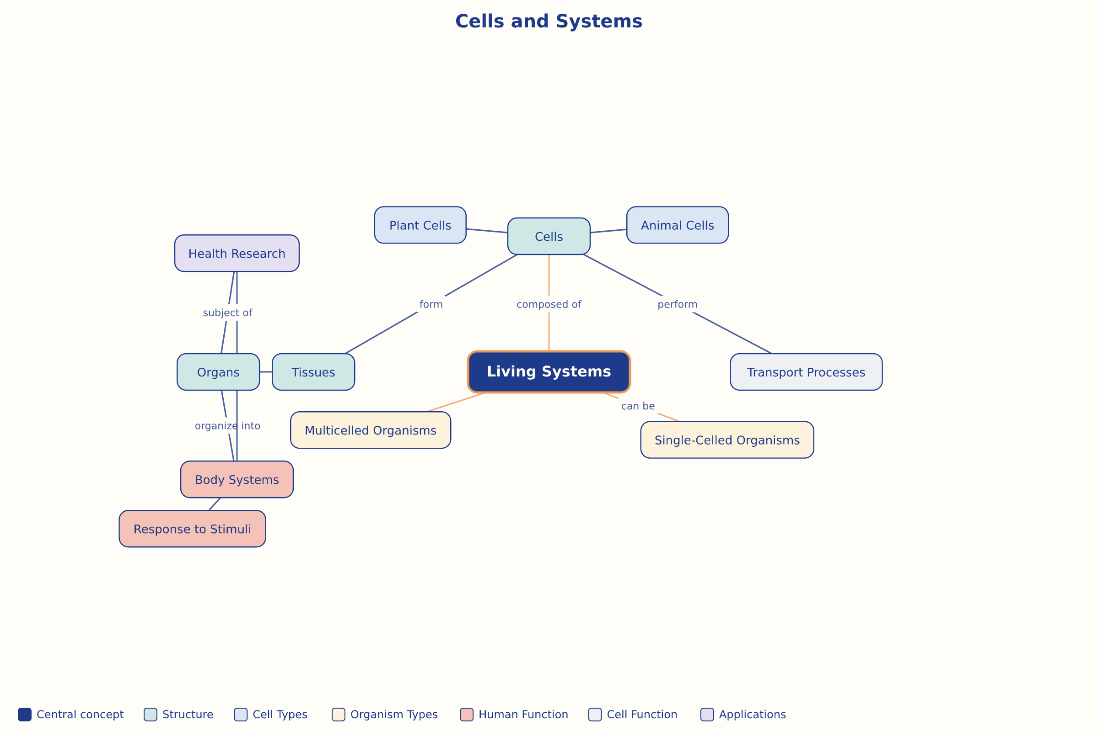

AILI word map · en · claude-haiku-4-5-20251001 · 2026-09-17

