Adding and Subtracting to 100: Tens, Facts, and Flexible Sums
Building fact fluency and flexible strategies to 100 with hands-on blocks, measuring, and word problems
Audience: Grade 2 classroom teacher planning a full-class mathematics lesson
Grades: Grade 2
Subjects: Mathematics
Time: about 60 minutes
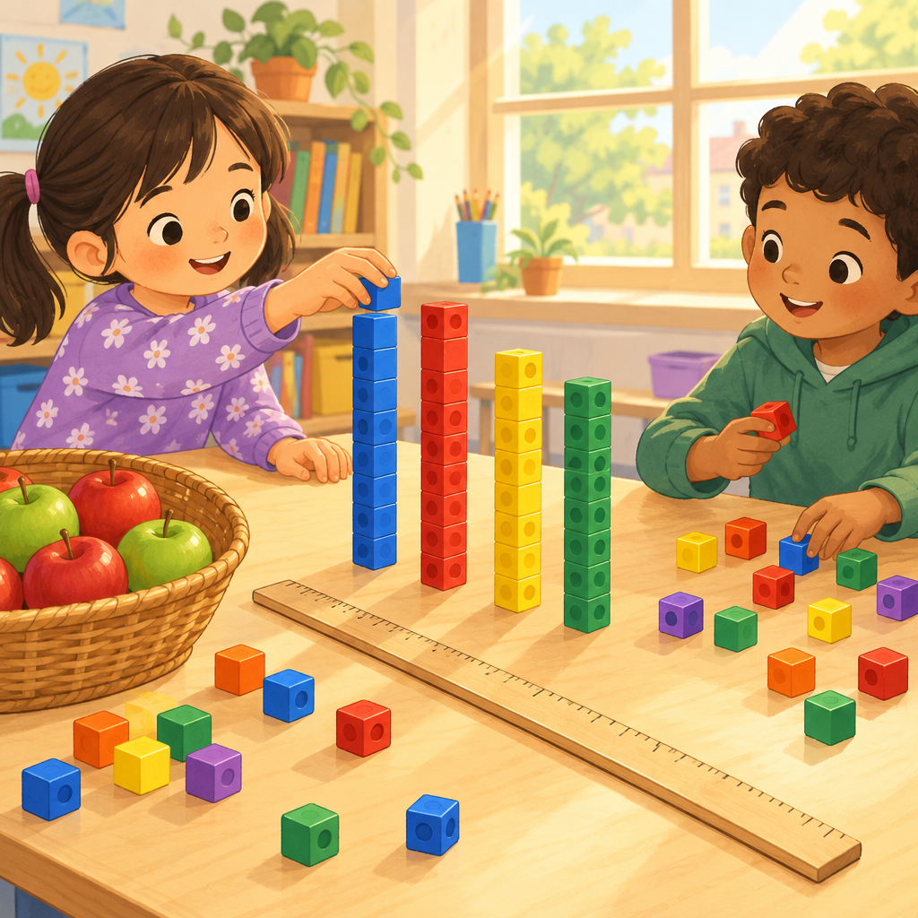

Overview
This Grade 2 mathematics lesson builds addition and subtraction skills within 100 (Outcome). Students start with quick fact recall, move into building 100 with tens, practise adding and checking with base-ten blocks, solve word problems about objects and lengths, and finish by showing that one sum can be made in several ways.
The lesson connects fact fluency to bigger two-digit strategies, so students see how known facts to 10 support harder addition and subtraction (Knowledge, Skills, Skills, Knowledge). Hands-on materials like base-ten blocks, counters, and a metre stick keep the math concrete and touchable throughout.

Outcomes covered
- Students investigate addition and subtraction within 100. (Outcome, Outcome)
This is the focus learning outcome for the lesson, connecting number facts, strategies, and problem solving into one skill set for Grade 2 (Outcome, Outcome).
- Recall and apply addition number facts, with addends to 10, and related subtraction number facts. (Skills, Skills)
Quick recall of facts to 10 is the foundation students need before tackling two-digit addition and subtraction strategies.
- Investigate strategies for addition and subtraction of two-digit numbers, including making multiples of ten and using doubles. (Knowledge, Skills, Skills, Knowledge)
Strategy-based thinking, rather than memorization alone, helps students flexibly solve larger addition and subtraction problems.
- Add numbers up to a sum of 100 and subtract numbers with a maximum minuend of 100. (Skills, Skills)
This sets the concrete number range students must work within confidently by the end of Grade 2.
- Verify a sum or difference, using inverse operations. (Skills, Skills)
Checking work with the inverse operation builds number sense and helps students catch their own errors.
- Determine a missing quantity in a sum or difference, within 100, in a variety of ways. (Skills, Skills)
Missing-number problems prepare students for algebraic thinking and flexible equation reading.
- Solve problems, using addition and subtraction of countable quantities or measurable lengths. (Skills, Understanding, Skills, Understanding)
Connecting addition and subtraction to real objects and lengths makes the math concrete and useful.
- Visualize 100 as a composition of multiples of 10 in various ways, and compose a sum in multiple ways, including with more than two addends. (Skills, Skills)
Seeing 100 as flexible groups of tens builds a strong base-ten foundation for place value and mental math.
- A sum can be composed in multiple ways. (Understanding, Understanding)
This understanding helps students see addition as flexible rather than fixed to one method.
- The order in which more than two numbers are added does not affect the sum (associative property). (Knowledge, Knowledge)
Knowing this property lets students regroup addends for easier mental math, such as grouping to make tens first.

Materials
- Ten frame flash cards (at least 5)
- Ten bundles of ten straws or ten linking-cube rods of ten
- Base-ten blocks (tens rods and ones cubes), one set per pair
- Small whiteboards and markers, one per pair and one per student
- Counters, at least 20 per small group
- A metre stick
- Paper strips cut to different lengths for the measuring word problem
- Exit ticket paper or whiteboard divided into three boxes, one per student

Sequence of activities

1. Warm-Up: Ten Frame Facts Flash (8 min, whole class)
- Show a ten frame card (like a picture of a box with ten dots) for two seconds, then hide it.
- Ask: "How many dots did you see? How many empty spots?"
- Students show the matching addition fact on fingers, for example 6 + 4 = 10.
- Repeat with five different ten frame cards, mixing full and part-full frames.
- Ask one related subtraction fact for each card, for example 10 − 6 = 4.
- Praise fast, confident answers and gently correct any mix-ups by counting the dots together.
This warms up addition facts to 10 and their related subtraction facts before harder two-digit work (Skills, Skills). Watch for students who need to count all instead of using known facts; note them for the small group later.
Sources: Skills, Skills

2. Mini-Lesson: Building 100 with Tens (10 min, whole class)
- Hold up ten bundles of ten straws (or ten rods of ten linking cubes).
- Ask: "How many tens do we need to make 100?" Count together by tens: 10, 20, 30... 100.
- Show that 100 can be made in different ways, such as 5 tens + 5 tens, or 7 tens + 3 tens, or 4 tens + 4 tens + 2 tens.
- Write two examples on the board: 50 + 50 = 100 and 70 + 30 = 100.
- Ask students to turn and tell a partner one more way to make 100 using tens.
- Introduce the strategy of making a ten (or a multiple of ten) to add two-digit numbers, for example 38 + 2 = 40, then 40 + 25 = 65.
- Model one two-digit addition problem on the board using this strategy: 47 + 26. Break 26 into 3 + 23. Add 47 + 3 = 50. Add 50 + 23 = 73.
This activity addresses visualizing 100 as a composition of tens and using the making-tens strategy (Skills, Knowledge, Knowledge, Skills). Keep the modelled problem slow and think aloud each step.
Sources: Skills, Knowledge, Knowledge, Skills

3. Guided Practice: Add and Check with the Inverse (10 min, pairs)
- Give each pair a set of base-ten blocks (tens rods and ones cubes) and a whiteboard.
- Write three problems on the board: 24 + 35, 58 + 6, 19 + 19.
- Partners build the first number, then add the second number using blocks, trading ten ones for a rod when needed.
- Partners record the sum on the whiteboard.
- Partners check their sum using subtraction, for example 24 + 35 = 59, so 59 − 35 should equal 24.
- Repeat for the other two problems, switching who builds and who checks each time.
- Circulate and ask: "How do you know your answer is right?"
This practises adding to a sum within 100 and verifying with the inverse operation (Skills, Skills). The doubles problem (19 + 19) lets students notice the doubles strategy from Knowledge.
Sources: Skills, Skills, Knowledge, Knowledge

4. Word Problems: Missing Numbers and Measuring Lengths (15 min, small group)
- Sort students into groups of three or four at stations with counters, a metre stick, and strips of paper of different lengths.
- Present problem one: "A ribbon is 63 centimetres long. Another ribbon is 100 centimetres long. How much longer is the second ribbon?" Students measure paper strips to model it, then write the subtraction sentence.
- Present problem two: "There are some apples in a basket. Someone adds 18 more apples. Now there are 45 apples. How many apples were there at the start?" Students use counters to find the missing addend, then write the number sentence with a box for the unknown, for example ___ + 18 = 45.
- Present problem three: "48 marbles plus some more marbles makes 100 marbles. How many marbles were added?" Students solve and check using the inverse operation.
- Each group shares one problem and their strategy with the class.
- Ask the class: "Did anyone solve it a different way?" and record two different strategies on the board.
This activity covers solving problems with countable quantities and measurable lengths, and finding a missing quantity within 100 (Skills, Understanding, Skills, Understanding). Encourage groups to use different strategies, connecting to Understanding and Understanding, the idea that a sum can be composed in multiple ways.
Sources: Skills, Understanding, Skills, Understanding, Understanding, Understanding

5. Wrap-Up: Three Ways to Make the Same Sum (12 min, individual)
- Give each student a small whiteboard or paper divided into three boxes.
- Write a target sum on the board, for example 76.
- Ask students to write three different addition sentences that equal 76, using two or more addends, for example 50 + 26, 40 + 30 + 6, 70 + 6.
- Ask students to check one of their sentences using subtraction as the inverse.
- Invite two or three students to share a sentence with more than two addends and explain why the order of adding did not change the total.
- Collect whiteboards or papers as an exit check.
This closer checks composing a sum in multiple ways, including more than two addends, and the associative property that order does not change the sum (Knowledge, Skills, Understanding, Skills, Understanding, Knowledge). Use this as your exit ticket for today's formative assessment.
Sources: Knowledge, Skills, Understanding, Skills, Understanding, Knowledge

Differentiation
Extension
- Challenge students to find three addends that make 100 without using any multiple of ten, for example 37 + 28 + 35.
- Ask early finishers to write their own missing-length word problem for a partner to solve.
- Invite students to explain, in their own words, why changing the order of three addends does not change the sum, using cubes as proof.
Support
- Provide a hundred chart and ten frames for students who need a visual count-by-tens support during the mini-lesson and guided practice.
- Reduce numbers in the word problems to within 20 for students still building confidence with two-digit addition, keeping the same problem structures.
- Allow extra time and a partner during the exit ticket, and accept two correct addition sentences instead of three.
Inclusive supports
- Offer manipulatives (base-ten blocks, counters, ten frames) at every station so all students can show thinking with objects, not only numbers.
- Pair students with mixed strengths for the guided practice and word problem stations so peer explanation supports language and math needs together.
- Read all word problems aloud twice and display them in print for students who benefit from both auditory and visual input.

Assessment
Formative. Observe pairs during the base-ten block activity as they build, add, and check sums with subtraction.
Look for: Student correctly trades ten ones for a tens rod, records the sum, and uses subtraction to confirm it matches the addition. (Skills, Skills)
Formative. Listen to group shares during the word problem station rotation.
Look for: Student explains a missing-addend or length-comparison problem using a number sentence and can point to the strategy used to find the unknown. (Skills, Understanding, Skills, Understanding)
Summative. Collect the three-box exit ticket where students write three ways to make the same sum and check one with subtraction.
Look for: Student produces at least two correct addition sentences for the target sum, one with more than two addends, and successfully checks a sentence with the inverse operation. (Knowledge, Skills, Understanding, Skills, Understanding, Knowledge)

Vocabulary
- sum: A sum is the answer you get when you add numbers together. Example: the sum of 7 and 3 is 10.
- difference: A difference is the answer you get when you subtract one number from another. Example: the difference between 10 and 4 is 6.
- addend: An addend is one of the numbers being added together. In 6 + 4 = 10, both 6 and 4 are addends.
- inverse operation: An inverse operation undoes another operation. Subtraction is the inverse of addition, so you can use it to check an addition answer.
- associative property: The associative property means you can change the order you add numbers in a group, and the total sum stays the same.
- minuend: The minuend is the starting number in a subtraction problem, the number you subtract from. In 100 − 40 = 60, 100 is the minuend.

For families
- Practise making 100 at home by counting coins in groups of ten, like ten pennies at a time.
- Ask your child to find two different ways to make the same total when you are adding up grocery items or toy collections.
- Use a tape measure to compare the length of two objects at home and ask your child to find the difference.

Sources
- Guiding question: "How can addition and subtraction be interpreted?"
- Outcome: "Students investigate addition and subtraction within 100."
- Knowledge: "The order in which more than two numbers are added does not affect the sum (associative property)."
- Skills: "Visualize 100 as a composition of multiples of 10 in various ways."
- Understanding: "A sum can be composed in multiple ways."
- Knowledge: "Addition and subtraction strategies for two-digit numbers include making multiples of ten and using doubles."
- Skills: "Add numbers up to a sum of 100 and subtract numbers with a maximum minuend of 100."
- Understanding: "Addition and subtraction can represent the sum or difference of countable quantities or measurable lengths."
- Skills: "Recall and apply addition number facts, with addends to 10, and related subtraction number facts."
- Knowledge: "Familiar addition and subtraction number facts facilitate addition and subtraction strategies."
- Skills: "Compose a sum in multiple ways, including with more than two addends."
- Outcome: "Students investigate addition and subtraction within 100."
- Understanding: "A sum can be composed in multiple ways."
- Understanding: "Addition and subtraction can represent the sum or difference of countable quantities or measurable lengths."
- Knowledge: "The order in which more than two numbers are added does not affect the sum (associative property)."

All activities use everyday classroom materials and age-appropriate scenarios (ribbons, apples, marbles), with no content that is unsafe or culturally sensitive for Grade 2 students.

AILI detailed pack · en · claude-sonnet-5 · 2026-09-17

