Cells and Systems: From Single Cells to Organisms
Understanding how cells work together to build living things.
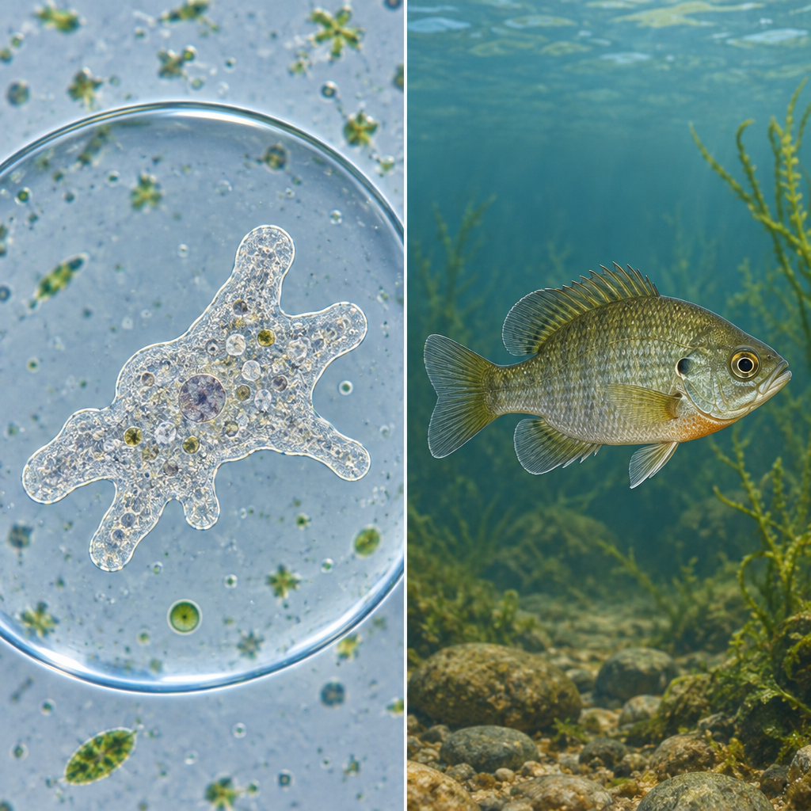

Learning intentions
We are learning to describe the role of cells as the basic unit of life and explain how cells work together in multicellular organisms to carry out life functions.

Success criteria
I can:
- describe what a cell is and why it is called the basic unit of life
- identify the main differences between plant and animal cells
- explain how single-celled organisms differ from multicellular organisms
- describe how cells, tissues and organs work together as systems in living things

Curriculum alignment
- Specific Outcome 2: Investigate and describe the role of cells within living things (Outcome, Outcome)
- Specific Outcome 1: Investigate living things and apply the concept of system in describing organisms (Outcome, Outcome)
- Unit B overview: Understanding structure, function and systems in living things (Topic)

Materials
- Microscope slides and microscopes (or digital microscope images)
- Prepared slides of animal cells (cheek cells) and plant cells (onion cells)
- Coloured pencils or markers
- Large paper or poster board (one per pair)
- Diagram templates showing plant and animal cell structures (printed or drawn on board)
- Images of single-celled organisms (amoeba, paramecium) and multicellular organisms (human, oak tree, fish)
- Optional: salt water and fresh water for osmosis demonstration

Lesson sequence

1. Hook (5 minutes)
Show students a microscope image of a cheek cell on the board or screen without explanation. Ask: "What are you looking at? How big is it? Could you see it with your eyes alone?"
Take responses. Then reveal that this is a single cell from inside a human mouth. Ask: "If one cell is this small, how many cells do you think are in your body right now?" Allow brief discussion.
Say: "Every living thing, from bacteria too small to see without a microscope to whales that weigh 200 tons, is made of cells. Today we're going to find out why cells matter so much and how they work together to build the organisms around us."

2. Direct instruction: What is a cell? (8 minutes)
Explain: A cell is the smallest unit of life that can do all the things a living thing does. It can take in food, get energy, grow, respond to its surroundings and make copies of itself (Outcome, Outcome).
Write on the board: "Cell = basic unit of life."
Ask students: "If a cell is the smallest living unit, what does that tell us about all living things?" Guide them to the idea that all living things are made of at least one cell.
Show images of three organisms side by side: a bacterium (single cell), an amoeba (single cell) and a human (multicellular). Ask: "What do you notice? Are they all alive? Are they all made of cells?"
Explain: Single-celled organisms like bacteria and amoebas are complete living things made of just one cell. That one cell does everything the organism needs to survive (Outcome, Outcome). Multicellular organisms like humans, plants and animals are made of many cells working together. Each cell has a job, and together they allow the organism to do much bigger and more complicated things.
Ask: "Why might it be useful for an organism to have many cells instead of one giant cell?" Accept answers. Guide toward ideas like specialization (different cells can do different jobs), size limits (very large single cells would not work well), and repair (if one cell is damaged, others can replace it).

3. Direct instruction: Plant and animal cells (10 minutes)
Display a labelled diagram of an animal cell and a plant cell side by side on the board or screen.
Say: "Animal cells and plant cells are similar in many ways, but they have some key differences. Let's find out what those are."
Point to each structure as you name it. For animal cells, identify: cell membrane, nucleus, cytoplasm, mitochondria. For plant cells, identify the same structures plus: cell wall, chloroplasts, large vacuole.
Explain the function of each in simple terms:
- Cell membrane: controls what goes in and out of the cell
- Nucleus: contains instructions for the cell (DNA)
- Cytoplasm: the jelly-like substance inside the cell where work happens
- Mitochondria: the powerhouse; breaks down food to release energy
- Cell wall (plants only): a tough outer layer that gives the plant cell its shape and support
- Chloroplasts (plants only): contain chlorophyll, which traps light energy to make food
- Large vacuole (plants only): stores water and helps keep the plant cell firm
Ask: "Why do you think plant cells have a cell wall but animal cells don't?" Guide students to think about how plants need to stand up on their own (trees, grass) while animals can move around. The cell wall provides rigid support.
Ask: "Why do plant cells have chloroplasts but animal cells don't?" Guide them to understand that plants make their own food from sunlight, while animals eat other organisms for food.

4. Guided practice: Comparing cells and organisms (10 minutes)
Hand out or project a comparison table with three columns: "Single-celled organism," "Multicellular organism," and "Example."
Work through the first row together as a class. For single-celled organisms, write: "One cell does all jobs" and give the example "amoeba." For multicellular organisms, write: "Many cells, each with a specific job" and give the example "human."
Ask: "If an amoeba is a single cell, how does it move, eat and reproduce?" Take responses. Explain that the amoeba's one cell has to do all of these jobs on its own. It moves by changing shape, eats by wrapping around food, and reproduces by splitting in two.
Ask: "A human has trillions of cells. Why don't all of them have to do all the jobs?" Guide students to understand that in multicellular organisms, cells are specialized. Some cells are nerve cells that sense the world. Some are muscle cells that move. Some are blood cells that carry oxygen. Together, they form tissues and organs that allow the organism to do complex things.
Write on the board: "Cells → Tissues → Organs → Organisms."
Explain: A tissue is a group of similar cells that work together to do one job. An organ is made of different tissues working together to do a bigger job. An organism is made of many organs working as a system (Outcome, Outcome).
Give an example: "Your heart is an organ. It is made of muscle tissue, nerve tissue, and blood tissue. These tissues work together to pump blood around your body."
Ask: "Can you think of another organ and name some of the tissues inside it?" Take a few responses (brain, lungs, stomach, etc.).

5. Independent practice: Cell diagram and labelling (5 minutes)
Hand out a blank or partially labelled cell diagram (either animal or plant, or one of each depending on your class level).
Ask students to label the structures and write one sentence about what each structure does. Circulate and check for understanding. Look for accurate labelling and clear explanations of function.
For students who finish early, ask them to draw a second cell type or to add a note about which structures are found in both types and which are unique.

6. Consolidation (2 minutes)
Bring the class back together. Ask three quick questions to check understanding:
- "What is a cell?" (The basic unit of life.)
- "Name one difference between a plant cell and an animal cell." (Cell wall, chloroplasts, or large vacuole in plants; accept any correct answer.)
- "Why is it useful for an organism to have many cells instead of just one?" (Specialization, size, repair, complexity.)
Collect the labelled diagrams as a formative check (see Assessment below).

Differentiation

Support
- Provide a partially completed cell diagram with some labels already filled in.
- Pair students with a peer or adult for the labelling activity.
- Use a simplified diagram showing only the main structures: nucleus, cell membrane, cytoplasm, and (for plant cells) cell wall and chloroplasts.
- Ask yes/no or multiple-choice questions during discussion rather than open-ended questions.

Extension
- Ask students to research and report on a specific organelle (e.g., mitochondria, endoplasmic reticulum, Golgi apparatus) and explain its role in the cell.
- Have students design a poster comparing three different organisms (a bacterium, a plant cell and an animal cell) and explain why each is suited to its environment.
- Ask students to predict what would happen to a plant cell if it were placed in salt water and explain their reasoning using the idea of osmosis (movement of water based on concentration differences).
- Challenge students to create a model of a cell using everyday materials and label all the structures.

Assessment

Formative check: Cell diagram labelling
Collect the labelled cell diagrams from the independent practice section. Look for:
- Accurate identification and placement of all major structures (nucleus, cell membrane, cytoplasm, mitochondria for all cells; cell wall, chloroplasts, large vacuole for plant cells)
- Clear, one-sentence descriptions of what each structure does
- Evidence that the student understands the difference between plant and animal cells (if both were required)
Use the results to identify which students need further support on cell structure and function before moving to the next lesson on how cells work together in tissues and organs (Outcome, Outcome). If most of the class shows gaps in understanding, plan a short review activity before the next lesson.

AILI rapid lesson · en · claude-haiku-4-5-20251001 · 2026-09-17

