Building Tens: Addition and Subtraction Within 100
Students use base-10 blocks to add and subtract two-digit numbers, then check their work with the opposite operation.
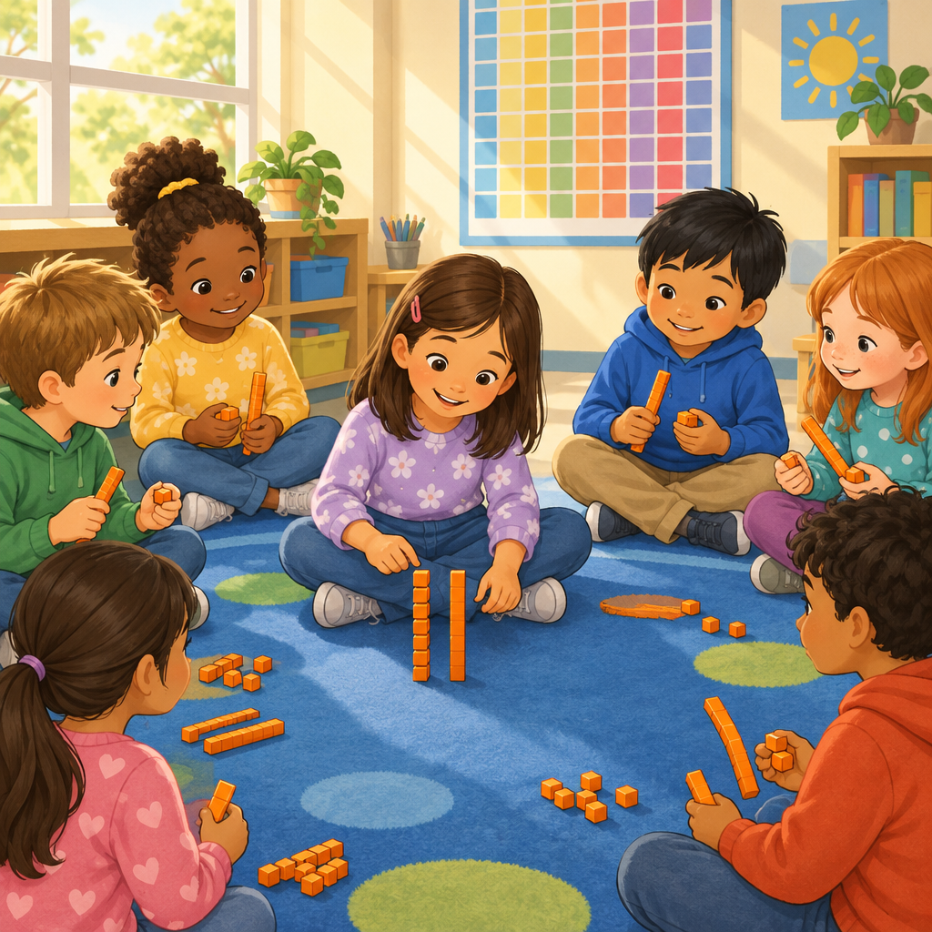

Learning intentions
We are learning to add and subtract two-digit numbers by working with tens and ones.
We are learning to check our answers using the opposite operation.

Success criteria
I can build a two-digit number with tens and ones blocks.
I can add two-digit numbers by making a ten.
I can subtract two-digit numbers by breaking apart a ten.
I can check my answer using addition or subtraction.

Curriculum alignment
- Students investigate addition and subtraction within 100 (Outcome, Outcome).
- Add numbers up to a sum of 100, subtract with a maximum minuend of 100, and verify using inverse operations (Skills, Skills).
- Addition and subtraction strategies for two-digit numbers include making multiples of ten and using doubles (Knowledge, Knowledge).
- Visualize 100 as a composition of multiples of 10, and compose a sum in multiple ways (Skills, Skills).
- A sum can be composed in multiple ways (Understanding, Understanding).
- Addition and subtraction can represent the sum or difference of countable quantities or measurable lengths (Understanding, Understanding).
- The order in which numbers are added does not change the sum (Knowledge, Knowledge).
- Base-10 blocks model regrouping by place value for addition and subtraction (Resource).

Materials
- Base-10 blocks (tens rods and ones cubes), enough for pairs
- Small whiteboards and markers, one per pair
- A hundred chart, posted where all students can see it
- Two ten-sided or six-sided dice per pair
- Printed problem cards: 10 addition and 10 subtraction problems within 100 (mix of single-digit and two-digit numbers)

Lesson sequence

1. Hook (5 minutes)
Hold up a tens rod and a ones cube. Ask: "How many small cubes fit along this whole rod?" Let two or three students guess. Show that ten ones cubes equal one tens rod.
Say: "Today we build numbers using tens and ones. We will add them, take them apart, and check our work."
Write 47 on the board. Ask: "How many tens and how many ones is that?" Take a few answers. Confirm: 4 tens and 7 ones.

2. Direct instruction (10 minutes)
Model 34 + 28 with base-10 blocks on the document camera or a table students can see.
Say: "I build 34. That is 3 tens rods and 4 ones cubes. Now I build 28. That is 2 tens rods and 8 ones cubes."
Push the tens rods together. Say: "3 tens plus 2 tens makes 5 tens. That's 50."
Push the ones cubes together. Say: "4 ones plus 8 ones makes 12 ones. But 12 ones is more than one ten. I trade 10 of these cubes for one more tens rod."
Show the trade. Say: "Now I have 6 tens and 2 ones. That is 62."
Write on the board: 34 + 28 = 62.
Ask: "How can I check this answer without adding again?" Guide students toward subtraction: 62 − 28 = 34. Write it down. Say: "If I subtract one addend from the sum, I should get the other addend back. That's how we check our work."
Now model a subtraction: 52 − 27. Build 52 with 5 tens and 2 ones. Say: "I need to take away 7 ones, but I only have 2 ones. I break apart one tens rod into 10 ones cubes."
Show the trade. Say: "Now I have 4 tens and 12 ones. I take away 2 tens and 7 ones. That leaves 2 tens and 5 ones. The answer is 25."
Ask: "How do we check this one?" Guide students to 25 + 27 = 52.

3. Guided practice (10 minutes)
Pair students. Give each pair base-10 blocks and a whiteboard.
Write on the board: 46 + 35.
Say: "Build both numbers with your blocks. Combine the tens. Combine the ones. Trade if you have 10 or more ones. Write your answer on your whiteboard."
Walk the room. Ask pairs: "How many tens do you have now? Did you need to trade any ones?"
After two minutes, ask one pair to show their blocks to the class and explain their trade.
Write on the board: 61 − 24.
Say: "Build 61. Try to take away 4 ones. What happens?" Let pairs work through the trade themselves.
Ask: "What did you have to do before you could take away 4 ones?" Expect answers like "break apart a ten."
Write on the board: 24 + 37 = ___. Ask: "Can we check this by finding 61 − 37? Try it with your blocks."

4. Independent practice (10 minutes)
Hand out the problem cards, one set per pair. Each card has one addition or subtraction problem within 100.
Say: "Choose four cards. Solve each one with your blocks or by drawing tens and ones on your whiteboard. Then check every answer using the opposite operation. Write both equations."
Example card set students might see:
- 38 + 45 = ___, checked by ___ − 45 = ___
- 73 − 29 = ___, checked by ___ + 29 = ___
- 27 + 16 + 10 = ___ (three addends, any order)
- 90 − 56 = ___, checked by ___ + 56 = ___
For the three-addend card, ask: "Does it matter which two numbers you add first?" Let students test both orders and confirm the sum stays the same.

5. Consolidation (5 minutes)
Bring the class back together. Ask: "Who found a problem where you had to trade ones for a ten, or a ten for ones?" Let two or three students share their equation and their check.
Ask: "Why does checking with the opposite operation work?" Listen for language like "it undoes the first one" or "it gets back the number you started with."
Close by asking: "If I add 3 tens and 5 tens in any order, do I still get 8 tens?" Confirm that order does not change the sum.

Differentiation
Extension: Give problems with three or four addends, such as 18 + 24 + 13 + 15, and ask students to group tens first before adding ones. Ask them to find two different orders that give the same sum, showing why order does not matter.
Support: Reduce problems to numbers within 50, and allow continued use of the hundred chart to count forward and backward instead of trading blocks. Pair these students with a peer for the independent practice and reduce the card set to two problems.

Assessment
Formative check: During independent practice, collect one whiteboard per pair before students erase it. Look for:
- Correct grouping of tens and ones with an accurate trade when needed
- A matching check equation using the inverse operation
- Whether the checked answer matches the original addend or minuend
Students who cannot yet explain why the check works, or who add ones without trading a full ten, need a small group session with blocks before moving to the next lesson on adding without physical materials.

AILI rapid lesson · en · claude-sonnet-5 · 2026-09-17

